# SPLWD: Student Profiling for Learners with Disabilities in Sta. Cruz District of Laguna

A Capstone Project Presented to the

Faculty of College of Computer Studies Laguna State Polytechnic University Sta. Cruz Campus

In Partial Fulfillment of the Requirements of the Degree

**BACHELOR OF SCIENCE IN INFORMATION TECHNOLOGY**

**By:**

**JOSHUA B. PASCUAL**

**IRISH CATHLYN E. NUAL DAN HENRY T. BONOZO**

**JUNE 2022**

# VISION

LSPU is a center of technology innovation that promotes interdisciplinary learning, sustainable utilization of resources, and collaboration and partnership with the community and stakeholders

# MISSION

LSPU, driven by progressive leadership, is a premier institution providing technology-mediated agriculture, fisheries and other related and emerging disciplines significantly contributing to the growth and development of the region and nation

# QUALITY POLICY

LSPU delivers quality education through responsive instruction, distinctive research, sustainable extension, and production services. Thus, we are committed with continual improvement to meet applicable requirements to provide quality, efficient and effective services to the university stakeholders’ highest level of satisfaction through an excelled management system imbued with utmost integrity, professionalism, and innovation.

# COLLEGE OF COMPUTER STUDIES GOAL

The College of Computer Studies graduates are expected to become globally competitive and innovative computing professionals imbued with utmost integrity, contributing to the country’s national development goals.

# BSIT PROGRAM EDUCATIONAL OBJECTIVES

The Bachelor of Science in Information Technology graduates are professionals that can adapt with the fast-paced computing trends responsive to global IT demands. It is designed to enable students to achieve the following by the time they graduate:

1. Apply knowledge for solving computing problems employing design and development solutions for business-driven application, installation, processes, operation, maintenance and administration of IT hardware and software.
2. Utilize modern computing tools and techniques in research and development projects.
3. Communicate effectively as a member or leader of the computing society with social, moral and legal responsibilities to accomplish a common goal.
4. Engage in life-long learning as foundation for continuing professional advancement.

# APPROVAL SHEET

The thesis entitled “**SPLWD: STUDENT PROFILING FOR LEARNERS WITH DISABILITIES IN STA. CRUZ DISTRICT OF LAGUNA**” prepare and submit by **JOSHUA B. PASCUAL, IRISH CATHLYN E. NUAL,** and **DAN HENRY T. BONOZO** in partial fulfillment of the requirements for the degree of Bachelor of Science in Information Technology is hereby recommended for approval and acceptance.

**Mia V. Villarica, DIT**

Thesis Adviser

Approved by the Committee on Oral Examination with a grade of .

**Ma. Laureen B. Miranda Mark P. Bernardino**

Subject Specialist Technical Editor

**Ma. Cezanne D. Dimaculangan Cherobie Aranas**

Language Critic Statistician

**Mia V. Villarica, DIT**

Research Implementing Unit Head

Accepted and approved in partial fulfillment of the requirement for the degree of Bachelor of Science in Information Technology.

**Reynalen C. Justo, MM-ITM, LPT**

Associate Dean, CCS

**Rina J. Arcigal, Ed. D.**

Director/Chairperson Research and

Development Date Signed

**RESEARCH CONTRIBUTION NO.**

# ACKNOWLEDGEMENT

With deepest gratitude and appreciation, the researchers humbly give thanks first to our **ALMIGHTY GOD** for giving strength, knowledge, wisdom, and guidance for their everyday life and to finish this study. To those people who helped them in making this study a possible one.

**HON. MARIO R. BRIONES, ED.D.,** the University President, for providing good leadership and care to the students, teachers, and non-teaching staff in the University;

**ENGR. MANUEL LUIS R. ALVAREZ,** the University Campus Director, for his continuous support and concern to all the students;

**REYNALEN C. JUSTO, MM-ITM,** Associate Dean of the College of Computer Studies, for the support and good leadership to all the students of CCS. For listening to the needs and problems of every student;

**MIA V. VILLARICA, DIT,** Thesis Adviser, for her suggestions and guidance from the start-up to the end of this research.

**LAUREEN B. MIRANDA**, Specialization Expert, for her suggestions and guidance in improving the study of the researchers.

**MARK P. BERNARDINO**, Technical Editor, for his time and guidance in checking the manuscript of the research study.

**MA. CEZANNE D. DIMACULANGAN**, Language Critic, for her time in checking the construction and grammar of the research paper.

**CHEROBIE ARANAS,** Statistician, for her time in sharing statistical knowledge to the researchers.

# ABSTRACT

The Sta. Cruz District has 16 schools, but only three of them provide Special Education. Sta. Cruz Central Elementary School, Bagumbayan Elementary School, and Gatid Elementary School. Using the knowledge obtained from the initial interview, There are 111 pupils at Sta. Cruz Central Elementary School, 32 at Bagumbayan Elementary School, and 20 at Gatid Elementary School, there are 163 LWD pupils overall. As a result of in depth interviews with SPED teachers the researchers they found out that there are numerous file that teachers are submitting annually and quarterly. Their current management system are still traditional way this current system is not convenient and vulnerable to natural disasters that’s why researcher came up with " SPLWD: Student Profiling for Learners with Disabilities in Sta. Cruz District of Laguna”. The goal of the study is to assist teachers in organizing and maintaining student evaluations, observations, and notes in web-based storage so that teachers can conveniently access them and monitor students' progress. This study will use descriptive and developmental research methods in designing the mobile application functionalities and features. The researchers utilize Agile Software Methodology for software development to determine the process of the study from data collection to system design, module development to meet needs, and testing the developed system. In the study's testing phase, ten out of ten IT experts who tested the system received a "passed" frequency with a 100% rate, indicating that the system's functionality was completely satisfied. During the evaluation phase, three principals and three principal's assistants from SCES, BES, GES, 12 LWD teachers, and 72 parents answered a questionnaire based on the TAM criteria, achieving a response scale of "Strongly Agree" and showing that users are extremely satisfied with the presented system.

***Keywords:*** *Student Profiling, Learners with Disabilities, Special Education, Principal, Principal’s Secretary, Teachers, Parents, Agile Software Methodology,*

# TABLE OF CONTENTS

Preliminaries Page

Title Page i

Visoion, Mission, Quality Policy, College of Computer Studies Goal, BSIT Program Educational Objectives ii

Approval Sheet iii

Acknowledgement iv

Abstract v

Table of Contents vi

List of Table viii

List of Figures ix

List of Appendices x

Operational Terms xi

Technical Terms xiii

**Chapter** 1

**1** **INRODUCTION AND ITS BACKGROUND** 1

Project Context 2

Research Objective 3

Conceptual Framework 5

Project Purpose 6

Scope and Limitation of the Study 7

**2** **REVIEW OF RELATED LITERATURE AND STUDIES** 8

Learning Disabilities 8

Parent Involvement 14

Special Education 18

Student Profiling 21

Agile Methodology 22

Descriptive and Developmental Research 23

Technology Acceptance Model 24

Likert Scale 27

Black Box Testing 27

Technology Gap Analysis 28

Synthesis 29

**3** **RESEARCH METHODOLOGY** 31

Research Design 31

Locale of the Study 32

Population of the Study 32

Sampling Design 33

Tester’s Profile 34

Data Collection Instrument 34

Project Design 38

System Architecture 38

Software Testing Phase 42

Testing Methods 48

Software Evaluation Phase 49

Design and Development of the Evaluation Tool 49

Validation of Questionnaire 51

Evaluation Tool 51

Distribution of Questionnaire 56

# LIST OF TABLE

**Table Page**

1 Frequency Distribution of Respondents 33

2 Tester's Profile 34

3 Test Case Description: Test the Functionality of (Login & System ADMIN) 44

4 Test Case Description: Test the Functionality of (Login & Principal’s Secretary) 46

5 Test Case Description: Test the Functionality of (Login & Parents) 47

6 Questionnaire for Teachers in terms of Quality Factors 52

7 Questionnaire for Teachers in terms of Perceived Ease of Use 52

8 Questionnaire for Teachers in terms of Perceived of Usefulness 53

9 Questionnaire for Teachers in terms of Experience 54

10 Questionnaire for Teachers in terms of Attitude towards Using 54

11 Questionnaire for Teachers in terms of Behavioral Intention of use 55

12 Likert Scale 56

# LIST OF FIGURES

**Figure Page**

1 SPLWD: Students Profiling for Learners with Disabilities in Sta. Cruz District of Laguna 5

2 System Architecture Diagram 39

3 Agile Software Development 40

4 Black Box Testing 43

5 Actual Structural Format of the Testing Tool 48

6 Technology Acceptance Model (TAM) 49

7 ISO/IEC 25010 Software Quality Metrics 50

8 Structural Format of the Evaluation Tool 50

# LIST OF APPENDICES

**Appendix**

**A. TECHNICAL BACKGROUND**

Transcribed Interview

Current Process Flowchart

Storyboard

Use Case Diagram

System Context Diagram

Data Flow Diagram

Data Dictionary

Project Schedule

Hardware and Software Resources

Testing and Evaluation Instruction

Questionnaire

Relevant Source Code

Sample Questionnaires

**B. COMMUNICATION LETTERS AND FORMS**

Communication Letter

ISO Forms

Final Oral Defense Rating Sheet

Summary of Recommendations for Final Oral Defense

**C. CURRICULUM VITAE**

Tester’s Curriculum Vitae

Researchers’ Curriculum Vitae

# Operational Terms

The operational terms defined the variables, concepts, or processes used by the researchers in the study. Also, these are the terms related to the research topic.

|  |  |
| --- | --- |
| **Administrator** | It is a type of end user with the authority to manage and control system operations. |
| **Agile Methodology** | It is a method for software development that involves iteration. It is used to reduce risk and to develop software in short time frames. |
| **Black box Testing** | It tests the system using no prior knowledge of its internal process. |
| **Descriptive Research** | It refers to the techniques used to characterize the properties of the variables being studied. |
| **Developmental Research** | It is defined as the systematic study of designing, developing, and evaluating instructional programs, processes, and products that need to adhere to internal consistency and effectiveness. |
| **Dichotomous Scale** | It is the total score obtained from a number of survey questions, each of which measures the same attribute. |
| **Individual Educational Plan (IEP)** | It includes information on the learning objectives, student strengths, skills, and interest in learning, as well as educational adjustments and inclusive strategies. |
| **Individual Learner’s Profile (ILP)** | The only difference between this form and an IEP is that it asks for a parent interview, which is essential because the SCES only provides a modular method. |
| **Learner Registration Number (LRN)** | It is a 12-digit number that must be kept by the pupil student, or learner throughout the basic education program, regardless of transfer to a different public or private school or learning center or promotion to the secondary level. |
| **Parent** | A type of end-user that can have an account with limited access using their child Learner Registration Number (LRN). |
| **Secretary** | It is a specific type of end user in the system. S/he has the authority to approve users of a specific school. |
| **Student Profiling** | It is a process uses to create and keep a record of learning experiences of the students over the course of their academic careers. |
| **Teacher** | A type of end-user that can have an account and upload IEP and ILP copy organize by date, IEP and ILP form where they can fill out online (printable). |
| **Web Based** | The applications that run on a web browser are typically referred to as web based. |

# Technical Terms

This section presents terms with their universal or dictionary definitions. The terms are used to describe the methods, equipment, and mechanisms used to create the system's features and functionalities. This section will serve as a reference for non-IT professionals

|  |  |
| --- | --- |
| **Bootstrap** | It is used on creating responsive and mobile-first websites. It serves as a framework for creating websites' front ends. |
| **CSS** | CSS is a language for describing reusable styles for displaying markup-language-written content. It is used for developing responsive websites. |
| **HTML** | It is used to structure the web page and its contents. |
| **JavaScript** | It is an interpreted client-side scripting language that gives web designers the power to add code to their websites. It enables the integration of complex features on web pages. |
| **Laptop / Computer** | It is an electronic device that may be programmed to store, retrieve, and process data. |
| **MySQL** | It is software used for databases. It is frequently used and a well-liked substitute for other SQL solutions due to the fact that it is open source and is available for free downloads. |
| **PHP** | It is short for PHP: Hypertext Preprocessor. Is a type of scripting language that is used to create websites. |
| **XAMPP** | Is an open source web server solution that includes everything required for server-side development. |

# CHAPTER I

# INRODUCTION

The Department of Education's basic education program includes special education. Special education, which began modestly in 1907, is now an important part of the basic education program in elementary and secondary schools. Special education programs are available in public and private elementary schools across the country. The number of children with disabilities in the Philippines is expected to be between 2.13 and 2.22 million in 2018 and only 231,631 are enrolled and dropped to 38,914, according to the DepEd records in the school year 2021-2022 (Philippines news agency).

Special education holds a lot of documents such as ILP (Individual Learners Plan), IEP (Individual Educational plan), ILMP (Individual Learners monitoring plan), BIR (Behavior Intervention Report) and Progress Report. This file contains the learning goals, strengths, education adjustment and inclusive strategies, these documents are important because it serve as a plan for educating LWD (Learners with Disabilities). Most of these documents are quarterly submitted, this makes the student files triple than the regular class documents.

The school in the Sta. Cruz district that offers special education is still using the traditional way of file management. Even though these documents are all organize these files are not accessible every time since it was stored at the school. Furthermore, the current system is prone to natural disasters, since Sta. Cruz Laguna is prone to flooding.

So as to address this problem, we create a web based student profiling, were teacher can have an account and upload IEP and ILP copy organize by date, Progress Report form were they can fill out online (printable), also Parent can have an account with limited access using their child Learner Registration Number (LRN) where they can fill out their observation about their children, and Teachers can search the profile of all LWD student in district of Sta. Cruz including previous observations, IEP and ILP to easily endorse student transferees or after the reshuffle.

In summary, the aim of the study is to help the teachers of Sta. Cruz District Schools easily accessed student profiles, easily tracked the improvement of their students and also endorsed transferee students or after the reshuffle in a convenient way.

## Project Context

The Sta. Cruz District has 16 schools, but only three of them provide Special Education. Sta. Cruz Central Elementary School (SCES), Bagumbayan Elementary School (BES) and Gatid Elementary School (GES). Based on the information gained from the preliminary interview, Sta. Cruz Central Elementary School has 111 students, Bagumbayan Elementary School has 32 students, and Gatid Elementary School has 20 students, resulting in a total of LWD students to 163. Because of the pandemic, the total number of LWD students has decreased.

There are numerous documents related to special education, including the Individual Learners Plan (ILP), Individual Educational Plan (IEP), Individual Learners Monitoring Plan (ILMP), Behavior Intervention Report (BIR), and Summary of Progress Report called Promotion. These documents are significant because they serve as a strategy for educating LWD (Learners with Disabilities) and contain information on learning objectives, strengths, educational adjustments, and inclusive tactics. Since the majority of these documents are submitted quarterly, the student files are three times as large as the typical class files.

The school that offers special education in the Sta. Cruz District is still using traditional way. These current system is not convenient to the teachers since the student files is only accessible at the school, and in addition to that the current system is vulnerable to natural disaster like flooding since the Sta. Cruz Laguna is prone to flooding. The researcher found the following problems: (a) How to design and develop a web based profiling that will help learners with disabilities, (b) How will the researchers helps the teachers test the main functionalities of the developed system, (c) How will the researchers help the principal, teachers, and parents evaluate the efficiency and usability of the system.

## Research Objective

The study aims to design, develop, test and evaluate the effectiveness of using a web based on learners with disabilities students profiling of Sta. Cruz district. To easily endorse their handled students after the reshuffle since there are three classes (Hearing Impairment, Transition Class and Non Graded class) of disabilities in every school that offers Special Education in Sta. Cruz District. Furthermore, keeping student assessments, observations, and remarks on the web based storage will organize them and can be easily accessed for teachers to easily track student improvement.

Specifically, this study sought to find out the following:

1. To design and develop a web based profiling for learners with disabilities of Sta. Cruz District of Laguna.
   1. IEP, ILP, ILMP and BIR
   2. LWD Students Profile
   3. LWD Progress Report, Evaluation and Observation
   4. Parents Observation
   5. LWD Monitoring
2. To test the main functionalities of the developed system by letting the teachers of Sta. Cruz District Schools use the web application.
   1. Adding new student to the system
   2. Updating student information
   3. Uploading the IEP, ILP, ILMP, BIR and Promotion of the student
   4. Adding parents observation to the student
3. To evaluate the efficiency and usability of the system by letting the principal, teachers, and parents use the web application
   1. Quality Factors of the System
   2. Perceived Ease of Use
   3. Perceived of Usefulness
   4. User Satisfaction
   5. Attitude Towards Using

## Conceptual Framework

This study shows how the developers must conduct an interview and make plans before using Agile Software Development, testing the system with experts to ensure user approval, and then evaluating the application's efficacy to help Learners with Disabilities in Sta. Cruz District of Laguna.

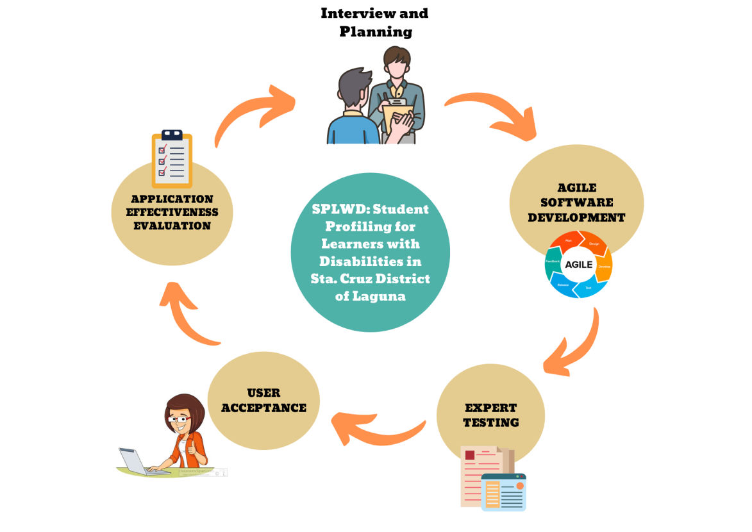

Figure 1. Conceptual Framework of Student Profiling for Learners with Disabilities

The conceptual framework above illustrates how the study was completed. The researchers gathered data from the client through interviews and planning. They also used data gathering techniques such as observations, interviews, questionnaires, internet searches, consultation, and, finally, brainstorming. The researchers will then develop a web-based solution. The researchers will used CSS, Bootstrap for front end, Php, JavaScript, for back-end, and Xampp, MySQL as a server-scripting language to store data in the database. The Agile Software Development model will be used in the system's development. And when the system was finalized, the researchers conducted system testing with the help of IT experts. The researchers used black box testing as a testing method. And also, the researchers conducted a face-to-face demonstration of the system and distributed printed questionnaires this determined the system’s functionality and user acceptance on TAM criteria. And at last, the evaluation phase which determines the study's outcome.

## Project Purpose

The purpose of the study entitled “SPLWD: Student Profiling for Learners with Disabilities in Sta. Cruz District of Laguna” is to help the teachers on keeping the student assessments, observations, and remarks on the web based storage to be organized, can be easily accessed for teachers and to easily track the students improvement. Furthermore, they easily endorse their handled students after the reshuffle since there are three classes (Hearing Impairment, Transition Class and Non Graded Class) of disabilities in every school that offers Special Education in Sta. Cruz District of Laguna.

* **LWD** – The researchers improve the effectiveness of the students’ lesson plans.
* **Teachers** – The researchers help the teachers by giving them a more practical method of monitoring student data that improves them for their learning plans for LWD in Sta. Cruz District.
* **Schools** – The researchers will provide Sta. Cruz District schools a much safer storage location for the LWD files.
* **Parents** – If their child is enrolled in a graded class, the researchers provide a convenient way for parents to view their child’s grades.

## Scope and Limitation of the Study

The study entitled “SPLWD: Student Profiling for Learners with Disabilities in Sta. Cruz District of Laguna” focus on developing a web based that helps the teachers on keeping the Individual Learners Plan (ILP), Individual Educational Plan (IEP), Individual Learners Monitoring Plan (ILMP), Behavior Intervention Report (BIR), and Promotion can be easily accessed and track student improvements.

To achieve the objective, the scopes of the study are the following:

* The study focuses mainly on the LWD profiling, record management and observation of the students in Sta. Cruz District School.
* The study covers only within the District of Sta. Cruz.
* The scope of the study concentrates on the development of a system that will help Sta. Cruz District organizes their data and information in a computerized and centralized format.

As this study has its scope, this study also has its limitations. The following are the limitations:

* The study does not cover deployment or implementation plans.
* The study was focused only on Learners with Disabilities
* The research would be done in Sta. Cruz Elementary Schools by testing and evaluating the web application.

# CHAPTER II

# REVIEW OF RELATED LITERATURE

This part of the research analyzes the relevant literatures to support the researchers' study. Reading some of the articles has really aided in deepening one's awareness of how learning researchers are vital in advancing the system's capacity for learning.

## Learning Disabilities

A learning disability is a lessened intellectual capacity and difficulties with day-to-day activities, such as taking care of the home, interacting with others, or managing money, that impacts a person for the rest of their life. Learning disabilities cause people to learn more slowly and may require assistance for them to communicate with others, gain new skills, and comprehend complex material.

In the article entitled “Specific Learning Disabilities” by Agiropoulos (2019) the specific issues and challenges in the learning environments of schools are described. Several European nations' laws fully acknowledge and take into account these definitions. This article presents a preliminary analysis of the topic with the intention of educating and directing readers in the recognition and differentiation of these disorders.

A research paper about providing a voice for students with special needs, understanding their educational experiences, and provide practice-relevant information entitled “Understanding the Educational Experiences of Individuals with Learning Disabilities: A Narrative Perspective” by Marita (2018). The majority of kids getting special education assistance and accommodations in schools are those with learning disabilities. Numerous studies have been conducted on the academic needs of these individuals and various classroom interventions that could help them.

Likewise, a study entitled “The Student Experience of Psychoeducational Assessment: A Phenomenological Study” by Hoffman (2021), interviews are conducted with students who have special learning disabilities (SLD) to learn more about how they felt during the psychoeducational evaluation process. Themes from the experiences include stigma, challenges with the testing process, and unpleasant interactions with professors. Students find it helpful to interact with their peers in special education.

In the study written by Ayoub (2018) entitled “The Effects of the RAP-WE Intervention on the Comprehension Performance Outcomes of Middle School Students with Learning Disabilities”, eight middle schoolers from a suburban school district who had been diagnosed with learning difficulties participated in the study. The goal of this study was to look at how middle school children responded to the RAP-WE (Read, Ask, Paraphrase-Write, Edit) intervention. Through multiple-choice questions, the expository text's participants' reading comprehension was evaluated. Results show that students with learning challenges performed better on reading comprehension tests after receiving the intervention. Future research directions and implications are discussed.

Similarly, a study by Parks (2020) entitles “Using Picture Books to Increase Comprehension of Expository Texts in Students with Learning Disabilities”, the goal of this study was to ascertain the outcomes and social acceptability of a high-quality picture book intervention on middle school students with LD. Instead of using conventional expository texts during daily instruction, the intervention used award-winning picture books. Data show that the HQPB intervention is successful and is regarded as having social validity. This study has several limitations, including a lack of reproducibility, a small sample size and data on social validity, and a global pandemic brought by COVID-19.

Also, a study by Sulaimon (2019) entitled “The impact of text-to-speech on comprehension for students with learning disabilities in an urban school”, The Read & Write Gold 11 text-to-speech program's effects on comprehension for two fourth grade students with learning disabilities in an urban school were investigated using the A-B-A-B withdrawal design. Participants read comprehension passages from a reading instruction resource that are appropriate for fourth grade. The student had 35 minutes for each session to read the comprehension text and respond. The TTS program's speech options (Pitch, Speed, Voice, and Word Pause) were adjusted by the students to their preferences. The TTS program had an impact on the students' comprehension score, according to the results. When the TTS application was used to read the comprehension passages, all participants' scores improved. The TTS program was very simple to use for the participants, requiring little to no assistance. This paper discusses limitations and their ramifications for upcoming research.

In support of the study above, a study by Reiser (2018) entitled “An Impact Analysis of Computer Assisted Instruction on The Reading Skills of Students with Disabilities”. The purpose of this quantitative, quasi-experimental study was to evaluate the effectiveness of a computer-assisted reading software. Improved reading fluency and comprehension abilities as well as higher value-added measurements of students' performance on Ohio's Common Core State Standards examinations were two potential benefits of the study for participants.

Addition to the study by Reiser (2018), a study entitled “Teaching a Learning Strategy for Computational Mathematics to Students with Moderate to Profound Intellectual Disabilities Using Video Prompting” by Dueker (2018), he stated that three of the five chapters that make up this dissertation are independent articles. In chapter one, he provides an overview of video prompting as well as the justification for the remaining chapters. A thorough literature analysis on employing video-based technology to teach academic skills to students with moderate to severe intellectual disability is presented in Chapter 2. In chapter three, he went into detail about a study in which he used video prompting to teach students with moderate and severe intellectual disabilities how to use a number line. The fourth chapter offers advice for organizing the fading of newly introduced video prompts and is a practitioner article that focuses on video prompting and prompt fading in the classroom. In chapter five, he concluded by reviewing his research for this doctoral program, including his dissertation, and outlining prospective future lines of research that are relevant to the current line.

Many kids with impairments perform at a lesser level than their peers without disabilities when it comes to reading. In the study entitled “The Effects of Time Delay Procedures on the Acquisition, Maintenance, and Generalization of Spelling Sight Words for Elementary Students with High-incidence Disabilities” by Ott (2019), In an urban school context, this study looked at how the Time Delay method affected the spelling of sight words in kindergarten and first grade for elementary kids with high incidences of impairments. Effective spelling instruction intervention packages have been shown to include immediate feedback, immediate self-correction, and repetition.

Kids with impairments perform at a lesser level than their peers without disabilities. Because of that, another concern is it is more likely for them to experience sexual abuse and have unfavorable pregnancy outcomes. In the study by Schmidt (2019) entitled “Usability and Feasibility of an Enhanced Sexual Health Education Program for Individuals with Intellectual and Developmental Disabilities”, For people with I/DD, there are knowledge gaps in the areas of pregnancy, reproduction, and contraception, contraception, and sexually transmitted illnesses. According to this study, parental characteristics, general traits, humiliation, a lack of organizational policies and/or standards, and a lack of adequate professional training for educators and providers are the main obstacles to sexual health education. Current sexual health education procedures, which are offered by numerous stakeholders and take place during organic learning opportunities, have hurdles and gaps. The ideal learning modalities for this program are videos, images, universal design for learning, and direct, explicit instruction. Individuals with I/DD and educators found the following activities to be usable, helpful, and desirable: gender unicorn (a gender identity visual) and identity film (66 percent), anatomy video (89 percent), sexually transmitted infections (STI) infographic (85 percent), and family planning video (63 percent).

In the study “Principal Perceptions of Students with Disabilities: A Q-Sort Investigation of Mindset and Leadership Practices” by Morgan (2019), looked at how leadership styles affect principal perceptions of children with disabilities in Ohio public schools. Three factor categories emerged from the analysis of Q-sorts completed by 20 public school principals. Empowering Principals demonstrated a strong sense of efficacy in staff and students' capacity to learn and grow, as well as in collaborative problem-solving, shared leadership decision-making, and it reduced the likelihood of encountering staff resistance or operational obstacles. The challenges of operational hurdles, staff reluctance, and challenges in distinguishing for student requirements were highlighted by Constrained Principals. Practical principals showed minimal site-based engagement in leadership decisions and prioritized handling daily emergencies, attendance, and discipline difficulties.

A case study by Milner (2018) entitled “What Factors Contribute to the Persistence of Adults with Learning Disabilities Sustaining Enrollment in College?”, Students with learning difficulties are increasingly enrolling in higher education programs. This study examines what factors contribute to the persistence of adults with learning disabilities to obtain a college degree. The data presents recommendations that could support a more seamless transition for other children from the K–12 environment to a postsecondary college environment. Future students can benefit from the knowledge obtained from this case study.

According to Dougherty (2021), his study entitled “The Effects of District Characteristics on the Achievement of Students with Disabilities”. Student achievement is impacted by district-level factors such socioeconomic status, the percentage of minorities, and instructional spending. It has been discovered that several of these characteristics significantly impact kids with impairments. Data from 108 public school districts in Northeast Ohio were taken from the website of the Ohio Department of Education.

A case study entitled “Collaboration Among Professionals Working with English Learners with Disabilities in a Newcomer School: A Case Study” by Mann (2018), the collaboration between teachers working with newbie English learners who have disabilities was examined. According to the study, in order for teacher collaboration to be sustainable, there must be a common aim and purpose, open communication, and regular assessments of student progress. Teachers will gain from obtaining professional development in the future to promote cooperative attitudes.

Professionalism in teaching is essential for collaborating with your pupils, especially if they have disabilities. Negative attitudes toward students with impairments frequently leave them feeling disengaged and discouraged. The study entitled “Changing Educator Attitudes About Students with Disabilities Through Literature” by Moser (2020), this study looked into whether pre-service teachers' attitudes toward students with disabilities may be improved by reading a first-person narrative and participating in a book study.

In the study “The Relationship of Stress and Test Anxiety in Children with Learning Disabilities” by Hinds (2020), the main goal of this study was to find out how students with learning disabilities respond to various testing situations and whether altering the testing conditions can lead to better results. Math fluency tests, heart rate monitors, and questionnaires were all used to gather quantitative data. Results suggest that computer testing in small groups may be most beneficial for kids with LD, but more research is required.

A paper written by Crish (2022) entitled “The Impact of Language Impairment on Learning Disabilities in Writing for K-12 Students: A Meta-Analytic Investigation”, Speech-language pathologists' job is to correct these fundamental errors so that additional encoding and decoding progress in the classroom is possible. Both groups of research concur that pupils' writing skills suffer when speech and language problems are present. There wasn't enough information available to say whether a student's socioeconomic situation, gender, or race affects the way their encoding is developed.

## Parent Involvement

Parent involvement is the process by which parents and educators work together to enhance the educational environment and academic performance of their children. Numerous studies have shown that parental participation in a kid's education is crucial for the kid to succeed in school.

In the study entitled “The Relationship Between Parent-School Involvement and Math Achievement in Economically At-Risk Students” by Tenenbaum (2018), academic success and achievement of students are significantly influenced by parent-school involvement. Due to its potential to serve as a protective factor, this involvement may be even more important for students whose families are struggling financially. Students from 36 schools in a Midwestern state who were economically challenged provided the data for this study.

Furthermore, a study entitled “The Relationship Between Parental Involvement and High School Students’ Academic Achievement: Parent Gender as A Moderator” by Sheng (2021), the growth of adolescents must be supported by parental involvement. In this study, parental engagement is conceptualized as a multifaceted construct that includes helping with schoolwork, intellectual stimulation, educational conversation, and parental expectations. The two significantly more potent determinants of adolescents' GPAs are engagement in school and help with homework.

Also, the study entitled “Parents’ Voice: International Relocatee Parents’ Perspectives on Parental Involvement Practices Utilized in Their Young Children’s Early Learning and Development” by Raimbekova, L. (2021) is to comprehend how parents who have moved abroad view the methods they use to encourage their small children's early learning and development. The study's findings contribute to the discussion of what it means to be an involved parent in the American public school system.

While in the study entitled “Best Practices for Parental Involvement in Suburban Schools” by Trame (2020), a study looks into what influences parent involvement in suburban schools favorably and unfavorably. Ten parents were enlisted from suburban school districts in southwest Ohio. The four main obstacles to parent involvement identified by participants were time constraints, rigid work schedules, an unwelcoming environment, and a lack of volunteer opportunities.

The study entitled “Measuring Meaningful Parent-School Interactions through the use of Telecommunications Technology Intervention” by Poe (2018), for children with impairments, the Individuals with Disabilities Education Act requires a framework for parent or guardian involvement. By establishing a virtual connection between home and school, technological improvements in education may give schools the chance to strengthen the role of parents and guardians as members of the IEP team.

A study written by Zeng (2020) entitled “The roles of student self-determination and parent involvement in postsecondary enrollment for students with learning disabilities”, this dissertation investigates the connection between learning disability students' self-determination, parental participation, and college enrolment (LD). In order to improve services for students with LD, practitioners, parents, and researchers in the field of secondary transition will benefit from the study's findings. Additionally, it offers empirically supported determinants for outcomes after high school.

In the study entitled “Reconsidering Parental Involvement: Chinese Parents of Infants in American Child Development Center” by Liu (2020), the bond between parents and infants has been seen as a crucial factor in effectively promoting the development of young children. By carefully examining Chinese parents' thoughts on putting their infant in a child development center for care, this study sought to understand parental engagement. Chinese parents' involvement in their children's development at home, at the center, and in the community is significantly impacted by their lack of exposure to American culture, language barriers, and the grandparents' position in the family. Teachers and administrators must be aware of any obstacles that Chinese parents and other minority groups may encounter in the American educational system.

A case study by Hicks (2018) entitled “A Case Study: Exploring African American Parental Involvement of Students with Disabilities in Transition Planning in an Urban School District”, this qualitative case study's goal is to examine how parents of African American students with disabilities are involved in transition planning in urban high schools. The author hopes to obtain a better knowledge of parental participation during the transition process in order to prepare for employment or college through an explanatory case study. To explain the main phenomenon of how African American parental engagement happens in metropolitan city schools, data were gathered through semi-structured interviews and document analysis, and they were then analyzed using Joyce Epstein's (1995) framework for parental involvement. The following themes were discovered: parents as subject matter experts; emphasis on addressing the particular needs of each student; opposition versus empowerment; and lack of understanding of parental rights. The area of counseling, parents, teachers, administrators, and kids with impairments are all affected.

According to Mikedis (2019) entitled “Parental Involvement and the Mental Health of Adolescents with Chronic Pain”, parents play a significant role in the pain experience and mental health of adolescents with chronic pain. Research on parental involvement and symptoms of anxiety and depression in adolescents is scarce. Findings have important clinical implications for identifying adolescents who are vulnerable to experiencing symptoms of anxiety and depression.

In the study entitled “An Examination of Parental Involvement and Reaction to Preschool Special Education Eligibility Determination” by Shannon (2019), to comprehend the family experience of a preliminary preschool special education examination, a phenomenological study was carried out. Parents expressed joy over the special education services their child would receive as well as regret over the fact that their child would require those same services.

## Special Education

Alternative instruction, support, and services known as special education are given to kids who require it because they have special requirements that cannot be satisfied by using regular teaching methods in their academic, behavioral, physical, or health demands.

A study by Librea-Carden (2018) entitled “Nature of Science in a Special Education Context: Conceptions and Sense-Making of Preservice Special Education Teachers”, the nature of science (NOS) and NOS instructional strategies of preservice SPED teachers were investigated in this study. The students were taking a course that blended social studies and scientific methodology. The NOS Classroom Observation Protocol was used to examine lesson preparations and observed lessons.

As stated in the article written by Alhassan (2019), “Experiences of African Immigrant Parents with Children Receiving Special Education Services in an Urban School District: A Phenomenological Study”. This qualitative, phenomenological study aimed to increase our understanding of how parents viewed their child's disability by investigating how six African immigrant parents experienced and perceived the special education process in an urban school district. Four main themes emerged from a study of the information taken from six semi-structured interviews: 1) Lack of Empowerment, 2) Confusion, 3) Appreciation, and 4) Identity. Parents in this study frequently sought out advocates to make requests on their behalf because they did not feel empowered to express their demands to school employees. In this study, parents also expressed a sense of perplexity regarding the special education procedure and a comparable lack of understanding of their child's disability. The results of this study have significant practice-related ramifications. In general, when working with African immigrant families, educational employees must establish equitable relationships between parents and be culturally competent. This report also makes recommendations for additional studies.

Similarly, the study “Experiences of Immigrant/Culturally and Linguistically Diverse Families in the Special Education Process” by Varbanova (2021), the purpose of this study was to describe immigrant parents' experiences with the Special Education process involving their children. Participants indicated a need for more information about general education, progress in relation to grade-level standards and long-term implications related to receiving Special Education support.

Furthermore, a study by Divyank (2019) entitled “Design and Implementation of Parent Mediated Special Education Mobile Applications for Young Children”. Mobile technology is expanding the learning experience both inside and outside the classroom. We have designed a mobile application for teaching both the parents and their children. It will help keep track of user progress, provide supplemental instruction, and a way for families to communicate with intervention team members.

A study by Kelly (2018) entitled “A Case Study of an Inclusive Elementary and Special Education Teacher Preparation Program”. Discourses of deficit, exclusionary practices, and a behaviorist educational philosophy have dominated special education. Disability Studies offers a theoretical framework and alternative narrative that rejects the medical model of disability, gives priority to the lived experiences of the disabled, and recognizes disability as a component of human diversity. Changes to the dominant discourse and practices can be evolved toward more socially just practices in education at the teacher preparation level. This in-depth qualitative case study of an inclusive primary and special education program at one university that has ties to disability studies aimed to understand the variables that contributed to the program's success and the function that disability studies serve. Five contributing themes that are involved in this inclusive curriculum were discovered through data collection from various sources. Values, Philosophy, and Mission; Legacy; Disability Studies; University Value and Support; and Service / Action are the names of these themes.

In support of the study above, a study entitled “Special Education Teacher Educators’ Perceptions of High-Leverage Practices in Undergraduate Coursework” by Pigman (2019), scholars have recommended a new practice-based vision of special education teacher preparation. This research explored special education teachers' perceptions of the need for and significance of high-leverage practices. The findings have implications for teacher education as well as suggestions for future research.

A research paper entitled “Social-Emotional Learning Strategies in Special Education: An Action Research Project on the Implementation of the RULER Approach to Support Social-Emotional Goals of Tier-3 Intervention Students” by Hayes (2022), the purpose of this action research study is to determine if the RULER Approach to Social-Emotional Learning (SEL) is beneficial to students with disabilities. Data was gathered through a provided rubric that was completed by the general education teachers over the span of 6 weeks.

In this study, it aims to investigate the degree to which high school students with impairments feel a sense of belonging. A study by Ketterman (2022) entitled “Investigation of In-School Belonging by High School Students Enrolled in Special Education Services”, the inclusion classroom served as the least restrictive environment for five ninth-grade students with disabilities. The Psychological Sense of School Membership Likert scale was distributed to the students, and they were asked to rate how true they thought each of the 18 different assertions were. In order to learn more about the elements that could influence a student's sense of belonging, two students were interviewed about their experiences at school. To make inferences about the sense of belonging felt by the study participants, common themes in both the Likert scale responses and interview replies were collated.

A study written by Leachko (2020) entitled “The Implementation of PEAK Relational Training System in a Special Education Classroom”, it investigated the implementation of PEAK (Promoting the Emergence of Advanced Knowledge) Relational Training System: Direct Training Module. It focused on the behavior of a second-grade student with ASD within a specialized learning center. The data showed that the student's scores increased after the intervention.

## Student Profiling

Students create and keep a documentary record of their educational experiences as part of the career-long process known as student profiling. Profiling should be the cornerstone of each student's management of their own learning when done correctly.

A study by Baldres, Luceno, Fernand, Magadan, Noble & Cajipe (2020) entitled “Student Profiling System for Grade 12 Senior High School Students of Bestlink College of the Philippines”, the Bestlink College of the Philippines uses this approach to profile its students. The system is used to store information that the school needs to know about the pupils in addition to the student's personal data. Only school employees or administration should have access to the system because it is not universally usable. Planning included doing everything that needed to be done.

## Agile Methodology

For explaining what agile methodology is Azmee (2018) entitled “Agile Methodology” The agile software development methodologies and practices are built on ideals, concepts, and practices that streamline and accelerate the software development process. Scrum, Feature Driven Development, Extreme Programming, and other methodologies are included in the agile methodology. The importance of agile software development methodologies has been astounding. The purpose of this paper is to investigate current agile methodologies and practices and acquire new insights into them. In another article explaining the agile methodology Entitled “What are agile methodologies?” by Lamelas (2018) According to agile methodologies, we should aim for client satisfaction overall by making regular delivery of software that adds value, by maintaining constant contact with the client, and by putting a focus on team communication. In contrast to earlier approaches, the Agile strategy is distinguished by an active interaction that enables consistent delivery rather than by the complete specification of an item, a complete investigation, or the declaration of all categories/requirements.

The goal of the field of software engineering is to stay up with new technological developments and contemporary business needs. “Agile Software Development: Methodologies and Trends” by Al-Saqqa (2022). Agile software development is a simple strategy put forth to get beyond the drawbacks of conventional development techniques. This article lists the essential agile values and concepts as well as the key distinctions between agile and conventional methodologies. Additionally, it covers the most well-known agile approaches, including their life cycles, roles, and benefits and drawbacks.

## Descriptive and Developmental Research

Descriptive studies may be characterized as merely the attempt to determine, describe, or identify what is, while analytical research attempts to establish why it is that way or how it came to be. Moreover, the article entitled “New Methods of Market Research and Analysis” (Erickson 2017) stated that the traditional descriptive approaches and techniques are presented, including existing data, observation, and communication. It includes common concerns with questionnaires such as respondent cooperation, instrument design, and method of administration. The emphasis is on broad trends in observation research (or observation combined with the communication), ongoing relationships with respondents, and engagement. In particular, examples from advertising evaluation, social media observation, shopper tracking, and insight panels/enthusiast groups are employed to explain current trends. The researchers have used this kind of research design as a step and technique on conducting the study “Online Management Information System for the Girl Scout of the Philippines-Laguna Council”. While according to Mohamedbhai, Goolam (2014) entitled “Promoting Developmental Research: A Challenge for African Universities” there is no reason for developmental research to be regarded as inferior or of poor quality. Also, for developmental research to be meaningful the identified solution must be applied in the field and an assessment of the outcome made. However, this study has its limitation which is no implementation for the developed system.

## Technology Acceptance Model

Based on the study entitled “Technology Acceptance Model: A Literature Review from 1986 to 2013” by Marangunic, Granic (2015), a decision regarding its acceptance or dismissal remains an open question with the ever-increasing advancement of innovation and its integration into users’ private and proficient life. A respectable amount of work managing with the technology acceptance model (TAM), from its first appearance more than a quarter of a century ago, clearly demonstrates a ubiquity of the model within the field of technology acceptance. Started with the psychological theory of contemplated action and theory of planned behavior, TAM has evolved to end up a key model in understanding predictors of human behavior toward potential acceptance or rejection of the technology.

The main aim of the paper is to provide an up-to-date, well-researched resource of past and current references to TAM-related writing and to recognize conceivable headings for future TAM research. The paper presents a comprehensive concept-centric literature survey of the TAM, from 1986 onwards. According to a designed strategy, 85 logical distributions have been chosen and classified agreeing to their aim and content into three categories such as TAM literature reviews, advancement and extension of TAM, and modification and application of TAM. Continuous progress in uncovering new factors with significant impact on ‘TAM’s core variables, there are still numerous unexplored areas of model potential application that might contribute to its predictive validity. Thus, four conceivable future headings for TAM research based on the conducted literature survey and analysis are recognized and displayed.

As cited by Erasmus (2015) in the article entitled “A Structural Model of Technology Acceptance”, enterprise resource systems have not continuously driven to the significant organizational enhancement, and numerous ventures in which these frameworks have been implemented turn out to be over budget, not on time and unsuccessful. The purpose of this study was to test the technology acceptance model inside a South African SAP® Enterprise Resource Planning user environment. A cross-sectional survey design was utilized. The results affirmed significant ways from perceived usefulness of the information system to attitudes towards and behavioral intention to utilize it. Behavioral intention to use the system anticipated actual use thereof. Perceived ease of use indirectly influenced attitudes towards and behavioral intentions to use through the perceived value of the information system. Practitioners ought to construct client certainty by ensuring the ease of use of a new system, giving relevant education, preparing and guidance, and repeating its convenience and future included esteem to the user's work and career. This study contributes to logical information regarding the impact of individuals' perceptions of information system utilization on their attitudes, behavioral intentions, and actual use of such a system.

According to Lou et. al. (2016) entitled “The impact of website quality on user loyalty through perceived value and commitment” Web-user dependability or site stickiness is very critical for site proprietors, anything item or benefit they give. A bit like a conventional store environment, site quality will have a great influence on users' mental discernment, and after that advance influence their state of mind or behavior. Based on the writing related to the relationship between site quality and users` behavior or demeanor, we embrace the technology acceptance model (TAM) and stimulus-organism-response (S-O-R) hypothesis to construct a conceptual demonstration, considering how the site quality impact client devotion through users' seen esteem and commitment; other than, we investigate whether site quality will have a diverse impact on client dependability confronted with distinctive site sorts by conducting an experimental investigate.

Cited on “Adoption Model of Information and Communication Technologies in Education” by Chancusig and Bayona-Ore (2019) TAM (Technology Acceptance Model) is utilized in Computer Science inquire about to gather input from clients of Information Systems. In different investigate on the selection of Information and Communication Technology (ICT), TAM has been broadly utilized and adapted depending on the desires of analysts through the joining of modern components. The paper points to display the efficient audit centered on the models utilized in instruction to acknowledge the consideration of modern data and communication advances. A add up to the number of distinguished essentials ponders was 61. Comes about appear that TAM has been utilized to clarify client selection of e-learning, web 2.0, and m-learning. The variables most commonly utilized were PU (perceived utility) and PEOU (perceived ease of use).

In addition to the study above Chancusig and Bayona-Ore (2019) entitled “Information and communication technologies acceptance models in universities” Diverse adjustments have been consolidated into this model. An orderly audit strategy was utilized in arrange to distinguish considers related to purposeful to utilize innovation in colleges. 61 essential things were chosen from the distinctive logical databases.

The comes about to appear that TAM has been connected in considers related to the appropriation of e-learning, web 2.0, and ICT. Even though TAM has demonstrated to be a coherent show, it still has impediments that can be seen by other knowledge as openings for future inquires.

## Technology Gap Analysis

In the article entitled “Web-Based Student Profiling and Academic Performance Monitoring System: A Tool to an Effective Academic Advising” by Salac (2018). According to the research, its goal is to create a web-based platform that will assist students in creating personal profiles or portfolios that will track their academic success as well as the skills and experiences they earned while attending the university. Program Chairs and Associate Deans will benefit from this arrangement as well in terms of academic counseling. With the use of this web-based monitoring system, pupils can assess their efforts. This study is employed in the system since the researchers' suggested system included an academic performance monitoring system, but it was designed to track students' grades so they could decide what grade they should aim for in the next term.

Likewise, a study by Martins & Belo (2019) entitled Automatic Student Profiling for Evaluation Purposes”. All students who use the system can have learning profiles created by this monitoring system, allowing it to adapt the teaching methods to the specific needs of each student. The work done in developing the monitoring and profiling system is presented and discussed in this paper, with special emphasis on all the factors related to the choice and implementation of the mechanisms for automatically creating learning profiles, the various evaluation methods examined, the services implemented for data storage and processing, the architecture of the evaluation system developed, and, finally, a brief demonstration of the system. Similar to the study mentioned above, it was intended to keep track of students' marks so they could determine what grade they should aim for in the following term.

In conclusion, both are designed to track and assess grades, but it is undesirable that the student can do so. Additionally, the goal of this research is to create a related system. But in the system of the researcher, the system was created for kids with disabilities, and teachers are the only ones who can keep an eye on their pupils' grades.

## Synthesis

The data that the researchers have gathered is relevant to the proposed study. To aid researchers in comprehending and defending the study's conclusion, related studies and literature have been created.

A study by Martins & Belo (2019) entitled Automatic Student Profiling for Evaluation Purposes”. All students who use the system can have learning profiles created by this monitoring system, allowing it to adapt the teaching methods to the specific needs of each student. The work done in developing the monitoring and profiling system is presented and discussed in this paper, with special emphasis on all the factors related to the choice and implementation of the mechanisms for automatically creating learning profiles, the various evaluation methods examined, the services implemented for data storage and processing, the architecture of the evaluation system developed, and, finally, a brief demonstration of the system.

In support of the study above, a study entitled “Student Profiling System for Bagong Silang High School” by Remoto et al. (2020). The Student Profiling System can be utilized by the registrar to manage student data, faculties to examine student data, and EMIS to track student data. The system was created by researchers to not only be user-friendly but also advantageous to the client. It can accommodate all new features and information as well as technological advances.

Similarly, a study entitled “Student Profiling System for Grade 12 Senior High School Students of Bestlink College of the Philippines” by Baldres et al. (2020). The systems development life cycle method was employed to design this system. Planning included doing everything that needed to be done throughout the planning phase. This system is used to store information that the school needs to know about the pupils in addition to the student's personal data. Only school employees or administration should have access to this system because it is not universally usable.

# CHAPTER III

# RESEARCH METHODOLOGY

This chapter includes the researchers step-by-step to the Research Design, Study Population and Location, Sampling Design, Data Collection Instruments, Statistical Treatment, Project Design, and Software Development Model. It also includes the testing and evaluation instruments and methods that were used to meet the study objectives.

## Research Design

The researchers utilized both descriptive and developmental research design in their study. During the preliminary investigation, the researchers used the descriptive research design to collect data in Sta. Cruz District Schools through interviews and observation.

Descriptive studies may be characterized as merely the attempt to determine, describe, or identify what is, while analytical research attempts to establish why it is that way or how it came to be. Moreover, in the article entitled “New Methods of Market Research and Analysis” (Erickson 2017) stated that the traditional descriptive approaches and techniques are presented, including existing data, observation and communication. It includes common concerns with questionnaires such as respondent cooperation, instrument design and method of administration. The emphasis is on broad trends in observation research (or observation combined with communication), ongoing relationships with respondents, and engagement.

The developmental research design also utilized in order to achieve the study's goal of designing and developing a system. As a result, this approach includes a distinct evaluation process in order to obtain more reliable data and information about the research.

## Locale of the Study

Santa Cruz is a municipality in the landlocked province of Laguna. It serves as the provincial capital. The municipality has a land area of 38.59 square kilometers or square miles which constitutes 2.00% of Laguna's total area. Its population as determined by the 2020 Census was 123,574. This represented 3.65% of the total population of Laguna province, or 0.76% of the overall population of the CALABARZON region. Based on these figures, the population density is computed at 3,202 inhabitants per square kilometer or 8,294 inhabitants per square mile.

Sta. Cruz District schools of Laguna has a total of 16 elementary schools, in DEPED they use the term “District” that refers to a municipality. The Sta. Cruz District was chosen by the researchers as their location because this municipality is prone to flooding, and the system would benefit district schools since the LWD or special education file is important in terms of teaching LWD students. The system would be the secondary storage area for the LWD files, where they would be much safer, and teachers would be able to easily access the backtrack LWD profile that is required for teaching plans

## Population of the Study

The population of the study focuses on the Sta. Cruz District Schools of Laguna. Specifically, Sta. Cruz Central Elementary School, Bagumabayan Elementary School and Gatid Elementary School. The researchers focus on the principal,principal’s secretary, teachers and parents of learners with disabilities. They were interviewed and asked for their willingness to cooperate and based on their desires to improve their record management and student profiling of learners with disabilities.

Table 1.Frequency Distribution of Respondents

|  |  |  |  |
| --- | --- | --- | --- |
| **Respondents** | **Total**  **Population** | **Sample Size** | **Percentage** |
| SCES, BES, GES Principals | 3 | 3 | 3.26% |
| SCES, BES, GES Principal’s Secretary | 3 | 3 | 3.26% |
| SCES LWD Teachers | 8 | 8 | 8.70% |
| BES LWD Teachers | 2 | 2 | 2.17% |
| GES LWD Teachers | 2 | 2 | 2.17% |
| SCES Parents | 111 | 22 | 23.91% |
| BES Parents | 32 | 32 | 34.78% |
| GES Parents | 20 | 20 | 21.74% |
| **TOTAL** | **181** | **92** | **100%** |

The table shows the total number of researchers' target respondents who would be used to conduct the evaluation of the developed system. It also displays the calculated sample size and the percentage of respondents.

## Sampling Design

Non-probability sampling is a sampling technique in which the researcher chooses samples based on his or her subjective judgment rather than random selection. It is a more accommodating method. This sampling method is heavily reliant on the researchers' knowledge and experience. In the judgmental or purposive sampling method, researchers select samples entirely on the basis of their knowledge and credibility. In other words, researchers select only those individuals who they believe are qualified to participate in the research study. Ms. Cherobie Aranas, the researcher's statistician, requires that all teachers, principals, and principal's secretary participate in the study. For parents, 100% of BES and GES are required to be our respondents, while only 20% of the total population was chosen to be our respondents in SCES.

**Tester’s Profile**

The researchers invited ten credible testers to check out the process and functionality of the developed system entitled “SPLWD: Student Profiling for Learners with Disabilities in Sta. Cruz District of Laguna”.

Table 2.Tester's Profile

|  |  |  |
| --- | --- | --- |
| **Name** | **Years in the Industry** | **Credentials** |
| 1. Aries Tranate |  | Web Developer – IT Support |
| 1. John Mark Arguilles | 8 | Software Engineer Stratpoint, Mandaluyong |
| 1. Jarold Salmazan | 5 | Devops Engineer Stratpoint, Mandaluyong |
| 1. Earl Silvania | 5 | Cloud Engineer Stratpoint, Mandaluyong |
| 1. Jerem Micah Rivera |  | Head of Information Technology Department at Municipality of Nagcarlan |
| 1. Jed B. Malveda |  |  |
| 1. Zynell Mangilin | 2 | Information Systems Analyst II, DILG IV-A |
| 1. Mr. Reymart Joseph Pielago |  | BSIT Instructor at Laguna State Polytechnic University |
| 1. Mr. Carlos Camar | 10 | BSIT Instructor at Laguna State Polytechnic University |
| 1. Mr. Christian Jay Tantan | 5 | BSIT Instructor at Laguna State Polytechnic University |

The table illustrates the testers' names, years in the industry, and credentials, which are required to determine if they are qualified to evaluate the process and functionalities of the proposed system.

## Data Collection Instrument

The research project "SPLWD: Student Profiling for Learners with Disabilities in Sta. Cru z District of Laguna" required precise and mathematically significant data from the schools that provide special education in Sta. Cruz District. In order to obtain data, the researchers had to plan a strategic course of action for acquiring, evaluating, and presenting information from multiple study points. The following are the main techniques employed in order to collect the data required for the inquiry to move forward.

### *Observations*

In order to understand the situation of student profiles in the area, the researchers fully immersed themselves in the community. The researcher's main goal in using this type of data gathering is to learn more about the organization's current student profiling procedure. The researchers observe while each district's students are profiled. The researchers recorded their findings in notes and studied the nature and working process of the client's technology as it existed at the time.

### *Interviews*

The researchers then went on to conduct a number of interviews with study participants. To obtain all the necessary data and learn more about the teachers' existing student profiling and record-keeping practices for students with disabilities, the researchers conducted interviews with Mr. Cabrales and other LWD instructors. Through a very positive and courteous social engagement, the researchers gather a variety of information from these responses. This approach was employed by the researchers to learn more about the teachers' experiences.

### *Questionnaire*

After conducting a number of interviews, multiple sets of questions were created and distributed to a carefully chosen sample of the study's population. These questionnaires were distributed to the selected respondents before being collected and returned for data representation and analysis. The researchers were able to obtain a lot of data using this method in a short period of time, which makes it very useful.'

### *Internet Search*

Using the internet as a resource, the researchers have gathered ideas and information relevant to their study that would be helpful to them. The data that the researchers have collected helps in the development of the system.

### *Consultation*

By consulting and discussing it with their thesis adviser and topic expert who assists, supplied more details and insights to improve the standards of the study, the researchers learn more about the study's intended application and the methods required to create the system.

### *Brainstorming*

The system was created by researchers who collaborated and used brainstorming to share ideas and find solutions to clearly specified design issues. The gathered information has been formed to construct the system to make it more useful for its users with the guidance of the thesis adviser and system expert.

### *Statistical Treatment*

To determine the sample size needed for the distribution of the questionnaire, the researchers consulted with their statistician. The following formula was used to analyze the data after the respondents' responses to the researchers' questionnaire were gathered.

**Percentage Formula:**

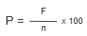

**Where:**

P = Percentage

F = Frequency

n = Number of respondents

In order to gain technical acceptance of the developed system, the researchers used Weighted Mean to statistically process survey responses based on the level of acceptability.

**Weighted Mean Formula:**

x = ∑x

*N*

**Where:**

X = Mean

∑x = Sum of the data values

N = The total number of respondents

The standard deviation was calculated as the square root of variance by determining each data point's deviation relative to the mean

**Standard Deviation Formula:**



**Where:**

σ = Standard Deviation

n = Number of respondents

μ = Population mean

The researchers used the Likert Scale to scale the respondents' level of satisfaction and acceptance of system functions and features in order to interpret the computed weighted mean.

Table 3. Likert Scale

|  |  |  |
| --- | --- | --- |
| **Ratings** | **Scale** | **Verbal Interpretation** |
| 5 | 4.21-5.00 | Strongly Agree |
| 4 | 3.41-4.20 | Agree |
| 3 | 2.61-3.40 | Neutral |
| 2 | 1.81-2.60 | Disagree |
| 1 | 1.00-1.80 | Strongly Disagree |

This table illustrates the Likert scale's scale, range, and verbal interpretation - Level of Satisfaction from Strongly Agree to Strongly Disagree. It is used to scale the quality factors, perceived ease of use, perceived of usefulness, user expectation and attitude towards using for principals, principal’s secretary, LWD teachers and for Parents who tested the system.

## Project Design

This section the researchers discussed the software methodology that they used in creating the study. It also demonstrates how the study will be conducted. The project design will enable the researchers to assess whether the system meets their client's requirements.

## *System Architecture*

The data flow of the proposed system is shown in the illustration below. The teacher can add a new student profile to the system, and the information in the profile will be saved in the database and reflected in the system. Using the student LRN, the teacher can access the student profile. If their child is in a graded class, parents can view the student grade and add student observations that the teacher can view. The administrator has the ability to create new student profiles, view log history, archive, and approve teacher accounts.

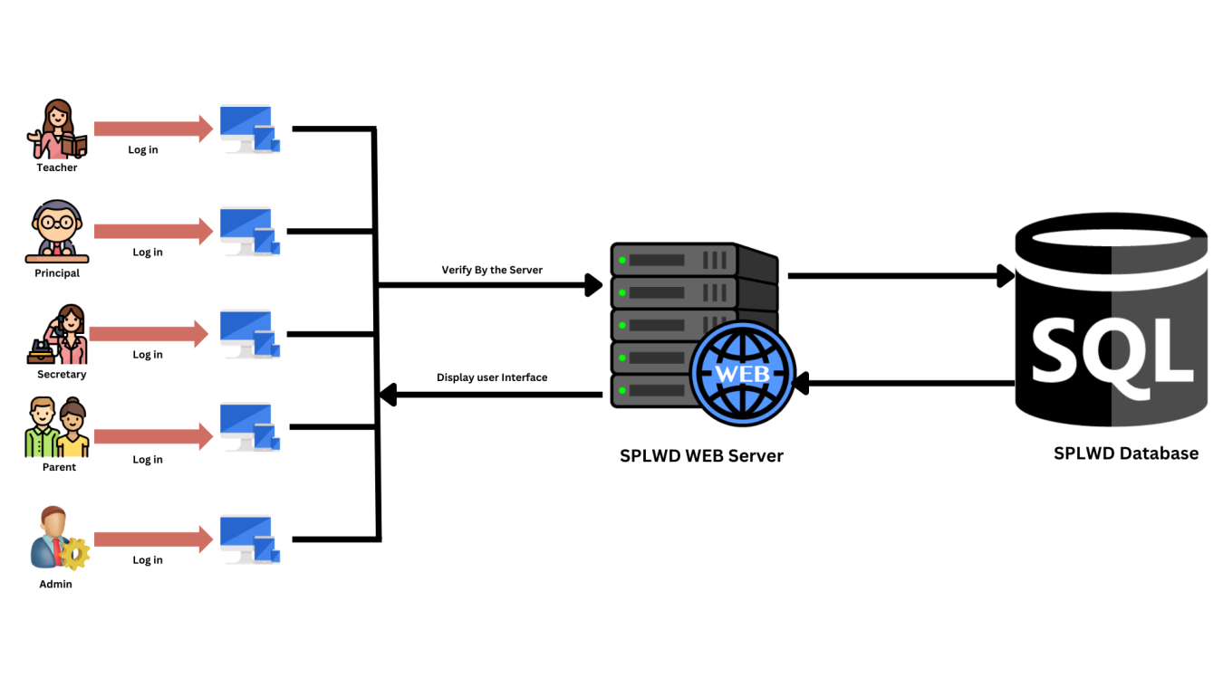

Figure 2. System Architecture Design

***Software Development Model***

The research design indicates which methodologies are used and how they are utilized. The researchers used the Agile Software Development Method to effectively create a system that meets the study's criteria.

A conceptual framework called "agile software development" is used to carry out software engineering tasks. Numerous agile software development approaches, such as Crystal Methods, Scrum, and the Dynamic Systems Development Model (DSDM).

According to Norsaremah (2018), “The Rise and Evolution of Agile Software Development”, in the last 50 years, the second half of software engineering has been dominated by agile software development. One of the most popular agile techniques is the retrospective, which allows for reflection on past performance, discussion of current advancement, and setting forth directions for future improvement. Agile requires its own retrospective due of its rising popularity as the go-to software development approach and an important research subdomain of software engineering.

By developing software in short time frames, known as iterations, which typically span one to four weeks, most agile methodologies try to reduce risk. Planning, requirements analysis, design, coding, testing, and documentation are all tasks that must be completed in order to release a mini-increment of new functionality. Each iteration is similar to a small software project on its own. Although iteration may not add enough features to justify the product's release, an agile software project aims to be able to do so at the end of each one. The team reassesses project priorities at the conclusion of each iteration.

Agile methodologies prioritize in-person interactions above textual correspondence in real-time communication. Most agile teams work in a bullpen and have all the members required completing the software. This comprises programmers as well as any other individuals that define the product, such as product managers, business analysts, or actual users. The bullpen may also consist of managers, interface designers, testers, and technical writers.

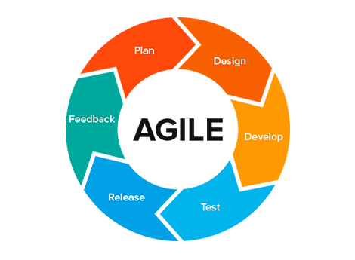

Figure 3.Agile Software Development

The figure above shows the flow that was used to determine the process of the study from data collection to system design, module development to meet needs, and testing the developed system.

### *Plan*

In order to obtain the data required for the study, the researchers interviewed the client. The researchers investigate the issue with the way they handle the student files and offer a resolution.

### *Design*

In this phase, the researchers conduct a thorough analysis of the issue and develop a study proposal named "SPLWD: Student Profiling for Learners with Disabilities in Sta. Cruz District of Laguna" Diagrams like flow charts and use case diagrams are used during the system design process to help users understand how the proposed system would operate.

### *Develop*

After creating the system's design for the application, the researchers added features, tested the system by putting it into use in the study area, and finally designed the system. After completing this phase, the researchers can go on to the following phase of the development.

### *Test*

Testing is the following stage of this process. To test the functionality of the created system, the researchers employed the black box testing technique. Finish the project and follow the set procedures.

### *Release*

The marketing of the system to the client by the researcher occurs during the release phase. There will be no changes or added functionality during this phase, which is the error-free stage.

### *Feedback*

The researcher allowed the client time to test the created system during the feedback phase. The feedback is essential in determining whether the system is in excellent working order and whether the client is satisfied.

## Software Testing Phase

This phase includes evaluating the developed system's functionalities on an actual test conducted by the researchers. The researchers will invite ten credible experts in the field of IT industry with at least five years of experience in the field to assess and evaluate the performance of the developed web-based system.

The researchers took the following steps to evaluate the functionality and performance of the developed web-based system:

1. The Design and Development Testing Tools
2. The Testing Method

### *Design and Development of Testing Tools*

A testing tool is important, it is requires to test the functionality of the developed system. The researcher used black box testing to evaluate the created system. According tothe study of Matt Heusser (2006), Black box testing evaluates a system solely from the outside, with the operator or tester not knowing what is going on inside the system to generate responses to test actions. A black box is a system whose behavior must be observed entirely through its inputs and outputs. Even if the internal structure of the application under test is understandable, the tester chooses to disregard it.

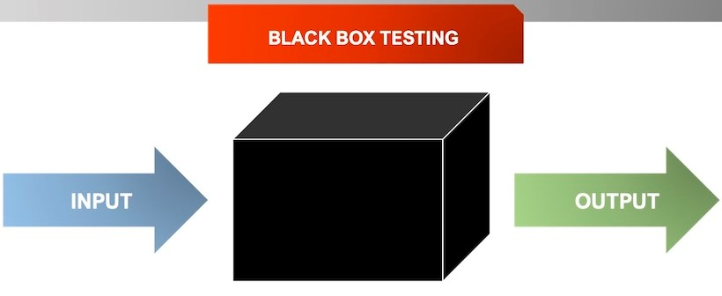

Figure 4. Black Box Testing

### *Testing Tools*

The researchers used Black Box Testing. The black box approach was a useful method for evaluating the application that was being tested from the viewpoint of the user. This type of testing focuses on the inputs that the program considers as well as the outputs that are generated. The researchers will develop a questionnaire for testing that includes developed system outcomes while being tested and will be distributed to IT experts. The testing sheet is included below, and it includes the step number, details, and expected result.

Table 4.Test Case Description: Test the Functionality of (Login & System ADMIN)

|  |  |  |
| --- | --- | --- |
| **Step No.** | **Step Details** | **Expected Result** |
|
| 1 | Input Credentials and click LOGIN | Right credentials:   1. If the credentials is correct the system will redirect to the dashboard of the admin. 2. If the credentials is incorrect the error message will display. |
| 2 | Dashboard | It shows the total number of Student, Teachers and files uploaded in District. |
| 3 | Student folders | Its shows all the folders of the student that contains all the file and information about the student.   1. Student information 2. Assessment file 3. Progress Report 4. Uploaded documents 5. ILP (Individual Learners Profile) 6. IEP(Individualized Education Plan) 7. ILMP (Individual Learning Monitoring Plan) 8. BIR (Behaviour Intervention Report) 9. ITP (Individual Transition Plan) |
| 4 | Promotion | This page shows the summary of progress report of the entire student. |
| 5 | View Log History | This Page shows all the log history done by teachers.   1. Added new Student 2. Update Student profile 3. Delete student file 4. Updated Progress Report 5. Uploaded a document |
| 6 | View Archive | It shows the deleted files and student data and admin can restore this deleted file |
| 7 | LOG OUT | Is a function for leaving the account |

The table above shows the testing evaluation of Admin account of the developed system. It shows the step-by-step of the function and process for the developed system. The results show that all the functions of the developed system are responding properly.

Table 5.Test Case Description: Test the Functionality of (Login & Principal’s Secretary)

|  |  |  |
| --- | --- | --- |
| **Step No.** | **Step Details** | **Expected Result** |
|
| 1 | Input Credentials and click LOGIN | Right credentials:   1. If the credentials is correct the system will redirect to the dashboard of the admin. 2. If the credentials is incorrect the error message will display. |
| 2 | Dashboard | It shows the total number of Student, Teachers and files uploaded in a School. |
| 3 | Student folders | Its shows all the folders of the student that contains all the file and information about the student.   1. Student information 2. Assessment file 3. Progress Report 4. Uploaded documents 5. ILP(Individual Learners Profile) 6. IEP(Individualized Education Plan) 7. ILMP(Individual Learning Monitoring Plan) 8. BIR(Behaviour Intervention Report) 9. ITP(Individual Transition Plan) |
| 4 | Promotion | This page shows the summary of progress report of the entire student. |
| 5 | View Log History | This Page shows all the log history done by teachers.   1. Added new Student 2. Update Student profile 3. Delete student file 4. Updated Progress Report 5. Uploaded a document |
| 6 | View Archive | It shows the deleted files and student data and admin can restore this deleted file |
| 7 | LOG OUT | Is a function for leaving the account |

The table above shows the testing evaluation for Teachers account of the developed system. It shows the step-by-step of the function and process for the developed system. The results show that all the functions of the developed system are responding properly.

Table 6.Test Case Description: Test the Functionality of (Login & Parents)

|  |  |  |
| --- | --- | --- |
| **Step No.** | **Step Details** | **Expected Result** |
|
| 1 | Input Credentials and click LOGIN | Right credentials:   1. If the credentials is correct the system will redirect to the dashboard of the driver. 2. If the credentials is incorrect the error message will display. |
| 2 | View student grade and evaluation | It show the student grade and evaluation |
| 3 | Add student observation | Parent can add their observation about their child quarterly |
| 4 | LOG OUT | Is a function for leaving the account |

The table above shows the testing evaluation for Parents account of the developed system. It shows the step-by-step of the function and process for the developed system. The results show that all the functions of the developed system are responding properly.

## Testing Methods

The researchers used a dichotomous scale – “pass” or “fail” for the actual test and black box testing evaluation. According to Alex Birkett (2022), Dichotomous scales have two choices that are diametrically opposed to each other. It gives you a clearer, binary answer, but it can also fall prey to fatigue. When that happens, respondents lean toward positive answers.

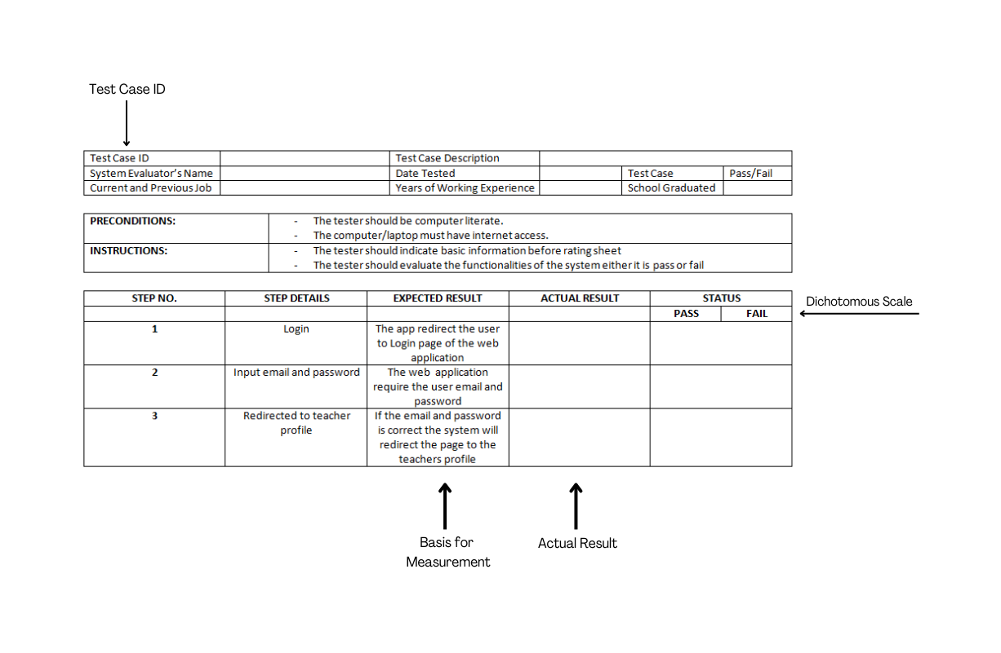

Figure 5. Actual Structural Format of the Testing Tool

The actual test's evaluation instrument is illustrated in the Actual Structural Format of the Testing Tool above, and a dichotomous scale will be used to determine whether the system passes or fails.

## Software Evaluation Phase

The testing phase is focused on assessing the functionality of the developed web application based on real-world test input from the researchers. Through people observation, the user expressed their opinion, perception, behavior, and response to the developed application and gathered feedback to indicate the effectiveness of the research study.

The researchers took the following steps to identify and assess the technology acceptance of the developed application:

1. The Design and Development of the Evaluation Tool
2. The Validation of Questionnaire
3. The Distribution of the Questionnaire

## Design and Development of the Evaluation Tool

The researchers established three questionnaires for system users to answer as an assessment tool. Quality, Perceived Ease of Use, Perceived Usefulness, Experience, Attitude towards Using, and Behavioral Intention to Use were all factors considered in the questionnaire.

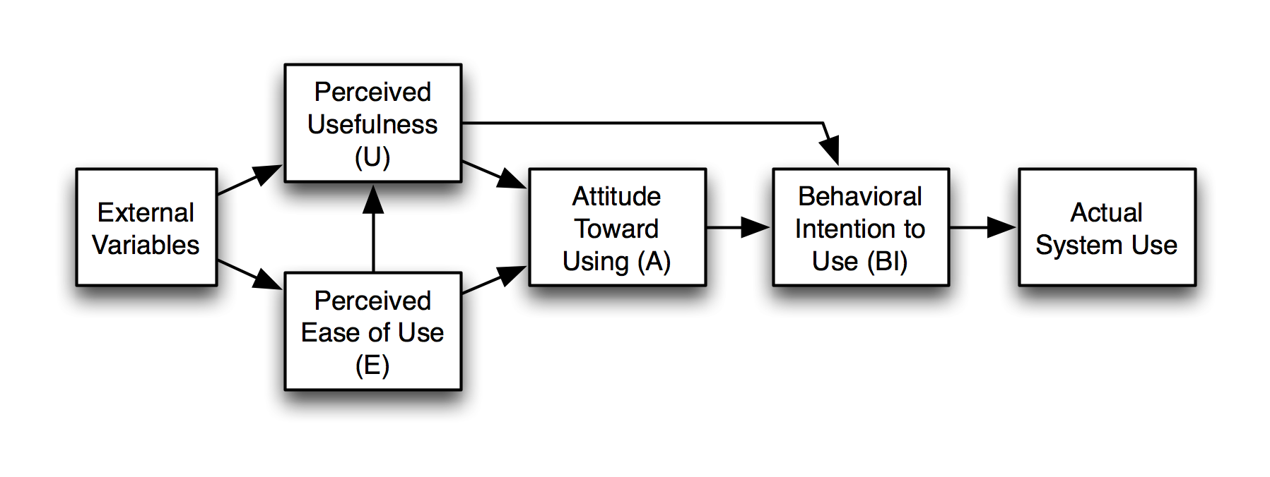The Technology Acceptance Model (TAM) will be used to create a questionnaire for principal, teachers, and parents. This questionnaire will be used as a tool for evaluation.

Figure 6. Technology Acceptance Model (TAM)

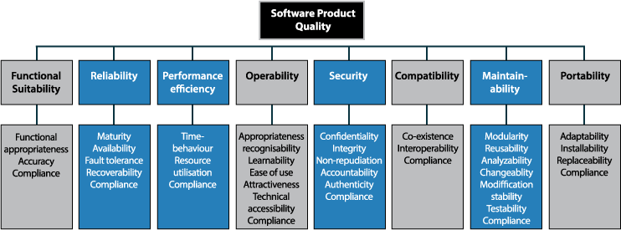

The figure above shows the flow of Technology Acceptance Model, which explains user acceptance based on Quality Factors, Perceived Ease of Use, Perceived Usefulness, Experience, Attitude towards Using, and Behavioral Intention to Use, which the researchers used.



Figure 7. ISO/IEC 25010 Software Quality Metrics

The figure above shows the various types of quality metrics that define which quality will be considered when evaluating the software's resources.

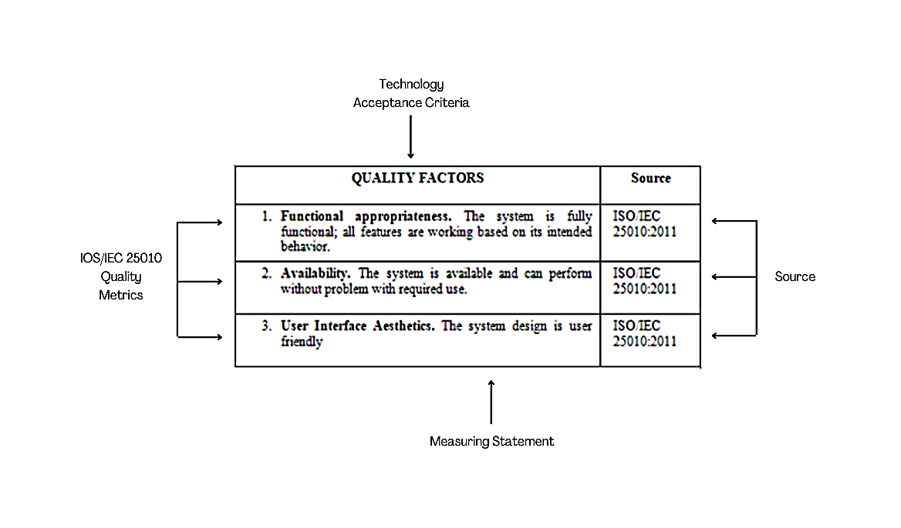

Figure 8. Structural Format of the Evaluation Tool

The figure above illustrates the evaluation instrument's initial structure, which is a combination of Technology Acceptance Criteria and three (3) ISO software metrics, including the source and measurement statement.

## Validation of Questionnaire

The validation of the questionnaire is required prior to the actual evaluation of the established system. It allows the research to be confirmed and the authenticity of each question to be verified before proceeding with the evaluation. In this validation procedure, the face validity method will be used to validate the reliability of the self-structured questionnaire. According to the study of Taherdoost, Hamed (2016), Face validity is a subjective assessment of a construct's operationalization. The degree to which a measure appears to be related to a specific construct in the opinion of non-experts such as test takers and legal system representatives is referred to as face validity. In other words, a test has face validity if the content appears relevant to the person taking the test. It assesses the questionnaire's appearance in terms of feasibility, readability, consistency of style and formatting, and the clarity of the language used. To examine the face validity, a dichotomous scale with categorical options of "Yes" and "No" which indicate a favorable and unfavorable item can be utilized.

## Evaluation Tool

The researchers used ISO as a set of standards and the Technology Acceptance Model (TAM) as a category when developing the survey questionnaire. The questionnaires will be handed to the principals, principal’s secretary, teachers and parents. The proposed evaluation tool for the developed system's various users is provided on the following page. The evaluation tool that is suggested for different users of the developed system is presented below.

Table 7. TAM Questionnaire for Teachers in terms of Quality Factors

|  |  |
| --- | --- |
| **QUALITY FACTORS** | **Source** |
| 1. **Functional appropriateness.** The system is fully functional; all features are working based on its intended behavior. | ISO/IEC 25010:2011 |
| 1. **Availability.** The system is available and can perform without problem with required use. | ISO/IEC 25010:2011 |
| 1. **User Interface Aesthetics.** The system design is user friendly | ISO/IEC 25010:2011 |

The table shows the questions for Quality Factors criteria. This also shows if the system has quality in terms of functional appropriateness, availability, and user interface aesthetics.

Table 8. TAM Questionnaire for Teachers in terms of Perceived Ease of Use

|  |  |
| --- | --- |
| **PERCEIVED EASE OF USE** | **Source** |
| 1. **Learnability.** Learning to use this system is easy for me. | ISO/IEC 25010:2011 |
| 1. **Operability.** The function of the developed system can lessen the time and work of the user | ISO/IEC 25010:2011 |
| 1. **Appropriateness recognizability.** I believed the developed system is appropriate for the user’s needs. | ISO/IEC 25010:2011 |
|  |  |

The table shows the questions for Perceived Ease of Use criteria. This also shows if the system is easy to use in terms of learnability, operability, and appropriates recognizability.

Table 9. TAM Questionnaire for Teachers in terms of Perceived of Usefulness

|  |  |
| --- | --- |
| **PERCEIVED OF USEFULNESS** | **Source** |
| 1. **Usability.** Using this system will help me finish my job of finding the information needed and lessen the time of my work. | ISO/IEC 25010:2011 |
| 1. **Operability.** I believed that system is easy to operate and input the information and assessment of the students. | ISO/IEC 25010:2011 |
| 1. **Learnability.** The developed system has simple features that can be easily learn by the user. | ISO/IEC 25010:2011 |
|  |  |

The table shows the questions for Perceived Usefulness Criteria. This also shows if the system is useful in terms of usability in the system’s features, operability, and learnability. Criteria for perceived usefulness are based in ISO/IEC 25010.

Table 10. TAM Questionnaire for Teachers in terms of User Satisfaction

|  |  |
| --- | --- |
| **USER SATISFACTION** | **Source** |
| 1. The system is very useful in terms of managing and storing the data and assessment of Learners with Disabilities students. | ISO/IEC 25010:2011 |
| 1. I believed that I can operate the system properly. | ISO/IEC 25010:2011 |
| 1. The developed system satisfies and meets the user’s expectation with the system. | ISO/IEC 25010:2011 |
|  |  |

The table shows the question for User Satisfaction criteria. This also shows if the system can help the users in terms of managing and storing the data and also, the assessment of the students.

Table 11. TAM Questionnaire for Teachers in terms of Attitude towards Using

|  |  |
| --- | --- |
| **ATTITUDE TOWARDS USING** | **Source** |
| 1. I prefer using the developed system in my job. | Yi, et al. (2006) |
| 1. I found the system to be quite simple to use. | Yi, et al. (2006) |
| 1. I like using the system. | Yi, et al. (2006) |
|  |  |

The table shows the actual evaluation tool in the perception of respondents in terms of Attitude towards Using. Criteria for attitude towards using are based in the study of Yi, Jackson, Park, & Probst (2006).

Table 12. TAM Questionnaire for Parents in terms of Quality Factors

|  |  |
| --- | --- |
| **QUALITY FACTORS** | **Source** |
| 1. The system is fully functional; all features are working based on its intended behavior. (Ang sistem ay ganap na nagagamit at ang lahat ng katangian ay gumagana base sa nilalayon nitong gawi.) | ISO/IEC 25010:2011 |
| 1. The system is operational and capable of meeting the requirements based on the required use. (Ang sistem ay gumagana ng walang problema base sa intensiyon nito nang paggamit.) | ISO/IEC 25010:2011 |
| 1. The system can be effortlessly operated by the user. (Ang disensyo ng sistem ay mabilis matutunan na gamitin.) | ISO/IEC 25010:2011 |
|  |  |

Table 13. TAM Questionnaire for Parents in terms of Percieved Ease of Use

|  |  |
| --- | --- |
| **PERCIEVED EASE OF USE** | **Source** |
| 1. The web application is user friendly for beginners. (Ang sistem ay mabilis gamitin para sa mga baguhan.) | ISO/IEC 25010:2011 |
| 1. The function of the developed system can lessen the time and work of the user. (Ang tungkulin ng nagawang sistem ay kayang mapadali ang oras at trabaho ng user.) | ISO/IEC 25010:2011 |
| 1. I believed the developed system is appropriate for the user’s needs. (Naniniwala ako na angkop ang sistem sa pangangailangan ng mga user.) | ISO/IEC 25010:2011 |
|  |  |

Table 14. TAM Questionnaire for Parents in terms of Percieved of Usefulness

|  |  |
| --- | --- |
| **PERCIEVED OF USEFULNESS** | **Source** |
| 1. **Usability.** Using this system will help me finish my job of finding the information needed and lessen the time of my work. (Sa pag gamit ng sistem ay natutulungan ako nitong mahanap ang mga kailangan kong impormasyon at napapabilis nito ang oras ng aking trabaho.) | ISO/IEC 25010:2011 |
| 1. **Operability.** I believed that system is easy to operate and input the information and assessment of the students. (Naniniwala ako na ang sistem ay mabilis gamitin sa paglalagay ng impormasyon at pagsusuri sa mga estudyante.) | ISO/IEC 25010:2011 |
| 1. **Learnability.** The developed system has simple features that can be easily learn by the user. (Ang ginawang sistem ay may simple na disensyo at maaring matutunan agad ng user.) | ISO/IEC 25010:2011 |
|  |  |

The table shows the questions for Perceived Usefulness Criteria. This also shows if the system is useful in terms of usability in the system’s features, operability, and learnability for the Parents. Criteria for perceived usefulness are based in ISO/IEC 25010.

Table 15. TAM Questionnaire for Parents in terms of User Satisfaction

|  |  |
| --- | --- |
| **USER SATISFACTION** | **Source** |
| 1. The system is very useful in terms of managing and storing the data and assessment of Learners with Disabilities students. (Ang sistem ay kapaki-pakinabang ayon sa tuntunin nitong pamamahala at pag-iimbak ng datos ng mga learners with disabilities.) | ISO/IEC 25010:2011 |
| 1. I believed that I could operate the system properly. (Naniniwala ako na kaya kong gamitin ang sistem nang maayos.) | ISO/IEC 25010:2011 |
| 1. The developed system satisfies and meets the user‘s expectation with the system. (Ang nagawang sistem ay natugunan ang ekspektasyon ng user.) | ISO/IEC 25010:2011 |
|  |  |

The table shows the question for User Satisfaction criteria. This also shows if the system can operate and meet the expectation of the user. Criteria for user satisfaction are based in ISO/IEC 25010.

Table 16. TAM Questionnaire for Parents in terms of Attitude towards Using

|  |  |
| --- | --- |
| **ATTITUDE TOWARDS USING** | **Source** |
| 1. I prefer using the developed system in my job. (Gusto ko na gamitin ang nagawang sistem sa aking trabaho.) | Yi, et al. (2006) |
| 1. I found the system to be quite simple to use. (Nalaman ko na ang sistem ay simple na gamitin.) | Yi, et al. (2006) |
| 1. I like using the system. (Gusto ko na ginagamit ang sistem) | Yi, et al. (2006) |
|  |  |

## Distribution of Questionnaire

The researchers would demonstrate and explain how the developed system works based on the system testing, and the validated questionnaire would be distributed to the target respondents in two ways. The first method of distribution is face-to-face distribution of printed questionnaires, and the second method of distribution is an uploaded video presentation for the parents of learners with disabilities. Before allowing them to answer the questionnaire, the researchers demonstrated the system. The printed questionnaires were distributed through face-to-face on December 6, 2022 (11:30am) at Gatid Elementary School. The next face-to-face distribution took place in Bagumbayan Elementary School on December 7, 2022 (1:15pm). The last face-to-face distribution was held on December 13, 2022 (11:30am) at Sta. Cruz Central Elementary School. The researchers provide the link of video presentation to the LWD adviser and the teachers distribute the printed questionnaire to the parents who pick up their child.

Following the completion of the target respondents, the researcher collects all of the evaluation questionnaires in order to evaluate the level of satisfaction with the developed system. The information gathered was analyzed and interpreted.

**Chapter IV**

**RESULTS AND DISCUSSION**

In this chapter, the research findings are discussed and presented in connection to the objectives that the researcher set at the beginning of the complete research study. This section examines whether the study's goals and the client's needs were accomplished. It also includes information on how to analyze data gathered during system testing and evaluation.

**Project Concept**

Learners Monitoring Plans (ILMP), Behaviour Intervention Reports (BIR), and SF9/Progress Reports, for students who have learning disabilities. Since these are the plans and The majority of schools now offer face-to-face instruction as the Philippines is recovering from the pandemic. As a result, Learners with Disabilities (LWD) teachers maintain much documentation, including Individualized Education Plans (IEP), Individual Learners Plans (ILP), Individual objectives for instructing the students in Special Education (SPED), they are only kept in a file rack in the teacher's office; this sort of document management is susceptible to natural disaster. Despite the fact that educators save copies of these materials on Google Drive, flash drives and other storage it is still not organize. By that, “SPLWD: Student Profiling for Learners with Disabilities in Sta. Cruz District of Laguna” were proposed for the teacher have a safe and organize storage for this valuable documents and an additional function online grading and monitoring for SF9/Progress Report.

**Research Objectives**

To develop the possible solutions, the researchers have established their research objective into a working system which is a web based on learners with disabilities students profiling of Sta. Cruz district. To easily endorse their handled students after the reshuffle since there are three classes (Hearing Impairment, Transition Class and Non Graded class) of disabilities in every school that offers Special Education in Sta. Cruz District. Furthermore, keeping student assessments, observations, and remarks on the web based storage will organize them and can be easily accessed for teachers to easily track student improvement.

**First Objective**

To design and develop a web based profiling for learners with disabilities of Sta. Cruz District of Laguna.

1.1 IEP, ILP, ILMP, BIR and Promotion record management

* 1. LWD Students Profile
  2. LWD Progress Report, Evaluation and Observation
  3. Parents Observation
  4. LWD Monitoring

**Design Conceptualization**

The researchers used different data collection methods to identify the requirements needed for system-based web design in order to achieve the first goal. The researchers began their investigation by gathering preliminary data in order to understand the problems with the LWD student file management process The researchers had a preliminary discussion with Mr. Armin Cabrales Principal of Sta. Cruz Central Elementary School, Mr. Cabrales refer us to interview LWD teachers to know more about the LWD processes.

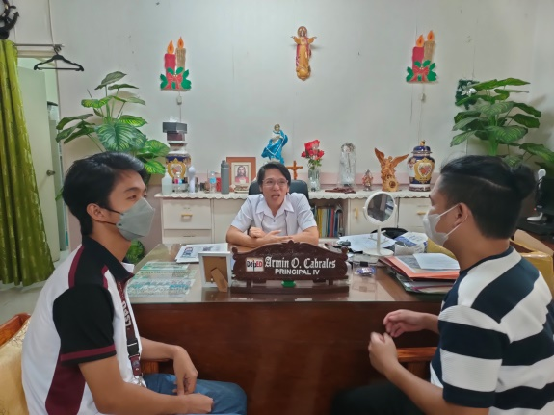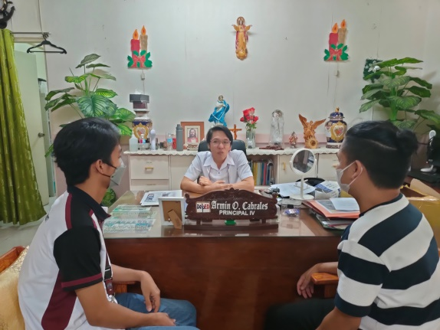

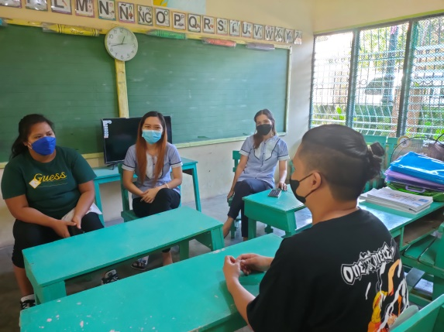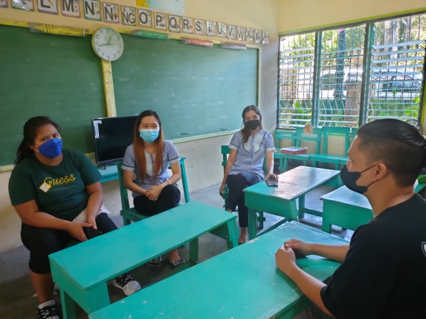

The researchers ask the teachers about the process of student assessments, from enrollment to the grading system, as well as the files handled by teachers in the Special Education curriculum. The researchers gathered a lot of information from this interview about how the LWD student grading system differs from regular students, and those LWD teachers handled more files than regular curriculum students.

In addition, the researchers found out that the DepEd teachers currently use existing system the Learner Information System (LIS).

**Developing the SPLWD**

Following the preliminary interview, the researchers developed the SPLWD: Student Profiling for Learners with Disabilities in Sta. Cruz District of Laguna. To build the system, the researchers used Agile Software Development as a software methodology. While, the development process is on going Mr. Bernardino and Ms. Miranda help us to

**System Interface**

**Second Objective**

To test the main functionalities of the developed system by letting the teachers of Sta. Cruz District Schools use the web application.

* 1. Adding new student to the system
  2. Updating student information
  3. Uploading the IEP, ILP, ILMP, BIR and Promotion of the student
  4. Adding parents observation to the student

The researchers used black-box testing to validate the functionality of the developed system. Black box testing is a method of software testing that examines a system entirely from the outside, with the operator or tester unaware of what is happening inside the system to generate responses to test actions.

The functionality of the developed system is included in the questionnaire, and the IT tester is not required to see the code. The researchers construct a series of questions that show the system’s functionality and features. The researchers presented their system in two ways, via Google Meet and face-to-face, to determine whether the functionalities in LWD files are actually needed.

After constructing a system questionnaire, the researchers began demonstrating the system through face-to-face with the Head of IT Department, Mr. Jerem Micah Rivera, on December 7, 2022 (9:10-9:40 am) at the Municipality of Nagcarlan, Laguna. The system demonstration continued on December 8, 2022, via Google Meet with Mr. Christian Jay Tantan, Mr. Carlos Camar, and Mr. Reymart Pielago, as well as face-to-face with Mr. Zynell Mangilin.. The next system demonstration happened on December 9, 2022 via Google Meet with Mr. John Mark Arguilles, Mr. Jarold Salmazan, and Mr. Earl Anthony Silvania. And the last system demonstration occurred on December 11, 2022 via Google Meet with Mr. Jed Malveda. The tester manages the system in order to test the features and functions of the system and gather feedback from the testing questionnaire.

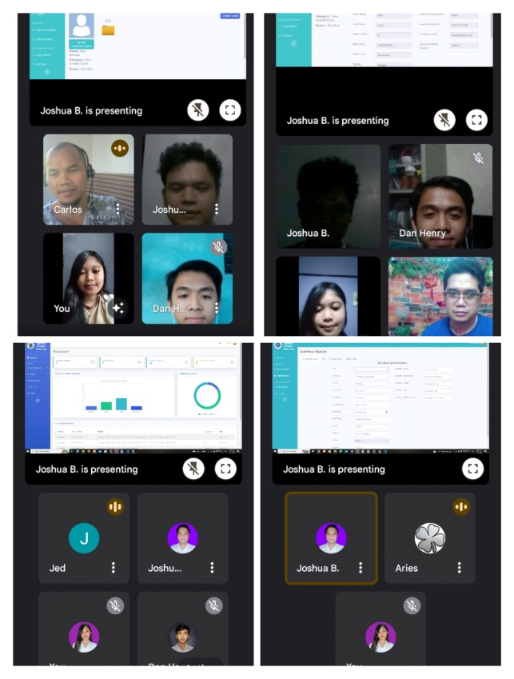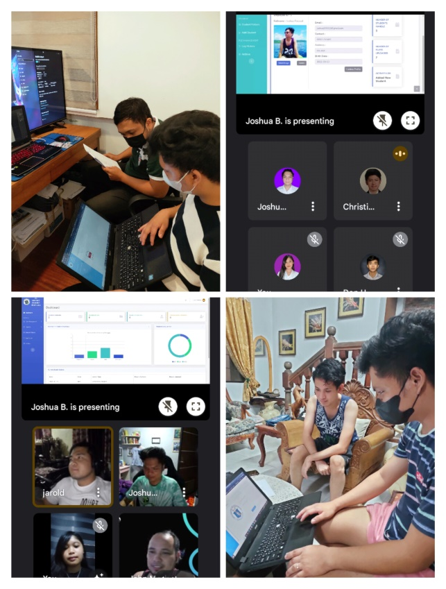

**Feedback of IT Experts for the Black Box Testing**

|  |  |  |
| --- | --- | --- |
| **System Evaluators** | **Name** | **Feedback** |
| 1 | Mr. John Mark Arguilles |  |
| 2 | Mr. Jarold Salmazan |  |
| 3 | Mr. Earl Silvania |  |
| 4 | Mr. Jerem Micah Rivera |  |
| 5 |  |  |
| 6 | Mr. Jed B. Malveda |  |
| 7 | Mr. Zynell Mangilin |  |
| 8 | Mr. Reymart Joseph Pielago |  |
| 9 | Mr. Carlos Camar |  |
| 10 | Mr. Christian Jay Tantan |  |

**Test case scenario for the functionality of Admin**

|  |  |  |  |  |
| --- | --- | --- | --- | --- |
| **Indicator** | **No. of**  **Testers** | **Passed**  **(Frequency)** | **Failed**  **(Frequency)** | **Percentage** |
|  |  |
| 1. Click **Login** | 10 | 10 | 0 | 100% |
| 1. **Dashboard** | 10 | 10 | 0 | 100% |
| 1. **Student Folder** | 10 | 10 | 0 | 100% |
| 1. **Pending Users** | 10 | 10 | 0 | 100% |
| 1. **Enrolment Record** | 10 | 10 | 0 | 100% |
| 1. **Progress Report** | 10 | 10 | 0 | 100% |
| 1. **Log History** | 10 | 10 | 0 | 100% |
| 1. **Archive** | 10 | 10 | 0 | 100% |
| 1. **Logout** | 10 | 10 | 0 | 100% |

**Test case scenario for the functionality of Teachers**

|  |  |  |  |  |
| --- | --- | --- | --- | --- |
| **Indicator** | **No. of**  **Testers** | **Passed**  **(Frequency)** | **Failed** | **Percentage** |
|  | **(Frequency)** |  |
| 1. Click **Login** | 10 | 10 | 0 | 100% |
| 2. **Profile** | 10 | 10 | 0 | 100% |
| 3. **Student Folder** | 10 | 10 | 0 | 100% |
| 4. **Add New Student** | 10 | 10 | 0 | 100% |
| 5. **Log History** | 10 | 10 | 0 | 100% |
| 6. **Archive** | 10 | 10 | 0 | 100% |
| 7. **Logout** | 10 | 10 | 0 | 100% |

**Test case scenario for the functionality of Principal’s Secretary**

|  |  |  |  |  |
| --- | --- | --- | --- | --- |
| **Indicator** | **No. of** | **Passed** | **Failed** | **Percentage** |
|  | **Testers** | **(Frequency)** | **(Frequency)** |  |
| 1. Click **Login** | 10 | 10 | 0 | 100% |
| 2. **Dashboard** | 10 | 10 | 0 | 100% |
| 3. **Student Folder** | 10 | 10 | 0 | 100% |
| 4. **Pending Users** | 10 | 10 | 0 | 100% |
| 5. **Add user Account** | 10 | 10 | 0 | 100% |
| 6. **Enrolment Record** | 10 | 10 | 0 | 100% |
| 7. **Progress Report** | 10 | 10 | 0 | 100% |
| 8. **Log History** | 10 | 10 | 0 | 100% |
| 9. **Logout** | 10 | 10 | 0 | 100% |

**Test case scenario for the functionality of Principal**

|  |  |  |  |  |
| --- | --- | --- | --- | --- |
| **Indicator** | **No. of** | **Passed** | **Failed** | **Percentage** |
|  | **Testers** | **(Frequency)** | **(Frequency)** |  |
| 1. Click **Login** | 10 | 10 | 0 | 100% |
| 2. **Dashboard** | 10 | 10 | 0 | 100% |
| 3. **Student Folder** | 10 | 10 | 0 | 100% |
| 4. **Pending Users** | 10 | 10 | 0 | 100% |
| 5. **Enrolment Record** | 10 | 10 | 0 | 100% |
| 6. **Progress Report** | 10 | 10 | 0 | 100% |
| 7. **Log History** | 10 | 10 | 0 | 100% |
| 8. **Logout** | 10 | 10 | 0 | 100% |

**Test case scenario for the functionality of Parents**

|  |  |  |  |  |
| --- | --- | --- | --- | --- |
| **Indicator** | **No. of** | **Passed** | **Failed** | **Percentage** |
|  | **Testers** | **(Frequency)** | **(Frequency)** |  |
| 1. Click **Login** | 10 | 10 | 0 | 100% |
| 2. **Student Profile** | 10 | 10 | 0 | 100% |
| 3. **Add Observation** | 10 | 10 | 0 | 100% |
| 4. **Logout** | 10 | 10 | 0 | 100% |

**Research Objective No. 3:** To evaluate the efficiency and usability of the system by letting the principal, teachers, and parents use the web application

* 1. Quality Factors of the System
  2. Perceived Ease of Use
  3. Perceived of Usefulness
  4. User Satisfaction
  5. Attitude Towards Using

The technology acceptance model, which includes quality factors, perceived ease of use, perceived of usefulness, user satisfaction, and attitude toward using, was tested by the researcher with the help of the schools in Sta. Cruz District of Laguna; Sta. Cruz Elementary School, Bagumbayan Elementary School and Gatid Elementary School. The questionnaire was developed in collaboration with Technology Acceptance Model (TAM) and ISO/ISEC 25010:2011. The researcher used TAM as a category and ISO/ISEC 25010:2011 as criteria.

***Pictures of Survey***

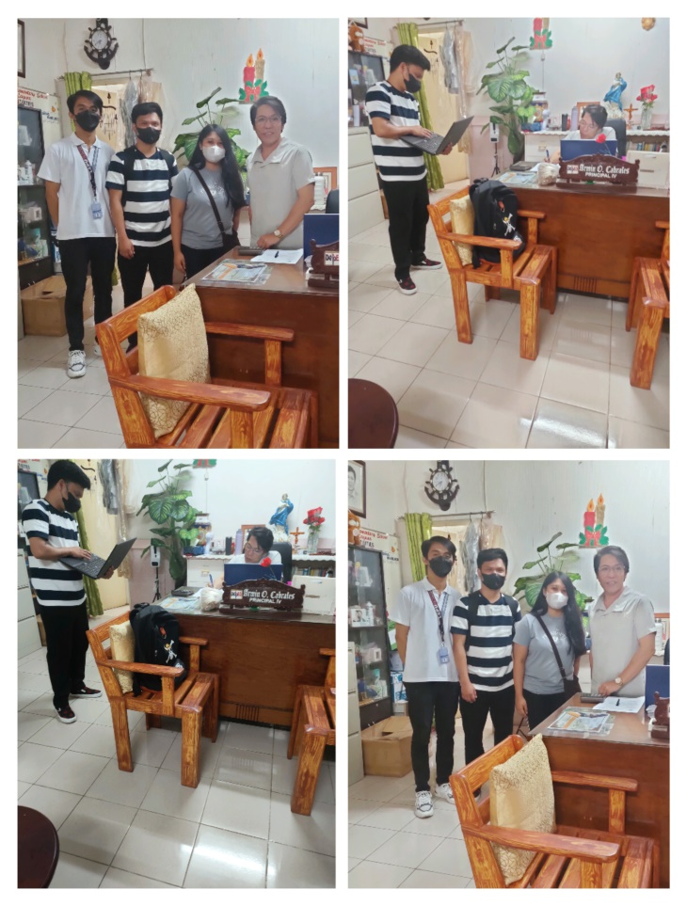

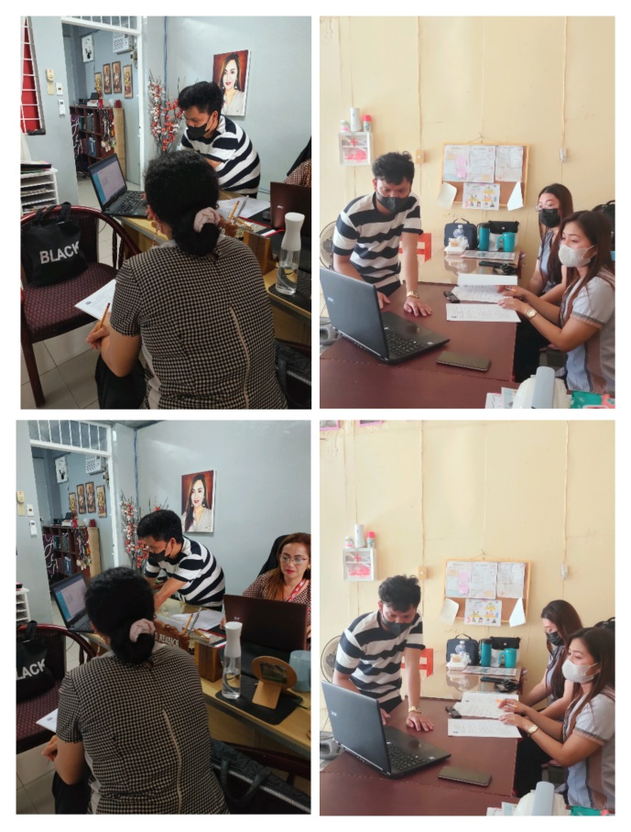

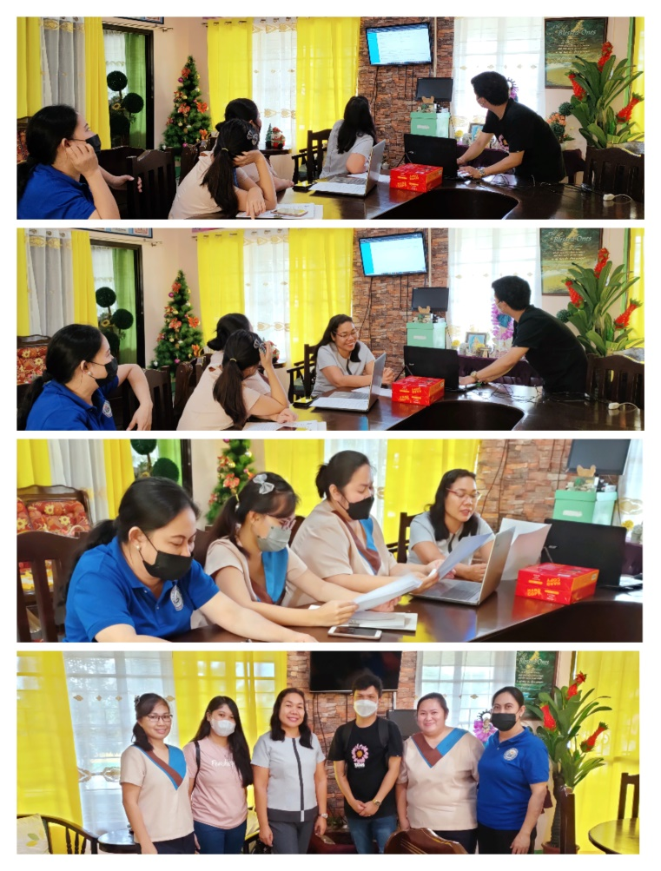

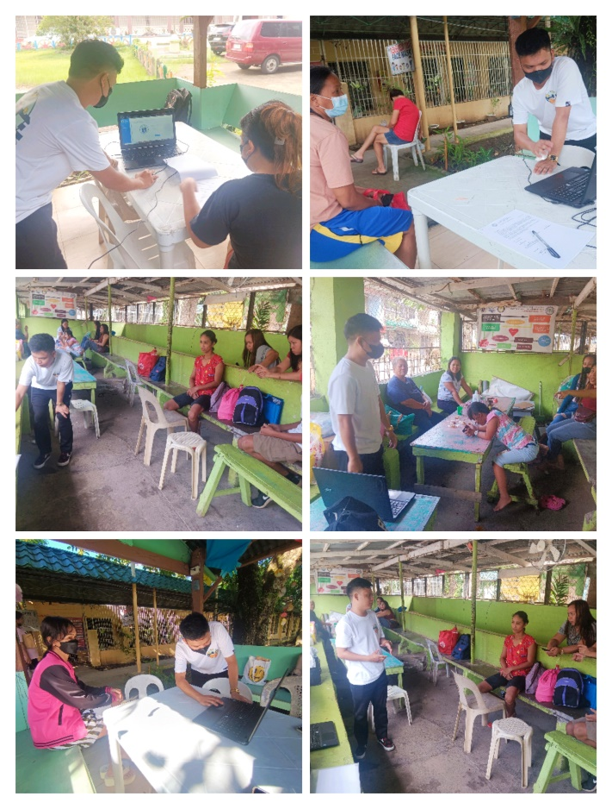

**Demographic Profile of the Respondents**

The figure below represents the demographic profile of the respondents based on their age, gender, and total number individuals who completed the questionnaire in each school using a web-based system.

1. Age

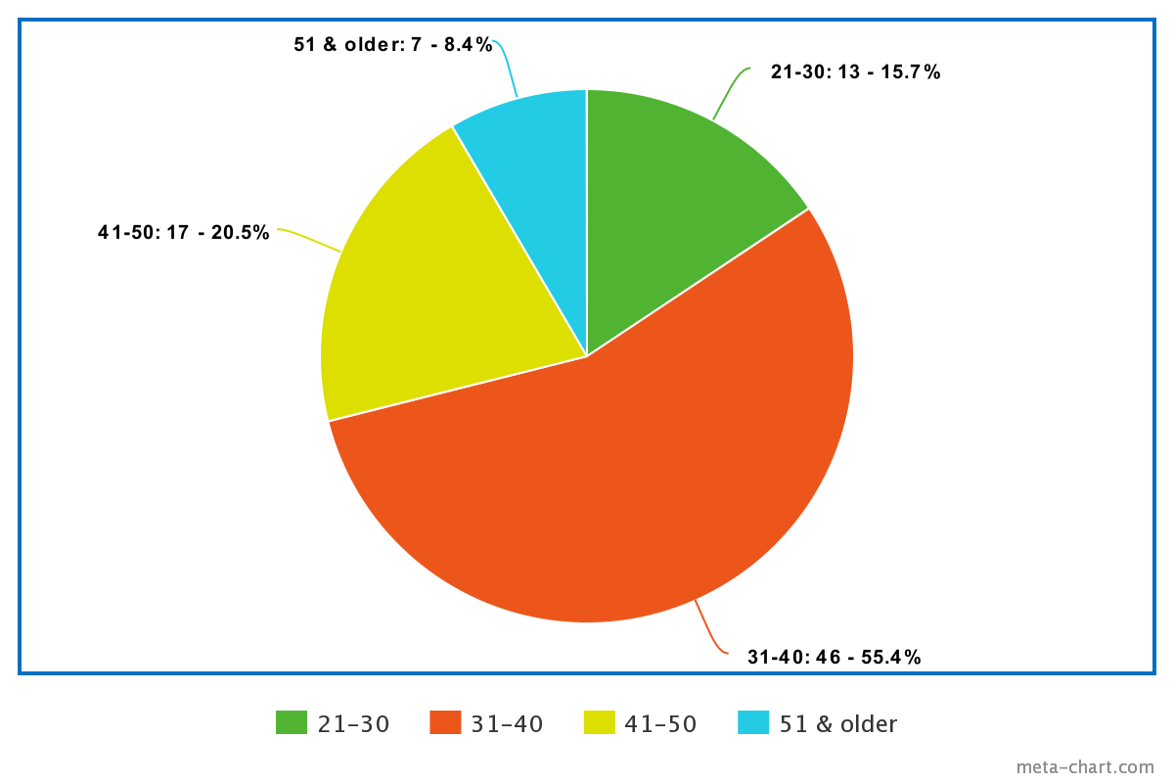

The chart above displays the division of the 83 total responses for the evaluation. The age range that the researchers had chosen for the evaluation questionnaire served as the demographic basis. In accordance with the graph, there are 55.4% of people aged 31 to 40, 20.5% aged 41 to 50, 15.7% aged 21 to 30, and 8.4% aged 51 and above.

1. Gender

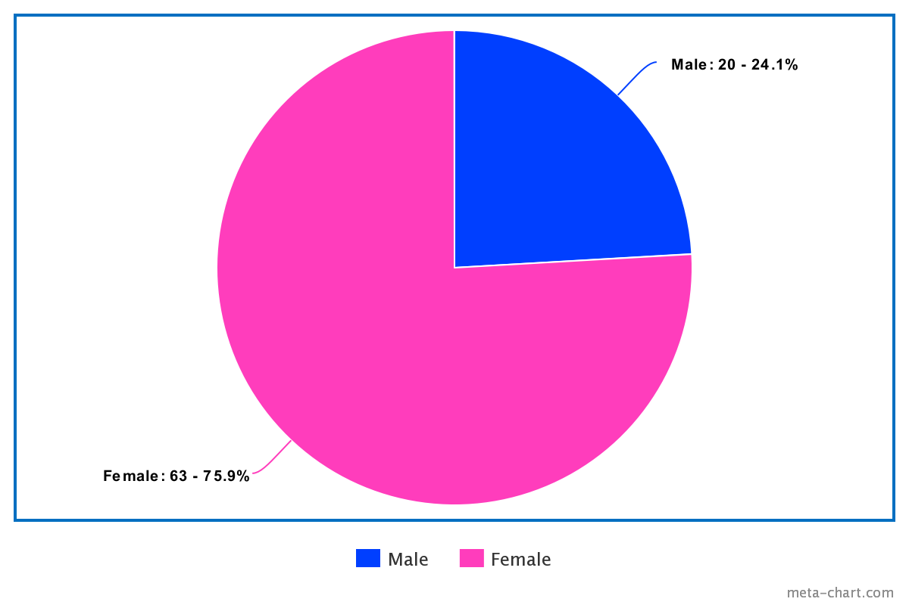

The divisions of the 83 total respondents during the evaluation are shown in the graph above. The graph shows that 75.9% of the population is female and 24.1% is male. The demography was based on the gender that the researchers had chosen on the evaluation questionnaire.

1. Total Number of Respondents

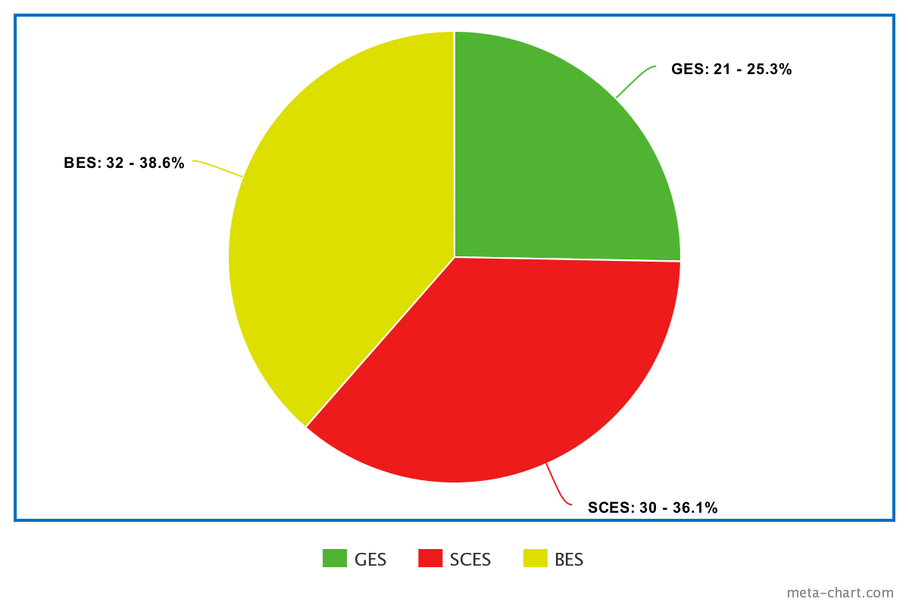

The divisions of the 83 total respondents during the evaluation are shown in the figure above. The demography was based on the total number of respondents from each school that the researchers had put on the evaluation questionnaire. The graph shows that 38.6% is from Bagumabayan Elementary School, 36.1% is from Sta. Cruz Central Elementary School, and 25.3% is from Gatid Elementary School.

**User Acceptance Survey Results and Interpretation**

This section summarizes the outcomes of the user acceptance questionnaires in a table format. The results of the Principals, Principal's Secretary, and Teachers of SCES are presented below as well as the Parents of the LWD students.

Level of Accebility of the SCES Principals, Principal’s Secretary, Teachers and Parents in terms of Quality Factors

|  |  |  |  |
| --- | --- | --- | --- |
| **Indicator** | **Mean** | **Standard Deviation** | **Verbal Interpretation** |
| 1. **Functional appropriateness.** The system is fully functional; all features are working based on its intended behavior. | 4.37 | 0.60 |  |
| 1. **Availability.** The system is available and can perform without problem with required use. | 4.27 | 0.63 |  |
| 1. **User Interface Aesthetics.** The system design is user friendly | 4.43 | 0.68 |  |
| **Total Average:** | 4.36 |  |  |

Level of Accebility of the SCES Principals, Principal’s Secretary, Teachers and Parents in terms of Perceived Ease of Use

|  |  |  |  |
| --- | --- | --- | --- |
| **Indicator** | **Mean** | **Standard Deviation** | **Verbal Interpretation** |
| 1. **Learnability.** Learning to use this system is easy for me. | 4.03 | 0.61 |  |
| 1. **Operability.** The function of the developed system can lessen the time and work of the user. | 4.5 | 0.67 |  |
| 1. **Appropriateness recognizability.** I believed the developed system is appropriate for the user’s needs. | 4.43 | 0.68 |  |
| **Total Average:** | 4.32 |  |  |

Level of Accebility of the SCES Principals, Principal’s Secretary, Teachers and Parents in terms of Perceived Usefulness

|  |  |  |  |
| --- | --- | --- | --- |
| **Indicator** | **Mean** | **Standard Deviation** | **Verbal Interpretation** |
| 1. **Usability.** Using this system will help me finish my job of finding the information needed and lessen the time of my work. | 4.07 | 0.68 |  |
| 1. **Operability.** I believed that system is easy to operate and input the information and assessment of the students. | 4.13 | 0.62 |  |
| 1. **Learnability.** The developed system has simple features that can be easily learn by the user. | 4.33 | 0.75 |  |
| **Total Average:** | 4.18 |  |  |

Level of Accebility of the SCES Principals, Principal’s Secretary, Teachers and Parents in terms of User Satisfaction

|  |  |  |  |
| --- | --- | --- | --- |
| **Indicator** | **Mean** | **Standard Deviation** | **Verbal Interpretation** |
| 1. The system is very useful in terms of managing and storing the data and assessment of Learners with Disabilities students. | 4.2 | 0.65 |  |
| 1. I believed that I can operate the system properly. | 4.2 | 0.75 |  |
| 1. The developed system satisfies and meets the user’s expectation with the system. | 4.26 | 0.68 |  |
| **Total Average:** | 4.22 |  |  |

Level of Accebility of the SCES Principals, Principal’s Secretary, Teachers and Parents in terms of Attitude towards Using

|  |  |  |  |
| --- | --- | --- | --- |
| **Indicator** | **Mean** | **Standard Deviation** | **Verbal Interpretation** |
| 1. I prefer using the developed system in my job. | 3.9 | 0.87 |  |
| 1. I found the system to be quite simple to use. | 4.3 | 0.69 |  |
| 1. I like using the system. | 4.07 | 0.73 |  |
| **Total Average:** | 4.09 |  |  |

The results of the Principals, Principal's Secretary, and Teachers of BES are presented below as well as the Parents of the LWD students.

Level of Accebility of the BES Principals, Principal’s Secretary, Teachers and Parents in terms of Quality Factors

|  |  |  |  |
| --- | --- | --- | --- |
| **Indicator** | **Mean** | **Standard Deviation** | **Verbal Interpretation** |
| 1. **Functional appropriateness.** The system is fully functional; all features are working based on its intended behavior. | 4.63 | 0.54 |  |
| 1. **Availability.** The system is available and can perform without problem with required use. | 4.56 | 0.50 |  |
| 1. **User Interface Aesthetics.** The system design is user friendly | 4.66 | 0.47 |  |
| **Total Average:** | 4.62 |  |  |

Level of Accebility of the BES Principals, Principal’s Secretary, Teachers and Parents in terms of Perceived Ease of Use

|  |  |  |  |
| --- | --- | --- | --- |
| **Indicator** | **Mean** | **Standard Deviation** | **Verbal Interpretation** |
| 1. **Learnability.** Learning to use this system is easy for me. | 4.53 | 0.50 |  |
| 1. **Operability.** The function of the developed system can lessen the time and work of the user. | 4.69 | 0.46 |  |
| 1. **Appropriateness recognizability.** I believed the developed system is appropriate for the user’s needs. | 4.5 | 0.5 |  |
| **Total Average:** | 4.57 |  |  |

Level of Accebility of the BES Principals, Principal’s Secretary, Teachers and Parents in terms of Perceived Usefulness

|  |  |  |  |
| --- | --- | --- | --- |
| **Indicator** | **Mean** | **Standard Deviation** | **Verbal Interpretation** |
| 1. **Usability.** Using this system will help me finish my job of finding the information needed and lessen the time of my work. | 4.56 | 0.50 |  |
| 1. **Operability.** I believed that system is easy to operate and input the information and assessment of the students. | 4.59 | 0.49 |  |
| 1. **Learnability.** The developed system has simple features that can be easily learn by the user. | 4.62 | 0.48 |  |
| **Total Average:** | 4.59 |  |  |

Level of Accebility of the BES Principals, Principal’s Secretary, Teachers and Parents in terms of User Satisfaction

|  |  |  |  |
| --- | --- | --- | --- |
| **Indicator** | **Mean** | **Standard Deviation** | **Verbal Interpretation** |
| 1. The system is very useful in terms of managing and storing the data and assessment of Learners with Disabilities students. | 4.78 | 0.41 |  |
| 1. I believed that I can operate the system properly. | 4.53 | 0.50 |  |
| 1. The developed system satisfies and meets the user’s expectation with the system. | 4.72 | 0.45 |  |
| **Total Average:** | 4.68 |  |  |

Level of Accebility of the BES Principals, Principal’s Secretary, Teachers and Parents in terms of Attitude towards Using

|  |  |  |  |
| --- | --- | --- | --- |
| **Indicator** | **Mean** | **Standard Deviation** | **Verbal Interpretation** |
| 1. I prefer using the developed system in my job. | 4.25 | 0.75 |  |
| 1. I found the system to be quite simple to use. | 4.72 | 0.45 |  |
| 1. I like using the system. | 4.41 | 0.49 |  |
| **Total Average:** | 4.46 |  |  |

The results of the Principals, Principal's Secretary, and Teachers of GES are presented below as well as the Parents of the LWD students.

Level of Accebility of the GES Principals, Principal’s Secretary, Teachers and Parents in terms of Quality Factors

|  |  |  |  |
| --- | --- | --- | --- |
| **Indicator** | **Mean** | **Standard Deviation** | **Verbal Interpretation** |
| 1. **Functional appropriateness.** The system is fully functional; all features are working based on its intended behavior. | 4.57 | 0.58 |  |
| 1. **Availability.** The system is available and can perform without problem with required use. | 4.52 | 0.73 |  |
| 1. **User Interface Aesthetics.** The system design is user friendly | 4.71 | 0.45 |  |
| **Total Average:** | 4.6 |  |  |

Level of Accebility of the GES Principals, Principal’s Secretary, Teachers and Parents in terms of Perceived Ease of Use

|  |  |  |  |
| --- | --- | --- | --- |
| **Indicator** | **Mean** | **Standard Deviation** | **Verbal Interpretation** |
| 1. **Learnability.** Learning to use this system is easy for me. | 4.67 | 0.64 |  |
| 1. **Operability.** The function of the developed system can lessen the time and work of the user. | 4.76 | 0.43 |  |
| 1. **Appropriateness recognizability. .** I believed the developed system is appropriate for the user’s needs. | 4.67 | 0.47 |  |
| **Total Average:** | 4.7 |  |  |

Level of Accebility of the GES Principals, Principal’s Secretary, Teachers and Parents in terms of Perceived Usefulness

|  |  |  |  |
| --- | --- | --- | --- |
| **Indicator** | **Mean** | **Standard Deviation** | **Verbal Interpretation** |
| 1. **Usability.** Using this system will help me finish my job of finding the information needed and lessen the time of my work. | 4.76 | 0.43 |  |
| 1. **Operability.** I believed that system is easy to operate and input the information and assessment of the students. | 4.71 | 0.45 |  |
| 1. **Learnability.** The developed system has simple features that can be easily learn by the user. | 4.67 | 0.47 |  |
| **Total Average:** | 4.71 |  |  |

Level of Accebility of the GES Principals, Principal’s Secretary, Teachers and Parents in terms of User Satisfaction

|  |  |  |  |
| --- | --- | --- | --- |
| **Indicator** | **Mean** | **Standard Deviation** | **Verbal Interpretation** |
| 1. The system is very useful in terms of managing and storing the data and assessment of Learners with Disabilities students. | 4.61 | 0.58 |  |
| 1. I believed that I can operate the system properly. | 4.52 | 0.79 |  |
| 1. The developed system satisfies and meets the user’s expectation with the system. | 4.71 | 0.55 |  |
| **Total Average:** | 4.61 |  |  |

Level of Accebility of the GES Principals, Principal’s Secretary, Teachers and Parents in terms of Attitude towards Using

|  |  |  |  |
| --- | --- | --- | --- |
| **Indicator** | **Mean** | **Standard Deviation** | **Verbal Interpretation** |
| 1. I prefer using the developed system in my job. | 4.57 | 0.66 |  |
| 1. I found the system to be quite simple to use. | 4.62 | 0.58 |  |
| 1. I like using the system. | 4.65 | 0.57 |  |
| **Total Average:** | 4.61 |  |  |

**CHAPTER V**

**SUMMARY OF CONCLUSIONS AND RECOMMENDATIONS**

The findings from the previous chapter are covered in more detail in this chapter. The study is briefly summarized in this chapter, along with the research's findings. Finally, it discusses the challenges of limitation and future study.

**Summary**

The study entitled "SPLWD: Student Profiling for Learners with Disabilities in Santa Cruz District" was created by the researchers. The study's main goal was to simplify and improve the reliability of the manual recording of student profiles and other information, such as student specialization, grades, etc., in Special Education schools. Their work was completed after much effort. The role of computerized systems is to assist in creating a secure system, ensuring that all records are saved and secured. A computerized recording has the advantages of taking up less time, being more precise than a manual, and making it simple to record and retain the student's profile. Also, parents can add to the teachers' knowledge of their children by merely sharing their observations.

Since the District of Santa Cruz was prone to flooding, a system was built to help keep the data secure, and it will be saved via cloud storage. The typical Santa Cruz District method of student profiling for students with special needs was the focus of the research. The system was created with a primary focus on student profiling for learners with disabilities using laptop and desktop computers.

The study's goal was to retain records in a uniform manner for teachers' convenience, as well as to help secure all sensitive information and produce reliable results. The developers used questionnaires that included indicators such as perceived ease of use, perceived usefulness, experience, attitude toward using, and behavioral intension of use to address the overall performance of the developed system. The programming tools used was Visual Studio Code, XAMPP, and Libre Office

The results were satisfactory to the evaluators after the researcher’s collected comments by distributing the questionnaire to the school and parents.

Following completion of the evaluation, the research will proceed. The chapter provides a summary of the study's conclusions and recommendations.

**Conclusion**

These conclusions were reached by the researchers based on the study's findings and include the following:

1. The goal of this study, "SPLWD: Student Profiling for Learners with Disabilities at Santa Cruz District," was to collect information about students who had special needs.
2. In order for parents to access the system, students' LRN serves as a tool.
3. Researchers develop a system that can store and create student profiles that will benefit teachers and schools.

**Recommendations**

Recommendations for further study to enhance the system are provided below:

1. The system's functionality and design should be improved for more attractive user experience and more engaging features.
2. Future research can create a system that is designed for all students, not just those with specific needs.

**LITERATURE CITED**

Agiropoulos, D. (2019). Specific Learning Disabilities. Psychological Counseling and Psychotherapy. Deepdyve. Retrieved from <https://www.deepdyve.com/lp/unpaywall/specific-learning-disabilitiesqLTtGULv9Y?articleList=%2Fsearch%3Fquery%3DLearning%2BDisabilities%26page%3D2>

Alhassan, H. (2019). Experiences of African Immigrant Parents with Children Receiving Special Education Services in an Urban School District: A Phenomenological Study [Doctoral dissertation, Ohio State University]. OhioLINK Electronic Theses and Dissertation Center. Retrieved from <http://rave.ohiolink.edu/etdc/view?acc_num=osu1563446471535179>

Ayoub, S. S. (2018). The Effects of the RAP-WE Intervention on the Comprehension Performance Outcomes of Middle School Students with Learning Disabilities [Doctoral dissertation, Ohio State University]. OhioLINK Electronic Theses and Dissertations Center. Retrieved from <http://rave.ohiolink.edu/etdc/view?acc_num=osu1523709612112469>

Baldres, E. ., Luceno, J. ., Fernand, D. ., Magadan, K. ., Noble, M. G. ., & Cajipe, E. J. . (2020). Student Profiling System for Grade 12 Senior High School Students of Bestlink College of the Philippines. Ascendens Asia Singapore – Bestlink College of the Philippines Journal of Multidisciplinary Research, 2(1). Retrieved from <https://ojs.aaresearchindex.com/index.php/aasgbcpjmra/article/view/2375>

DepEd targets to hike enrollment of learners with disability. Retrieved from https://www.pna.gov.ph/articles/1170845

Dingsøyr, T., Dybå, T., & Moe, N. B. (Eds.). (2010). Agile software development: current research and future directions.

Divyank, V. (2019). Design and Implementation of Parent Mediated Special Education Mobile Applications for Young Children [Master's thesis, Kent State University]. OhioLINK Electronic Theses and Dissertations Center. Retrieved from http://rave.ohiolink.edu/etdc/view?acc_num=kent156207758098824

Dougherty, C. J. (2021). The Effects of District Characteristics on the Achievement of Students with Disabilities [Undergraduate thesis, Walsh University]. OhioLINK Electronic Theses and Dissertations Center. Retrieved from <http://rave.ohiolink.edu/etdc/view?acc_num=walshhonors1619817311030259>

Dueker, S. A. (2018). Teaching a Learning Strategy for Computational Mathematics to Students with Moderate to Profound Intellectual Disabilities Using Video Prompting [Doctoral dissertation, Ohio State University]. OhioLINK Electronic Theses and Dissertations Center. Retrieved from http://rave.ohiolink.edu/etdc/view?acc_num=osu1523452761926852

EMISD-PS, E., ICTS-SDD, I., & ICTS-USD, I. (2011). Learner Information System. DEPED. Retrieved from https://www.deped.gov.ph/wpcontent/uploads/2020/06/LIS-Presentation-for-OBE-202 0-MA2420.pdf

Ensure health care services for learners with disabilities: solon. Retrieved from https://www.pna.gov.ph/index.php/articles/1111368

Hayes, S. G. (2022). Social-Emotional Learning Strategies in Special Education: An Action Research Project on the Implementation of the RULER Approach to Support Social-Emotional Goals of Tier-3 Intervention Students [Master's thesis, Otterbein University]. OhioLINK Electronic Theses and Dissertations Center. Retrieved from http://rave.ohiolink.edu/etdc/view?acc_num=otbn1653931789605053

Hicks, S. B. (2018). A Case Study: Exploring African American Parental Involvement of Students with Disabilities in Transition Planning in an Urban School District [Doctoral dissertation, Ohio University]. OhioLINK Electronic Theses and Dissertations Center. Retrieved from http://rave.ohiolink.edu/etdc/view?acc_num=ohiou1522178399548356

Hinds, J. A. (2020). The Relationship of Stress and Test Anxiety in Children with Learning Disabilities [Doctoral dissertation, University of Toledo]. OhioLINK Electronic Theses and Dissertations Center. Retrieved from http://rave.ohiolink.edu/etdc/view?acc_num=toledo159802598136399

Hoffman, T. (2021). The Student Experience of Psychoeducational Assessment: A Phenomenological Study [Doctoral dissertation, Antioch University]. OhioLINK Electronic Theses and Dissertations Center. Retrieved from http://rave.ohiolink.edu/etdc/view?acc_num=antioch1629334058213182

Kelly, M. D. (2018). A Case Study of an Inclusive Elementary and Special Education Teacher Preparation Program [Doctoral dissertation, Miami University]. OhioLINK Electronic Theses and Dissertations Center. Retrieved from http://rave.ohiolink.edu/etdc/view?acc_num=miami1543353817073722

Ketterman, T. M. (2022). Investigation of In-School Belonging by High School Students Enrolled in Special Education Services [Master's thesis, Wittenberg University]. OhioLINK Electronic Theses and Dissertations Center. Retrieved from http://rave.ohiolink.edu/etdc/view?acc_num=witt165608142547391

Leachko, K. (2020). The Implementation of PEAK Relational Training System in a Special Education Classroom [Master's thesis, Otterbein University]. OhioLINK Electronic Theses and Dissertations Center. Retrieved from http://rave.ohiolink.edu/etdc/view?acc_num=otbn1598463691915892

Librea-Carden, PHD, M. R. L. (2018). Nature of Science in a Special Education Context: Conceptions and Sense-Making of Preservice Special Education Teachers [Doctoral dissertation, Kent State University]. OhioLINK Electronic Theses and Dissertations Center. Retrieved from http://rave.ohiolink.edu/etdc/view?acc_num=kent1531142164652274

Liu, Y. (2020). Reconsidering Parental Involvement: Chinese Parents of Infants in American Child Development Center [Doctoral dissertation, Ohio University]. OhioLINK Electronic Theses and Dissertations Center. Retrieved from http://rave.ohiolink.edu/etdc/view?acc_num=ohiou1594896940552559

Mann, N. M. (2018). Collaboration Among Professionals Working with English Learners with Disabilities in a Newcomer School: A Case Study [Doctoral dissertation, University of Akron]. OhioLINK Electronic Theses and Dissertations Center. Retrieved from <http://rave.ohiolink.edu/etdc/view?acc_num=akron1527103216058588>

Marita, S. (2018). Understanding the Educational Experiences of Individuals with Learning Disabilities: A Narrative Perspective [Doctoral dissertation, University of Cincinnati]. OhioLINK Electronic Theses and Dissertations Center. Retrieved from http://rave.ohiolink.edu/etdc/view?acc_num=ucin1522320041872335

Mikedis, A. (2019). Parental Involvement and the Mental Health of Adolescents with Chronic Pain [Doctoral dissertation, Antioch University]. OhioLINK Electronic Theses and Dissertations Center. Retrieved from <http://rave.ohiolink.edu/etdc/view?acc_num=antioch1519048374432054>

Milner, M. R. (2018). What Factors Contribute to the Persistence of Adults with Learning Disabilities Sustaining Enrollment in College? [Doctoral dissertation, Ohio University]. OhioLINK Electronic Theses and Dissertations Center. Retrieved from http://rave.ohiolink.edu/etdc/view?acc_num=ohiou1523572109516428

Mitchell, W., & Sloper, P. (2002). Quality services for disabled children. York: Social Policy Research Unit, University of York.Crish, K. S. (2022). The Impact of Language Impairment on Learning Disabilities in Writing for K-12 Students: A Meta-Analytic Investigation [Doctoral dissertation, Youngstown State University]. OhioLINK Electronic Theses and Dissertations Center. Retrieved from http://rave.ohiolink.edu/etdc/view?acc_num=ysu1650618841102707

Morgan, S. L. (2019). Principal Perceptions of Students with Disabilities: A Q-Sort Investigation of Mindset and Leadership Practices [Doctoral dissertation, Youngstown State University]. OhioLINK Electronic Theses and Dissertations Center. Retrieved from http://rave.ohiolink.edu/etdc/view?acc_num=ysu155844256383976

Moser, A. E. (2020). Changing Educator Attitudes About Students with Disabilities Through Literature [Doctoral dissertation, Miami University]. OhioLINK Electronic Theses and Dissertations Center. Retrieved from http://rave.ohiolink.edu/etdc/view?acc_num=miami1594719874195461

Mun, Y. Y., Jackson, J. D., Park, J. S., & Probst, J. C. (2006). Understanding information technology acceptance by individual professionals: Toward an integrative view. Information & management, 43(3), 350-363.

Murphy, J. L. (2020). School Psychologists’ Experience of Identifying Students With Specific Learning Disabilities In Urban Schools [Doctoral dissertation, Cleveland State University]. OhioLINK Electronic Theses and Dissertations Center. Retrieved from http://rave.ohiolink.edu/etdc/view?acc_num=csu1605276941214278

Ott, J. C. (2019). The Effects of Time Delay Procedures on the Acquisition, Maintenance, and Generalization of Spelling Sight Words for Elementary Students with High-incidence Disabilities [Master's thesis, Ohio State University]. OhioLINK Electronic Theses and Dissertations Center. Retrieved from http://rave.ohiolink.edu/etdc/view?acc_num=osu1574421678377596

Parks, H. L. (2020). Using Picture Books to Increase Comprehension of Expository Texts in Students with Learning Disabilities [Master's thesis, Kent State University]. OhioLINK Electronic Theses

and Dissertations Center. Retrieved from http://rave.ohiolink.edu/etdc/view?acc_num=kent1594667815760761

Pigman, R. (2019). Special Education Teacher Educators’ Perceptions of High-Leverage Practices in Undergraduate Coursework [Doctoral dissertation, Ohio University]. OhioLINK Electronic Theses and Dissertations Center. Retrieved from http://rave.ohiolink.edu/etdc/view?acc_num=ohiou1562964696368288

Poe, Poe, K. M. (2018). Measuring Meaningful Parent-School Interactions through the use of Telecommunications Technology Intervention [Doctoral dissertation, Youngstown State University]. OhioLINK Electronic Theses and Dissertations Center. Retrieved from http://rave.ohiolink.edu/etdc/view?acc_num=ysu1526048700012771

Raimbekova, L. (2021). Parents’ Voice: International Relocatee Parents’ Perspectives On Parental Involvement Practices Utilized In Their Young Children’s Early Learning And Development [Doctoral dissertation, Kent State University]. OhioLINK Electronic Theses and Dissertations Center. Retrieved from http://rave.ohiolink.edu/etdc/view?acc_num=kent1626881390555884

Reiser, D. A. (2018). An impact analysis of computer assisted instruction on the reading skills of students with disabilities. [Doctoral dissertation, Ashland University]. OhioLINK Electronic Theses and Dissertations Center. Retrieved from <http://rave.ohiolink.edu/etdc/view?acc_num=ashland152328041292333>

Salac, D (2018). Web-Based Student Profiling and Academic Performance Monitoring System: A Tool to an Effective Academic Advising. Vol. 2 No. 6 (2018): Ascendens Asia Journal of Multidisciplinary Research Abstracts / Articles. Retrieved from https://ojs.aaresearchindex.com/index.php/AAJMRA/article/view/3484

Schmidt, E. K. (2019). Usability and Feasibility of an Enhanced Sexual Health Education Program for Individuals with Intellectual and Developmental Disabilities [Doctoral dissertation, Ohio State University]. OhioLINK Electronic Theses and Dissertations Center. Retrieved from http://rave.ohiolink.edu/etdc/view?acc_num=osu1574716076209766

Shannon, N. R. (2019). An Examination Of Parental Involvement And Reaction To Preschool Special Education Eligibility Determination [Doctoral dissertation, Kent State University]. OhioLINK Electronic Theses and Dissertations Center. Retrieved from http://rave.ohiolink.edu/etdc/view?acc_num=kent1561197060763449

Sheng, Y. (2021). The Relationship Between Parental Involvement and High School Students’ Academic Achievement: Parent Gender as A Moderator [Master's thesis, Ohio State University]. OhioLINK Electronic Theses and Dissertations Center. Retrieved from <http://rave.ohiolink.edu/etdc/view?acc_num=osu1619064085041391>

Sulaimon, T. (2019). The impact of text-to-speech on comprehension for students with learning disabilities in an urban school. [Master's thesis, Cleveland State University]. OhioLINK Electronic Theses and Dissertations Center. Retrieved from http://rave.ohiolink.edu/etdc/view?acc_num=csu1565217648124501

Strand, L. R. (2019). Toward the Transformative Inclusion of Students with Nonvisible Disabilities in STEM: An Intersectional Exploration of Stigma Management and Self-Advocacy Enactments [Doctoral dissertation, Ohio State University]. OhioLINK Electronic Theses and Dissertations Center. Retrieved from <http://rave.ohiolink.edu/etdc/view?acc_num=osu1554920049665926>

Taherdoost, Hamed. (2016). Validity and Reliability of the Research Instrument; How to Test the Validation of a Questionnaire/Survey in a Research. International Journal of Academic Research in Management. 5. 28-36. 10.2139/ssrn.3205040.

Tenenbaum, Tenenbaum, J. L. (2018). The Relationship Between Parent-School Involvement And Math Achievement In Economically At-Risk Students [Doctoral dissertation, Miami University]. OhioLINK Electronic Theses and Dissertations Center. Retrieved from http://rave.ohiolink.edu/etdc/view?acc_num=miami1529675587893696

Touassi, A. S. (2020). A Case Study of Inclusive Leadership Competencies for Building-Level Administrators in Elementary School [Doctoral dissertation, Xavier University]. OhioLINK Electronic Theses and Dissertations Center. Retrieved from http://rave.ohiolink.edu/etdc/view?acc_num=xavier1591361182364158

Trame, K. L. (2020). Best Practices for Parental Involvement in Suburban Schools [Electronic thesis or dissertation, University of Dayton]. OhioLINK Electronic Theses and Dissertations Center. Retrieved from <http://rave.ohiolink.edu/etdc/view?acc_num=dayton1594951928239029>

Varbanova, M. V. (2021). Experiences of Immigrant/Culturally and Linguistically Diverse Families in the Special Education Process [Doctoral dissertation, Miami University]. OhioLINK Electronic Theses and Dissertations Center. Retrieved from <http://rave.ohiolink.edu/etdc/view?acc_num=miami162336468884891>

Warshaw, P. R., & Davis, F. D. (1985). Disentangling behavioral intention and behavioral expectation. Journal of experimental social psychology, 21(3), 213-228.

Zeng, W. (2020). The roles of student self-determination and parent involvement in postsecondary enrollment for students with learning disabilities [Doctoral dissertation, University of Cincinnati]. OhioLINK Electronic Theses and Dissertations Center.

**APPENDIX A**

**Technical Background**

1. **Planning and Requirement Analysis Phase**

**CAPSTONE PROJECT 1: AUDIO INTERVIEW**

**GROUP CODE: BW09**

**TITLE:** **“SPLWD: Student Profiing for Learners with Disabilities in Sta. Cruz District of Laguna”**

**INTERVIEWERS: Pascual, Joshua B., Nual Irish Cathlyn E.**

**Interviewee: Mr. Armin O. Cabrales**

**Position:** **Principal IV (Sta. Cruz Central Elementary School)**

**Date of Interview: June 2, 2022**

**Location of Interview: A Kamatoy St. Santa Cruz, Laguna**

|  |  |
| --- | --- |
| **JOSHUA:** | For formality po, we are… student po kami ng LSPU, ahh… currently 3rd year po kami. Yung Interview po namin for capstone project po. Ah, ang capstone project namin ay maggagawa po kami ng isang website or application na makakatulong po sa offices. Ngayon po, na-address po ni Ma’am na… may current na po kaming na ipropose po na title which is Record Management, kasama nga po yung SPED na features. Kaso ang sinabi po sa amin ni Ma’am ay mag focus na lang po sa SPED. Dun pa… Kaya po ngayon need po namin na palawakin yung scope kasi po sa isang school po, kokonti lang yung SPED na… hindi po kami pinayagan na ganon lang po kadami yung macover, since kayo… ayon po yung… ang nais lang po naming malaman ay kung ilan po yung SPED student po sa… kahit po dito or sa buong district po ng Sta. Cruz. |
| **Mr Cabrales:** | More or less ah… within the district meron tayong mga 200 SPED learners. Oo. Dito meron tayong 89 lear… SPED learners, sa Sta. Cruz Central Elementary School and ah… if I were you, you focus on one school. Oo. And then ah… also this capstone project ay umm… mas focus in what area… are you going to do? |
| **JOSHUA:** | Ah… Profiling po sana… |
| **IRISH:** | Opo. For SPED students po. |
| **Mr Cabrales:** | Profiling. So Profiling. |
| **JOSHUA:** | Or kayo po kung may masa-suggest po kayong makakatulong na for SPED po. |
| **Mr Cabrales:** | Ah.. its upon. Ah… kasi kayo ang gagawa ano yoong sa inyo ay mas mabilis na… mas mabilis sa inyo, hindi kayo mahihirapan and then yung makakatulong naman sa paaralan, especially to our SPED teachers, SPED learners yung inyong gagawin. |
| **JOSHUA:** | Yes po, bali po kung profiling po sa tingin nyo po makakatulong siya as… ganto po yung magiging ano niya. Ah… lahat po nung SPED students po… yung profile po mapupunta po don. Ah bali po may nainterview na din kami na SPED Teachers na meron nga daw pong ah assessment para sa isang SPED student, Tas po parang may level nga po ba ng approach about doon sa bata, depende po doon sa ano nya, tama po ba? Pwede po kami makahingi ng further ano po don sa assessment at yung approach po? |
| **Mr Cabrales:** | Yes, yung assessment kasi, ito ay ginagawa ng Mga ano, ng ahh… mga expert. Oo. Sa… in this ahh… area ano. And ahh… hinihingi lang naming yun… yung result noong assessment para for school ah… record and then it is confidential kaya kung ah… profiling ang gagawin niyo hihingi parin tayo ng pahintulot sa mga magulang. |
| **JOSHUA:** | Yes po. |
| **Mr Cabrales:** | Oo. For confidentiality and then syempre yoon Data Privacy Act ay ating iiimpliment. Wag natin kalilimutan yon. |
| **IRISH:** | Okay po. |
| **JOSHUA:** | Opo. |
| **Mr Cabrales:** | Then other details ahh… pwede ninyong itanong sa ating mga guro. |
| **JOSHUA:** | Ahh sige po. Sino po kayang pwede naming makausap regarding. |
| **Mr Cabrales:** | Si Sir… ang ating grade leader ng SPED ay si Sir Hermie Lahon. |
| **IRISH:** | Opo. |
| **Mr Cabrales:** | You can ask Mr… |
| **JOSHUA:** | Nandito po kaya… |
| **Mr Cabrales:** | Oo nandiyan sila, ang ating mga teachers ay naandiyan. |
| **JOSHUA:** | Pwede po kaya makahingi ng referral po kung sakali, o ma, makausap kami na… |
| **Mr Cabrales:** | Just show this ano… letter, na approve ko para ma-entertain kayo. |
| **JOSHUA:** | Salamat po. |
| **Mr Cabrales:** | Okay. |
| **JOSHUA:** | Thank you Sir. |
| **IRISH:** | Thank you po. |
| **Mr Cabrales:** | You’re Welcome. |

**CAPSTONE PROJECT 1: AUDIO INTERVIEW**

**GROUP CODE: BW09**

**TITLE:** **“SPLWD: Student Profiing for Learners with Disabilities in Sta. Cruz District of Laguna”**

**INTERVIEWERS: Pascual, Joshua B., Nual Irish Cathlyn E.**

**Interviewee: Ms. Mariel Ansay**

**Position:** **Teacher in Special Education (Sta. Cruz Central Elementary School)**

**Date of Interview: June 2, 2022**

**Location of Interview: A Kamatoy St. Santa Cruz, Laguna**

|  |  |
| --- | --- |
| **JOSHUA:** | Ma’am, Good Morning. Ano pong pangalan nyo po ma’am? |
| **Ms. Ansay:** | Ako nga pala si Mariel Ansay. |
| **JOSHUA:** | Ano pong hawak nyo po sa SPED? |
| **Ms. Ansay:** | Hearing Impaired. |
| **JOSHUA:** | Hearing Impaired po. Ayun po Ma’am, ano pong… meron nga po bang level na tinatawag nung bata. Kunyari po ina-assess sa assessment po, may level po ba talaga yung bata… |
| **Ms. Ansay:** | Ang H.I., depende sa observation ng teacher kung pwedeng i-assess ang bata kasi ang H.I. ay nalalaman na kung ano yung madaling madetect kung ano yung ano nga kasi diba sa Hearing Impairment nga. Kaya lang namin ina-assess minsan kung magkakaron ng multi-disability ang bata. |
| **JOSHUA:** | Opo. Tas meron po bang ah… tinatawag na approach para po turuan sila, meron po bang ganon? |
| **Ms. Ansay:** | Meron. Yung, yun nga yung una Sign Language, Tapos magkakaron din kami ng… Speech Lesson, Speech Therapy. |
| **JOSHUA:** | Sa ngayon po, may currently po ba kayo na ginagamit na system or application na ginagamit po pagtuturo? Na makakatulong po sa… |
| **Ms. Ansay** | Ahh wa… ano yun lang, pag sa application, wala. Pero yung ginagamit naming way para maturuan, diba ngayon ay modular at online, so pumapasok kami minsan sa online, nag sesend na lang kami ng video sa bata. Minsan nag vivideo kami sa bahay, sinesend nalang naming sa mga parents para yun ang gagamitin ng bata. Pero sa application wala. |
| **JOSHUA:** | Opo. Currently po ilan po yung handle nyo na bata? |
| **Ms. Ansay:** | Ako, pito. Grade 1, grade 2, grade 3. |
| **JOSHUA:** | Ahh ayun nga po. Balak po kasi naming gawin ay, Student Profiling na, yun po yung sinuggest samin ni Ma’am na pag pukosan (focus) nalang po. Tapos, ayun nga po balak po naming gawan ng website na lahat ng bata po na ano na… SPE… Special Education Student, nandon na po lahat ng profile. Parang makikita na doon kung ano, kung ano po yung ano nila disabilities. Pero nasabi naman po ni Sir Armin kung ano, may ano daw po yun, ah… privacy ma kailangan naming ng consent dun sa nanay para makuha naming yung details po. Ayun po. |
| **Ms. Ansay:** | Kahit kaming mga teacher ay kailangan namin muna ng approval sa parents bago ipopost naming sa Social Media, kahit halimbawa ih, ilalagay naming ang picture ng bata sa documents, nahingi parin naman kami ng approval sa parents kasi meron na talaga tayong batas about diyan. Data Privacy Act. |
| **JOSHUA:** | Opo. Data Privacy. Ayun po. Sa… |
| **IRISH:** | Yung sa Online po, kamusta naman po yung nagiging ano nyo po. Yung feedback po ng bata sa online? |
| **Ms. Ansay:** | Okay naman. Nakakasabay naman sila kasi meron din naman kaming… parang nagkakaron din kami ng online na communication. Google Meet, minsan ay Zoom. Ganon. Para mas madaling makachat ng bata ang message. |
| **JOSHUA:** | Tas ano po, ngayon po may ginagamit po kayong ah… parang Log, pinaglalagyan ng mga kunyari po tulad ng improvement nung bata? Ganun kung… |
| **Ms. Ansay:** | Ano Toy? |
| **JOSHUA:** | Yung mga improvement po nung bata. Parang may Log or may Log Book po ba kayo don. Observation po, parang ganon? |
| **Ms. Ansay:** | Meron. Sa Google Meet, ay sa google meet. Sa Google Drive nilalagay yon. Tapos ay meron naman kaming mga, tawag dito… mga Class Record, doon naming nilalagay yung mga performance rating ng mga bata |
| **JOSHUA:** | Bali kada kalian po yung sa Observation? |
| **Ms. Ansay:** | Quarterly. |
| **JOSHUA:** | Quarterly po. Ah bali… okay na yon |
| **IRISH:** | Yun lang po Ma’am thank you po. |
| **JOSHUA:** | Thank you po. |

**CAPSTONE PROJECT 1: AUDIO INTERVIEW**

**GROUP CODE: BW09**

**TITLE:** **“SPLWD: Student Profiing for Learners with Disabilities in Sta. Cruz District of Laguna”**

**INTERVIEWERS: Pascual, Joshua B., Nual Irish Cathlyn E.**

**Interviewee: Ms. Mary Joice Nhel B. Ella**

**Position:** **Teacher in Special Education (Sta. Cruz Central Elementary School)**

**Date of Interview: June 2, 2022**

**Location of Interview: A Kamatoy St. Santa Cruz, Laguna**

|  |  |
| --- | --- |
| **JOSHUA:** | Kayo po Ma’am. Ah… Ano pong name po niyo ma’am? |
| **Ms. Ella:** | Ako nga pala si Ma’am Mary Joyce Nhel B. Ella pero Ma’am Joyce na lang. Ang handle ko Non Categ, ang disability ko ay… na hinahandle ay may mga intellectually disabled, meron ding autism. |
| **JOSHUA:** | Okay po. |
| **Ms. Ella:** | Then… |
| **JOSHUA:** | Ayun nga po, ah… may mga ap… ah assess… pano po yung assessment po niyo don sa bata? |
| **Ms. Ella:** | Meron kaming ah… Doktor talaga. Ah Development… Developmental Pediatrician na nag a-assess. Sila yung ah… nag i-… nagda-diagnose talaga. Nagbibigay ng pag sinabing autism yung bata. Pero as kami, hindi kami pwedeng magbigay o mag label na… Ah ang batang to autism base sa observation. So kami may bukod na Doktor talagang ah parang, tinatak para sya yung mag assess. |
| **JOSHUA:** | Naka… may, may level nga po ba yung bata ng ganon? May level din po ba sa autism at sa ano intellectual? |
| **Ms. Ella:** | Meron kaming sinasabing cato… category na merong ah mild, moderate, ah… severe, at tsaka yung profound |
| **JOSHUA:** | Opo. Tapos. Opo. Yung apat na po yon, may approach din po ba na, ng pag tuturo na ano… na para po dun sa level po nung bata? |
| **Ms. Ella:** | Yung in terms sa pag tuturo kasi, kami ay more on ano kami, hindi sya… hindi… kumbaga sa isang bata, magkakaibang approach hindi porket sila lahat mild na autism, isang atake. Dipende pa rin as individual kaya meron kaming sinasabing I.E.P., Individualize ah… Individual Educational Plan. Kumbaga sa bawat plan nayon, halibawa si bata ay hindi pa kayang umupo ng 5 minutes, pano mo tuturuan sya magsulat. So yun muna, dun ka muna magfo-focus. Ganon. Parang kumbaga, yun yung approach namin sa kanila. Sa ibang bata naman iba. Kasi may bata naman kaya nang tumagal ng ah… 1 hour pwede namang sa pagsulat namin sya tuturuan. Ganon. |
| **JOSHUA:** | Yung sa ano yun, yung sa Online Learning? |
| **IRISH:** | Oo. |
| **JOSHUA:** | Ito? |
| **IRISH:** | Yung po sa… nag o-online learning din po sila? Yung nag-aano din po kayo ng module, video, ganon po. |
| **Ms. Ella:** | Meron din po kami. |
| **IRISH:** | Kamusta naman po yung approach po dun ng mga bata. |
| **Ms. Ella:** | Yun pong sa nag-oonline class po namin, ah… dipende po kasi sa bata ih. May bata po kasi na meron ng ano eh, eye… eye… eye contact. May bata na hindi kayang pumirmi, pero may guide naman kasi ng magulang, sa panahon ngayon may guide naman, kaya ba… kaya naman ng bata sumunod. Kumbaga… talagang sa tulong ng magulang… talagang… atsaka lang naming parang nagagawa yung… yung, yung ganon. Nagiging possible siya. Pero dun sa mga bata naming kayang umupo mag-isa, yon pwede naman sila, Pwede rin, nakakapag operate din sila. |
| **IRISH:** | Okay po. Ilan po yung students na hawak nyo po na… |
| **Ms. Ella:** | Sa mismong section ko? |
| **IRISH:** | Opo. |
| **Ms. Ella:** | Ang handle ko ngayon ay 12. |
| **JOSHUA:** | 12 po. |
| **Ms. Ella:** | Pero yung may kakayanan mag Online Class ay halos parang mga dalawa lang, tatlo. Ganon. |
| **JOSHUA:** | Bali yung the rest po, nagka face-to-face po ba? |
| **Ms. Ella:** | Sa ngayon po ay wala kaming face-to-face, modular kaming lahat or yung iba po nakakapag online. |
| **JOSHUA:** | Sa Enrollment po, bali hindi po ba bumaba yung enrollment ng ano, ng special education… |
| **Ms. Ella:** | Bumaba nga po kasi… |
| **JOSHUA:** | Dati po ilan po talaga? |
| **Ms. Ella:** | Nung face-to-face ay nasa hundred plus kami eh. 160, ngayon ay 89 nalang… |
| **JOSHUA:** | 89 nalang… Bali yun lang po. Thank you po. |
| **IRISH:** | Thank you po. |

**CAPSTONE PROJECT 1: AUDIO INTERVIEW**

**GROUP CODE: BW09**

**TITLE:** **“SPLWD: Student Profiing for Learners with Disabilities in Sta. Cruz District of Laguna”**

**INTERVIEWERS: Pascual, Joshua B., Nual Irish Cathlyn E.**

**Interviewee: Ms. Gina Salcedo**

**Position:** **Teacher in Special Education (Sta. Cruz Central Elementary School)**

**Date of Interview: June 2, 2022**

**Location of Interview: A Kamatoy St. Santa Cruz, Laguna**

|  |  |
| --- | --- |
| **IRISH:** | Kay Ma’am naman po. |
| **JOSHUA:** | Ayun Ma’am, ah… ano pong pangalan nila Ma’am? |
| **Ms. Salcedo:** | Ah… ako si Ma’am Gina Salcedo. So ang ang handle naman yung matataanda na. So kasi… ang range, nag re-range sila ng ah pif… 14 to 20 up na kasi sila ay more on skills na kami. So unlike sa kanila , sa mga level nila, mga bata pa, kami kasi yun, yung mga nakikita niyo siguro yug mga SPED na is yung malalaki na, matatanda na, so more on skills na kami. Pero may time din na nag o-online kami pag kumustahan, ganyan pero hindi na kami masyadong dun sa academics. More on skills na lang. Halimbawa nagluluto, naggagarden. Ganun nalang ang kalimitang itinuturo sa kanila and ang pinakang goal naming sa kanila ay ano lang, maging independent, at saka mas ano namin talaga eh yun… yung matanggap sila sa work, kung kaya nila. Dipende rin sa kanilang mga ability and skills. |
| **JOSHUA:** | Bale ma’am yung handle nyo po is diba po ay sa age naman po, pero yung disabilities po nila, ano po. |
| **Ms. Salcedo:** | Ang disabilities namin ay halos ganto rin, pare parehas: I.D., may Down syndrome, may cerebral palsy, pero malimit sa amin ay, I.D., Intelectual Disability. Kasi nga sila yung marurunong sa bahay, maglinis, magluto. |
| **JOSHUA:** | Bale yung handle nyo po ay magkakasaka… halo halo basta po may bracket lang po ng age. Hanggang anong age po? |
| **Ms. Salcedo:** | Bali pagkanag edad na ang ang aming bata ng 14 ano, 14… up sa akin na. |
| **JOSHUA:** | Kayo na po yung naghahandle nun. |
| **Ms. Salcedo:** | Sa transition level na sila. Sila kasi yung mga, yung kumabaga sa ano yung wala nang pag-asang mapunta ng regular. Talagang ano sila, more on livelihood na sila and skills, hindi na sila sa acad. |
| **JOSHUA:** | Ayun po ma’am ah… bali yun lang po sana yung ma… ma… ta… for interview. May last na tanong na lang po kami, sa tingin nyo po, ah ano Web Application or website na makakatulong po sa SPED,sa tingin nyo lang po bukod po sa yung inaano po kasi naming ngayon ay profiling eh… kayo po kung ano po yung mas makakatulong siguro sa inyo po. |
| **Ms. Salcedo:** | Kasi samin sa sign language, noon may pumunta na dito, ganyan din. Parang ang ginagawa nilang apps is merong… umm… naggawa sila… kumuha sila ng estudyante sa depstud tas nagsa-sign, tas nilagay nila dun sa apps. Tapos parang ii… ahh… sasabihin lang ng parents yung word tapos lalabas na dun kung anong sign yon. |
| **JOSHUA:** | Ang galling! |

**CAPSTONE PROJECT 1: AUDIO INTERVIEW**

**GROUP CODE: BW09**

**TITLE:** **“SPLWD: Student Profiing for Learners with Disabilities in Sta. Cruz District of Laguna”**

**INTERVIEWERS: Pascual, Joshua B., Nual Irish Cathlyn E.**

**Interviewee: Ms. Mariel Ansay, Ms. Mary Joice Nhel B. Ella, Ms. Gina Salcedo**

**Position:** **Teacher in Special Education (Sta. Cruz Central Elementary School)**

**Date of Interview: June 2, 2022**

**Location of Interview: A Kamatoy St. Santa Cruz, Laguna**

|  |  |
| --- | --- |
| **Teachers:** | Halimbawa is… halimbawa is ano ba yon, halimabwa “My Name is”, ganon. Halimbawa kasi merong parents na hindi talaga marunong pang mag sign ih. Halibawa makikipag communicate sila sa bata, oo diba makikipag communicate, “What is your name?” lalabas na doon. Tas ipapakita lang noon sa parents… ah nung parents sa bata. Oh kaya halimbawa kahit kayo, may… may… may na… meron kayong apps, tas may naka salamuha kayong deaf, oh tas gusto nyong kausapin, ah parang magsasalita lang kayo don sa phone, tas parang lalabas na don sa phone, don sa… may lalabas na video kung ano yung sign nyo. Yun yung ginawa nila noon. Malaking tulong na malaking tulong para sa mga… sa mga regular na tao o, bata na makipag communicate sa mga deaf, sa commun… sa SPED ng… ng ano namin. Yun yung apps na ginawa nila noon. |
| **JOSHUA:** | Sa tingin nyo po Ma’am, yung ano kung sakaling online yung ano, online po yung mga profile ng bata, makakatulong din po kaya yun? |
| **Teachers:** | Oo! Malaking bagay naman nayun! |
| **JOSHUA:** | Na pwede din po don maglagay ng ano ng log, kunyari po, eto yung ano, yung ano nya nung naobserve, naobserbahan nyo po nung quarter nayun, parang magkakaron po ng, kasama po sa profile yung observation po nung quarter nayun, parang ganun po. |
| **Teachers:** | Oo, gagawa sila ng… oo parang sa I.E.P. lang na, mas madaling madedetect. Halimbawa ih lilipat si bata… |
| **JOSHUA:** | Opo, madali po. |
| **Teachers:** | Mas madaling makukuha ang profile ng bata. |
| **Teachers:** | Pwede. Pwede. |
| **JOSHUA:** | Opo. |
| **Teachers:** | Tas yung performance ba, kung ano ba sya, kung saang level na ba sya,… |
| **Teachers:** | Kung san sya magaling… |
| **Teachers:** | Kung na-accomplish na ba nya to, sa I.E.P. talaga. Tas kung individualize, kasi ang bata, sa kanila kasi iba yung sa buhat kasi… regular kasi yung kanila. Samin kasi yung nabanggit ko kanina individualize, yon pwede yon kung papasok sa I.E.P. namin. |
| **Teachers:** | Para maging Digitalize nadin yung I.E.P. natin. |
| **Teachers:** | Halimbawa specific skill, para malaman namin ang history kung maifo-forward na namin ang bata sa kanila. |
| **JOSHUA:** | Madali pong… |
| **Teachers:** | Oo, yung mga sick, ahh… about 5-14 years old na hindi na kaya sa regular, ah… school. |
| **JOSHUA:** | Bali yung ano po, yung pag e-endorse po sa ibang |
| **Teachers:** | Or kung mag sa-swap kami, mag-iiba iba ng ano or magta-transfer sila, pwedeng publicity sa teacher, pwede naming i-forward. |
| **JOSHUA:** | Bali, Ma’am, nangyayari nga po na nagkakapalit palit po kayo ng hinahandle? |
| **Teachers:** | Oo, possible. |
| **JOSHUA:** | Sige po. Ayun po. Pero ngayon po, currently may ginagamit po kayong Central School na Website na kasama po yung papers ng SPED? |
| **Teachers:** | Panong Website? |
| **JOSHUA:** | Website po or application na… |
| **Teachers:** | Kasi ano sila ih, parang ah… confidential. |
| **JOSHUA:** | Opo. |
| **Teachers:** | Hindi pwedeng ma-access kung kani- kanino. Pero sa ngayon wala rin kaming website. Yung sabi mo nga paglalagyan natin ng about sa kanila… |
| **JOSHUA:** | Tas ayun po Ma’am, ah… ilang po kayo ngayong SPED Teacher po? |
| **Teachers:** | Ngayon ay walo na ngayon. |
| **JOSHUA:** | Tas yun po, ano po yung… |
| **Teachers:** | Ano sya… yung parang sa assessment, yung halimbawa naka encode yung kanilang personal info, then yung assessment ng Doctor sa kanila, yun yung gusto rin sana naming, para incase na mawala yung mga hardcopy nila na record, meron kami sa computer. Parang ididi… |
| **JOSHUA:** | Digitalize. Opo. |
| **Teachers:** | Para kung halimbawa mabaha, mabasa, meron kaming record sa… |
| **IRISH:** | Yun, pwede po yun. |
| **Teachers:** | Balak palang naming pero di pa namin… |
| **JOSHUA:** | Yun po din yung… prefer po samin ni Ma’am Mia po, bali ayun po yung iaano namin… ipopropose po ulit kasi yung prinopose po naming dati ay… ano po parang additional features lang po si SPED yung log history nga po, ngayon po pinalawak po kasi. Eh kasi po don sa una naming client na napuntahan, currently ay 40 lang po yung SPED, parang gusto po ni Ma’am na lumaki yung mag-aano, mag bebenifit po. Bali Ma’am kung sakali, willing po kayo makipag cooperate sana no… research process po tulad po ng paggagawa nga po ng… opo. Tas ah yun nga po, kung ah… hihingi po kami ng permiso dun sa parents, ano po kayang kailangan namin, mahihingi po naming sa inyo yung list ng parents without… |
| **Teachers:** | Ah… siguro gagawa ng waver, papaalam muna, gagawa ng letter. Kasi yung data nila, Data Privacy yun ih. Confidential kasi sila, hindi pwede maglabas ng… |
| **JOSHUA:** | Sige po. |
| **Teachers:** | Parang gawa na lang kayo… halimbawa hihingiin nyo yung profile ng bata, at tsaka ng parents, gawa na lang kayo ng letter, na pwede naming ipasa sa parents na pipirmahan naming sa kanila na pumapayag sila. Para makuha natin ang profile ng bata. |
| **JOSHUA:** | Opo. Bali ano… Ma’am, wala na pong ibang SPED na na ano… |
| **Teachers:** | School? |
| **JOSHUA:** | Hindi po, SPED po na impairment po na ano, yung bracket po ng ano bay un, na… |
| **Teachers:** | Wala na… |
| **JOSHUA:** | Wala na po. Dito currently po sa Central… |
| **Teachers:** | Visually impaired kasi ay nasa Bagumabayan. Yun yung disability na wala samin. |
| **JOSHUA:** | Opo, nalipat na po? |
| **Teachers:** | Oo,nandon sa kanila. |
| **IRISH:** | Ma’am pwede po ulit matanong kung ano yung I.E.P. po? |
| **Teachers:** | Individual Educational Plan. |
| **JOSHUA:** | I.E.P.? |
| **IRISH:** | Thank you po! Opo. |
| **JOSHUA:** | Meron po siya sa L.I.S.? |
| **Teachers:** | Meron don yung mismong ano lang, diagnosis lang. Kung halimbawa autism ba sya… pero yung… |
| **JOSHUA:** | Observation po wala? |
| **Teachers:** | Wala. Wala. |
| **IRISH:** | Wala po. |
| **Teachers:** | Meron din kasi kaming pag walang assessment, meron don na difficulty lang. Kasi dalawang category lang. |
| **JOSHUA:** | Bali yung difficulty po, wala pa po siyang… diagnosis? |
| **Teachers:** | Walang diagnosis ng Doktor. |
| **JOSHUA:** | Pero hindi po talaga siya kailangan. |
| **Teachers:** | Ah… ano po? |
| **JOSHUA:** | Hindi po kailangan, kung meron po talagang SPED na hindi kailangan ng diagnosis or… |
| **Teachers:** | Kailangan talaga. Yung kasi yung… pag ganon naman ang case non yung mga, kumbaga wala pang budget. Pero kita naman namin na willing yung magulang na i-enroll dito, yun… pero yun ay priority namin for ah… assessment. |
| **JOSHUA:** | Ay, Ma’am, baka po naano kayo don sa word na disability baka po may ibang word po kayong ginagamit, baka po kasi nakaka ano kami don sa paggamit po ng word na yun. Ano pong ginagamit nyo? |
| **Teachers:** | Pero kasi… so far LWD. Oo, yun na kasi yung… Dati kami, Learners With Special Needs. Tas pinaltan uli kami, LWD. Dati SPED, naging LSEM, LWD… |
| **JOSHUA:** | LWD na po? |
| **Teachers:** | Learners with Disability |
| **JOSHUA:** | Yun na lang gamitin natin sa title? |
| **Teachers:** | Learners with special needs. Pwede rin gamitin. |
| **JOSHUA:** | Pero current, SPED parin po ang tawag sa Department nyo po? Or… |
| **Teachers:** | LWD |
| **JOSHUA:** | LWD na? |
| **Teachers:** | Yun yung latest na ano samin ih. |
| **IRISH:** | Okay po. |
| **JOSHUA:** | Thank you po Ma’am, Maraming Salamat po sa time. |
| **IRISH:** | Thank you po. |

**Current Process Flowchart**

The diagram below shows the current process of handling documents of Learners with Disabilities in Sta. Cruz District.

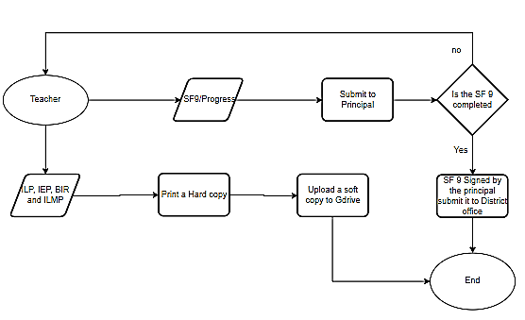

***Figure 20. The image above shows the current process of documents in Sta. Cruz District.***

**Proposed Process Flowchart**

This section displays the suggested process from the system.

**The Home Page Admin Account**

|  |  |  |
| --- | --- | --- |
| **Process Flow** | **People Involved** | **Description** |
|  | Admin | The Admin can choose from the features of the program from Secretary page |

***Figure 20. This shows how the Secretary can choose from a variety of processes***

***Once they have logged into the system. Each menu option has its own Possess equivalents.***

**The Dashboard Admin Account**

|  |  |  |
| --- | --- | --- |
| **Process Flow** | **People Involved** | **Description** |
|  | Admin | The Admin can view dashboard from Admin dashboard page |

***Figure 20. The figure above shows process flow of Dashboad in Admin account. This image summarizes what functions Admin can do in Dashboard page.***

**The Student Folders Admin Account**

|  |  |  |
| --- | --- | --- |
| **Process Flow** | **People Involved** | **Description** |
|  | Admin | The Admin can view student folders of all student of district in Admin student folders page |

***Figure 20. The figure above shows process flow of Student folders in Admin account. This image summarizes what functions Admin can do in Student folders page.***

**The Student File Folders Admin Account**

|  |  |  |
| --- | --- | --- |
| **Process Flow** | **People Involved** | **Description** |
|  | Admin | The Admin can transfer student, view and print student files in Admin student file folder page |

***Figure 20. The figure above shows process flow of Student file folders in Admin account. This image summarizes what functions Admin can do in Student file folder page.***

**The Add Student Admin Account**

|  |  |  |
| --- | --- | --- |
| **Process Flow** | **People Involved** | **Description** |
|  | Admin | The Admin can add new student by filling out required form in Admin Add student page |

***Figure 20. The figure above shows process flow of Student file folders in Admin account. This image summarizes what functions Admin can do in Student file folder page.***

**The Log History Process Admin Account**

|  |  |  |
| --- | --- | --- |
| **Process Flow** | **People Involved** | **Description** |
|  | Admin | The Admin can view all Log History of the ditrct in Log History Page. |

***Figure 20. The figure above shows process flow of Log History in Admin account. This image summarizes what functions Admin can do in Log History page.***

**The Archive Process Secretary Account**

|  |  |  |
| --- | --- | --- |
| **Process Flow** | **People Involved** | **Description** |
|  | Admin | The Admin can view, retrieve and permanently delete archive files of the district in Archive Page. |

***Figure 20. The figure above shows process flow of Archive in Admin Account. This image summarizes what functions Admin can do in Archive page.***

**The Pending Users Process Admin Account**

|  |  |  |
| --- | --- | --- |
| **Process Flow** | **People Involved** | **Description** |
|  | Admin | The Admin can approve and decline account in pending users page. |

***Figure 20. The figure above shows process flow of Pending users in Admin Account. This image summarizes what functions Admin can do in Pending users page.***

**The Add user Process Admin Account**

|  |  |  |
| --- | --- | --- |
| **Process Flow** | **People Involved** | **Description** |
|  | Admin | The Admin can add account in add users page. |

***Figure 20. The figure above shows process flow of Add user in Admin Account. This image summarizes what functions Admin can do in Add user page.***

**The Add user Process Admin Account**

|  |  |  |
| --- | --- | --- |
| **Process Flow** | **People Involved** | **Description** |
|  | Admin | The Admin can view and print the student enrollment list of the Districrt in Enrollment records page. |

***Figure 20. The figure above shows process flow of Enrollment records in Admin Account. This image summarizes what functions Admin can do in Enrollment records page.***

**The Add user Process Admin Account**

|  |  |  |
| --- | --- | --- |
| **Process Flow** | **People Involved** | **Description** |
|  | Admin | The Admin can view and print the current school year progress report of students list of the District in Progress report page. |

***Figure 20. The figure above shows process flow of Progress reports page in Admin Account. This image summarizes what functions Secretary can do in Progress reports page.***

**The Add user Process Admin Account**

|  |  |  |
| --- | --- | --- |
| **Process Flow** | **People Involved** | **Description** |
|  | Admin | The Admin can view and print the student list in the district in student list page. |

***Figure 20. The figure above shows process flow of Student list in Admin Account. This image summarizes what functions Admin can do in Student list page.***

**The Teacher Home Page**

|  |  |  |
| --- | --- | --- |
| **Process Flow** | **People Involved** | **Description** |
|  | Teachers | The Teachers can choose from the features of the program from teachers page |

***Figure 20. This shows how the Teachers can choose from a variety of processes***

***Once they have logged into the system. Each menu option has its own Possess equivalents.***

**The Teacher Profile Process**

|  |  |  |
| --- | --- | --- |
| **Process Flow** | **People Involved** | **Description** |
|  | Teachers | The Teachers can Account information such as number of student handle, numbers of file uploaded, Last log and personal information. |

***Figure 20. The figure above shows process flow of teachers profile.This image summarize what functions teachers can do in this page.***

**The Student Folders Process Teachers account**

|  |  |  |
| --- | --- | --- |
| **Process Flow** | **People Involved** | **Description** |
|  | Teachers | The Teachers can changed the view of the student folders to table view and can view student files in the folders |

***Figure 20. The figure above shows process flow of student folders in teachers account .This image summarize what functions teachers can do in student folders page.***

**The Student Files Process Teachers account**

|  |  |  |
| --- | --- | --- |
| **Process Flow** | **People Involved** | **Description** |
|  | Teachers | The Teachers can changed the enrolment status of the student, can create new folder for new school year and view files in the student folder. |

***Figure 20. The figure above shows process flow of student file folders in teachers account .This image summarize what functions teachers can do in student folders page.***

**The Student file Folders Process Teachers account**

|  |  |  |
| --- | --- | --- |
| **Process Flow** | **People Involved** | **Description** |
|  | Teachers | The Teachers can view and edit on the student file such as student information, IEP, Progress report, Student file, and forms |

***Figure 20. The figure above shows process flow of student file folders in teachers account .This image summarize what functions teachers can do in student file folders page.***

**The Student Information tab Process Teachers account**

|  |  |  |
| --- | --- | --- |
| **Process Flow** | **People Involved** | **Description** |
|  | Teachers | The Teachers can view and edit the student information in information tab |

***Figure 20. The figure above shows process flow of student information tab in teachers account .This image summarize what functions teachers can do in student information tab.***

**The Student IEP tab Process Teachers account**

|  |  |  |
| --- | --- | --- |
| **Process Flow** | **People Involved** | **Description** |
|  | Teachers | The Teachers can view, print and edit the student IEP in IEP tab |

***Figure 20. The figure above shows process flow of IEP tab in teachers account .This image summarize what functions teachers can do in IEP tab.***

**The Student Progress Report tab Process Teachers account**

|  |  |  |
| --- | --- | --- |
| **Process Flow** | **People Involved** | **Description** |
|  | Teachers | The Teachers can view, print and edit the student Progress Report in progress report tab. |

***Figure 20. The figure above shows process flow of student Progress report tab in teachers account .This image summarize what functions teachers can do in student Progress report tab.***

**The Student Filestab Process Teachers account**

|  |  |  |
| --- | --- | --- |
| **Process Flow** | **People Involved** | **Description** |
|  | Teachers | The Teachers can view, upload and delete student file in student files tab. |

***Figure 20. The figure above shows process flow of student files tab in teachers account .This image summarize what functions teachers can do in student files tab.***

**The Student Forms tab Process Teachers Account**

|  |  |  |
| --- | --- | --- |
| **Process Flow** | **People Involved** | **Description** |
|  | Teachers | The Teachers can view, edit and and fill out student forms in forms tab. |

***Figure 20. The figure above shows process flow of Forms tab in teachers account. This image summarizes what functions teachers can do in forms tab.***

**The Student Forms tab Process Teachers Account**

|  |  |  |
| --- | --- | --- |
| **Process Flow** | **People Involved** | **Description** |
|  | Teachers | The Teachers can add new student by filling out all required form in Add new Student page. |

***Figure 20. The figure above shows process flow of adding new student in teachers account. This image summarizes what functions teachers can do in Add Student page.***

**The Log History Process Teachers Account**

|  |  |  |
| --- | --- | --- |
| **Process Flow** | **People Involved** | **Description** |
|  | Teachers | The Teachers can view their Log History in Log History Page. |

***Figure 20. The figure above shows process flow of Log History in teachers account. This image summarizes what functions teachers can do in Log History page.***

**The Archive Process Teachers Account**

|  |  |  |
| --- | --- | --- |
| **Process Flow** | **People Involved** | **Description** |
|  | Teachers | The Teachers can view, Retrieve and Permanently delete file in archive page |

***Figure 20. The figure above shows process flow of Archive in teachers account. This image summarizes what functions teachers can do in Archive page.***

**The Home Page Secretary Account**

|  |  |  |
| --- | --- | --- |
| **Process Flow** | **People Involved** | **Description** |
|  | Secretary | The Secretary can choose from the features of the program from Secretary page |

***Figure 20. This shows how the Secretary can choose from a variety of processes***

***Once they have logged into the system. Each menu option has its own Possess equivalents.***

**The Dashboard Secretary Account**

|  |  |  |
| --- | --- | --- |
| **Process Flow** | **People Involved** | **Description** |
|  | Secretary | The Secretary can view their dashboard from Secretary dashboard page |

***Figure 20. The figure above shows process flow of Dashboad in secretary account. This image summarizes what functions secretary can do in Dashboard page.***

**The Student Folders Secretary Account**

|  |  |  |
| --- | --- | --- |
| **Process Flow** | **People Involved** | **Description** |
|  | Secretary | The Secretary can view student folders in Secretary student folders page |

***Figure 20. The figure above shows process flow of Student folders in secretary account. This image summarizes what functions secretary can do in Student folders page.***

**The Student File Folders Secretary Account**

|  |  |  |
| --- | --- | --- |
| **Process Flow** | **People Involved** | **Description** |
|  | Secretary | The Secretary can view and print student files in Secretary student file folder page |

***Figure 20. The figure above shows process flow of Student file folders in secretary account. This image summarizes what functions secretary can do in Student file folder page.***

**The Add Student Secretary Account**

|  |  |  |
| --- | --- | --- |
| **Process Flow** | **People Involved** | **Description** |
|  | Secretary | The Secretary can add new student by filling out required form in Secretary Add student page |

***Figure 20. The figure above shows process flow of Student file folders in secretary account. This image summarizes what functions secretary can do in Student file folder page.***

**The Log History Process Secretary Account**

|  |  |  |
| --- | --- | --- |
| **Process Flow** | **People Involved** | **Description** |
|  | Secretary | The Secretary can view all Log History in their school in Log History Page. |

***Figure 20. The figure above shows process flow of Log History in Secretary account. This image summarizes what functions Secretary can do in Log History page.***

**The Log History Process Secretary Account**

|  |  |  |
| --- | --- | --- |
| **Process Flow** | **People Involved** | **Description** |
|  | Secretary | The Secretary can view all Log History in their school in Log History Page. |

***Figure 20. The figure above shows process flow of Log History in Secretary Account. This image summarizes what functions Secretary can do in Log History page.***

**The Pending Users Process Secretary Account**

|  |  |  |
| --- | --- | --- |
| **Process Flow** | **People Involved** | **Description** |
|  | Secretary | The Secretary can approve and decline account in pending users page. |

***Figure 20. The figure above shows process flow of Pending users in Secretary Account. This image summarizes what functions Secretary can do in Pending users page.***

**The Add user Process Secretary Account**

|  |  |  |
| --- | --- | --- |
| **Process Flow** | **People Involved** | **Description** |
|  | Secretary | The Secretary can add account in add users page. |

***Figure 20. The figure above shows process flow of Add user in Secretary Account. This image summarizes what functions Secretary can do in Add user page.***

**The Add user Process Secretary Account**

|  |  |  |
| --- | --- | --- |
| **Process Flow** | **People Involved** | **Description** |
|  | Secretary | The Secretary can view and print the student enrollment list of the school in Enrollment records page. |

***Figure 20. The figure above shows process flow of Enrollment records in Secretary Account. This image summarizes what functions Secretary can do in Enrollment records page.***

**The Add user Process Secretary Account**

|  |  |  |
| --- | --- | --- |
| **Process Flow** | **People Involved** | **Description** |
|  | Secretary | The Secretary can view and print the current school year progress report of students list of the school in Progress report page. |

***Figure 20. The figure above shows process flow of Progress reports page in Secretary Account. This image summarizes what functions Secretary can do in Progress reports page.***

**The Add user Process Secretary Account**

|  |  |  |
| --- | --- | --- |
| **Process Flow** | **People Involved** | **Description** |
|  | Secretary | The Secretary can view and printthe student list in the district in student list page. |

***Figure 20. The figure above shows process flow of Student list in Secretary Account. This image summarizes what functions Secretary can do in Student list page.***

**The Home Page Principal Account**

|  |  |  |
| --- | --- | --- |
| **Process Flow** | **People Involved** | **Description** |
|  | Principal | The Principal can choose from the features of the program from Principal page |

***Figure 20. This shows how the Principal can choose from a variety of processes***

***Once they have logged into the system. Each menu option has its own Possess equivalents.***

**The Dashboard Principal Account**

|  |  |  |
| --- | --- | --- |
| **Process Flow** | **People Involved** | **Description** |
|  | Principal | The Principal can view their dashboard from Principal dashboard page |

***Figure 20. The figure above shows process flow of Dashboad in secretary account. This image summarizes what functions secretary can do in Dashboard page.***

**The Student Folders Principal Account**

|  |  |  |
| --- | --- | --- |
| **Process Flow** | **People Involved** | **Description** |
|  | Secretary | The Principal can view student folders in Principal student folders page |

***Figure 20. The figure above shows process flow of Student folders in Principal account. This image summarizes what functions Principal can do in Student folders page.***

**The Student File Folders Principal Account**

|  |  |  |
| --- | --- | --- |
| **Process Flow** | **People Involved** | **Description** |
|  | Secretary | The Principal can view and print student files in Principal student file folder page |

***Figure 20. The figure above shows process flow of Student file folders in Principal account. This image summarizes what functions Principal can do in Student file folder page.***

**The Log History Process Principal Account**

|  |  |  |
| --- | --- | --- |
| **Process Flow** | **People Involved** | **Description** |
|  | Principal | The Principal can view all Log History in their school in Log History Page. |

***Figure 20. The figure above shows process flow of Log History in Principal account. This image summarizes what functions Principal can do in Log History page.***

**The Archive Process Principal Account**

|  |  |  |
| --- | --- | --- |
| **Process Flow** | **People Involved** | **Description** |
|  | Principal | The Principal can view all Log History in their school in Log History Page. |

***Figure 20. The figure above shows process flow of Log History in Principal Account. This image summarizes what functions Principal can do in Log History page.***

**The Enrollment records Process Principal Account**

|  |  |  |
| --- | --- | --- |
| **Process Flow** | **People Involved** | **Description** |
|  | Secretary | The Principal can view and print the student enrollment list of the school in Enrollment records page. |

***Figure 20. The figure above shows process flow of Enrollment records in Principal Account. This image summarizes what functions Principal can do in Enrollment records page.***

**The Progress report Process Principal Account**

|  |  |  |
| --- | --- | --- |
| **Process Flow** | **People Involved** | **Description** |
|  | Secretary | The Principal can view and print the current school year progress report of students list of the school in Progress report page. |

***Figure 20. The figure above shows process flow of Progress reports page in Principal Account. This image summarizes what functions Principal can do in Progress reports page.***

**The Student List Process Principal Account**

|  |  |  |
| --- | --- | --- |
| **Process Flow** | **People Involved** | **Description** |
|  | Principal | The Principal can view and printthe student list in the district in student list page. |

***Figure 20. The figure above shows process flow of Student list in Principal Account. This image summarizes what functions Principal can do in Student list page.***

**Storyboard (Teachers)**

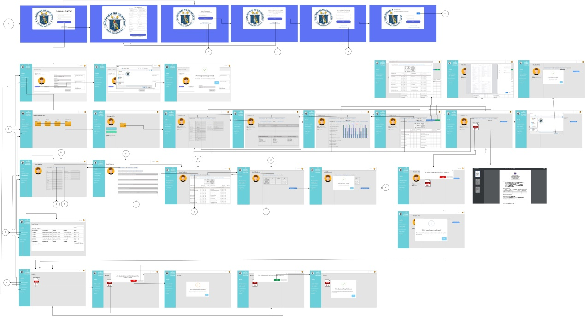

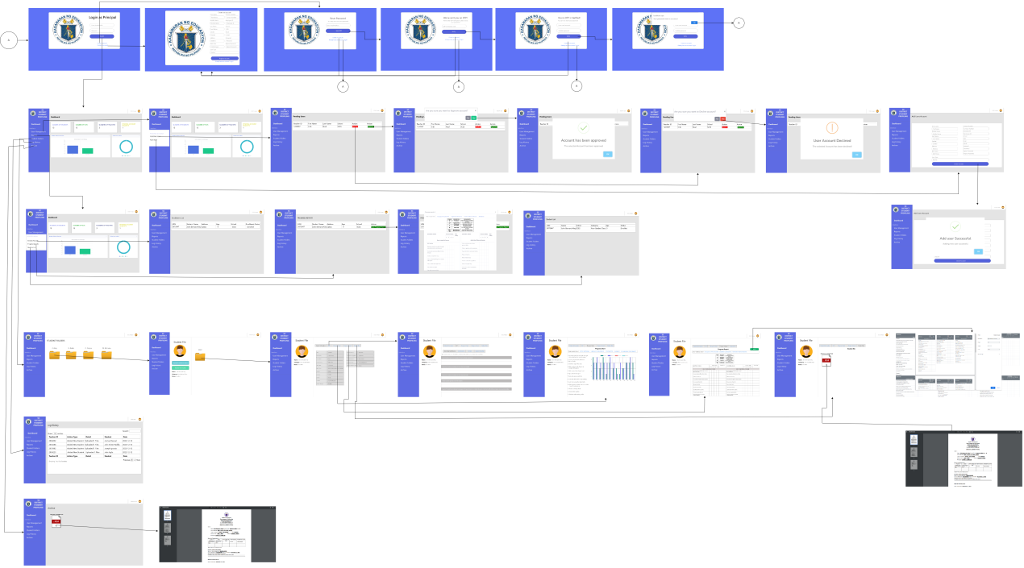**Storyboard (Principal)**

**Storyboard (Secretary)**

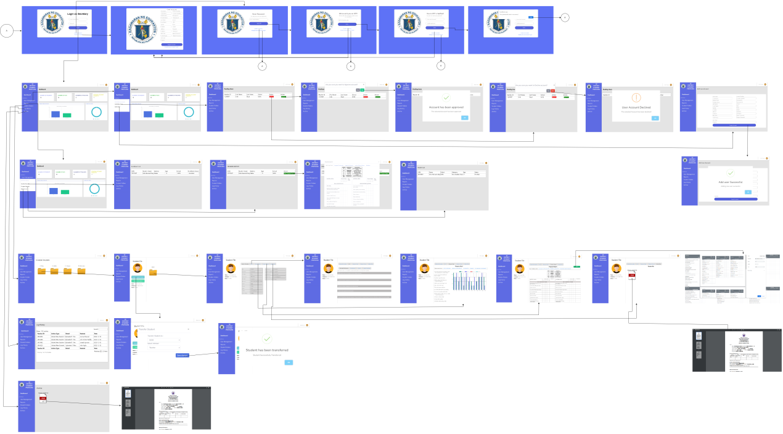

**Storyboard (Parents)**

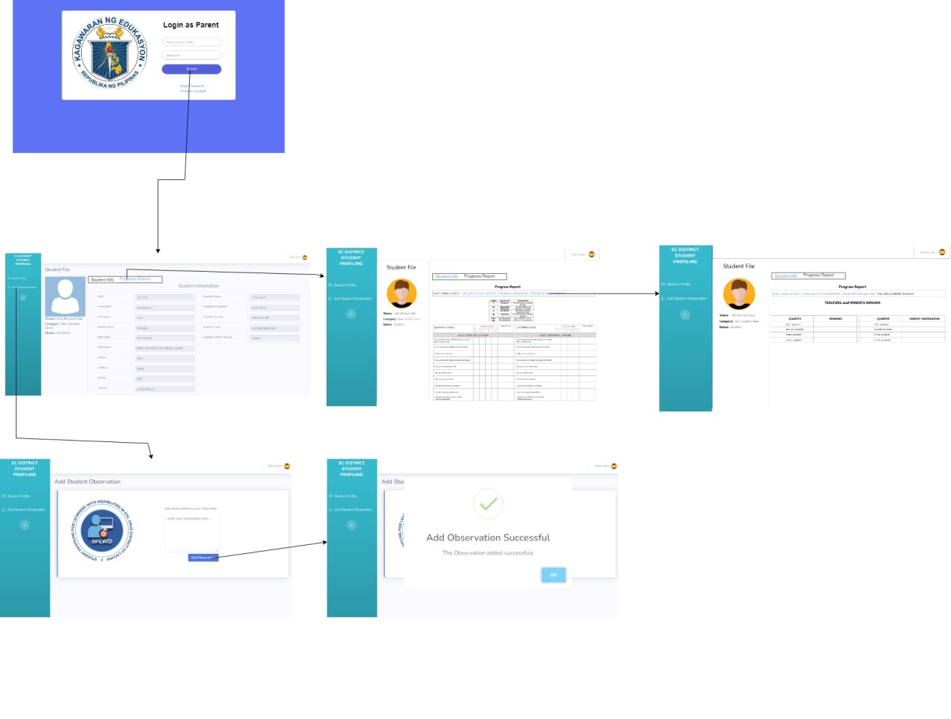

**Proposed Use Case Diagram**

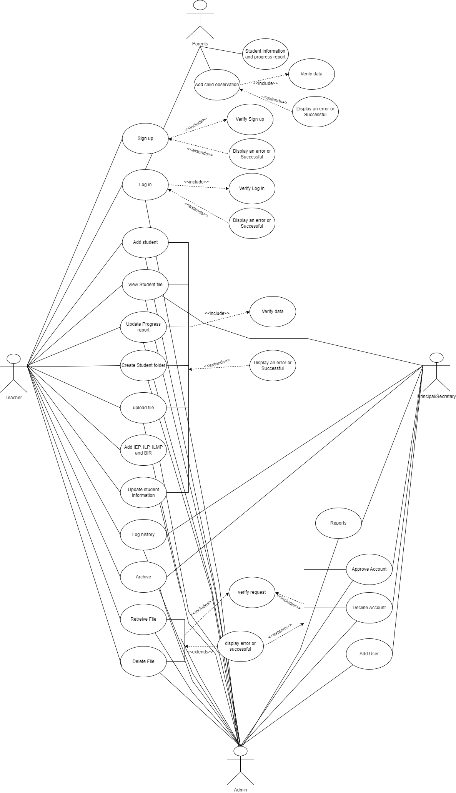

**Sy** **stem Architechture**



**System Context Diagram**

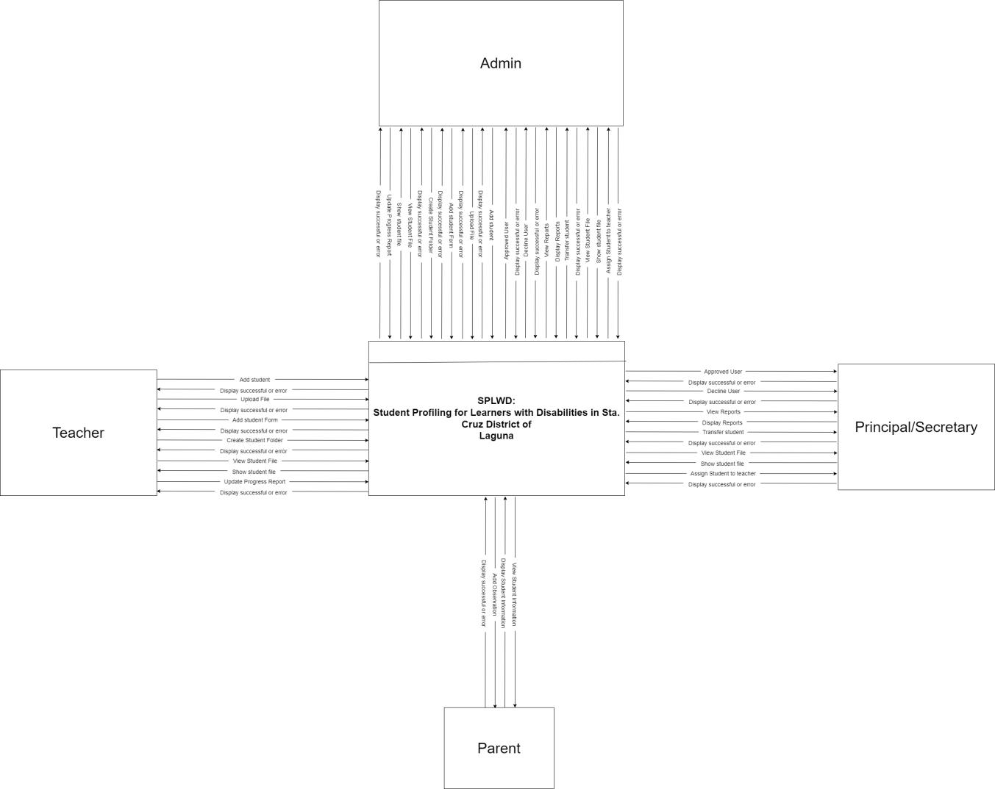

**Data Flow Diagram**

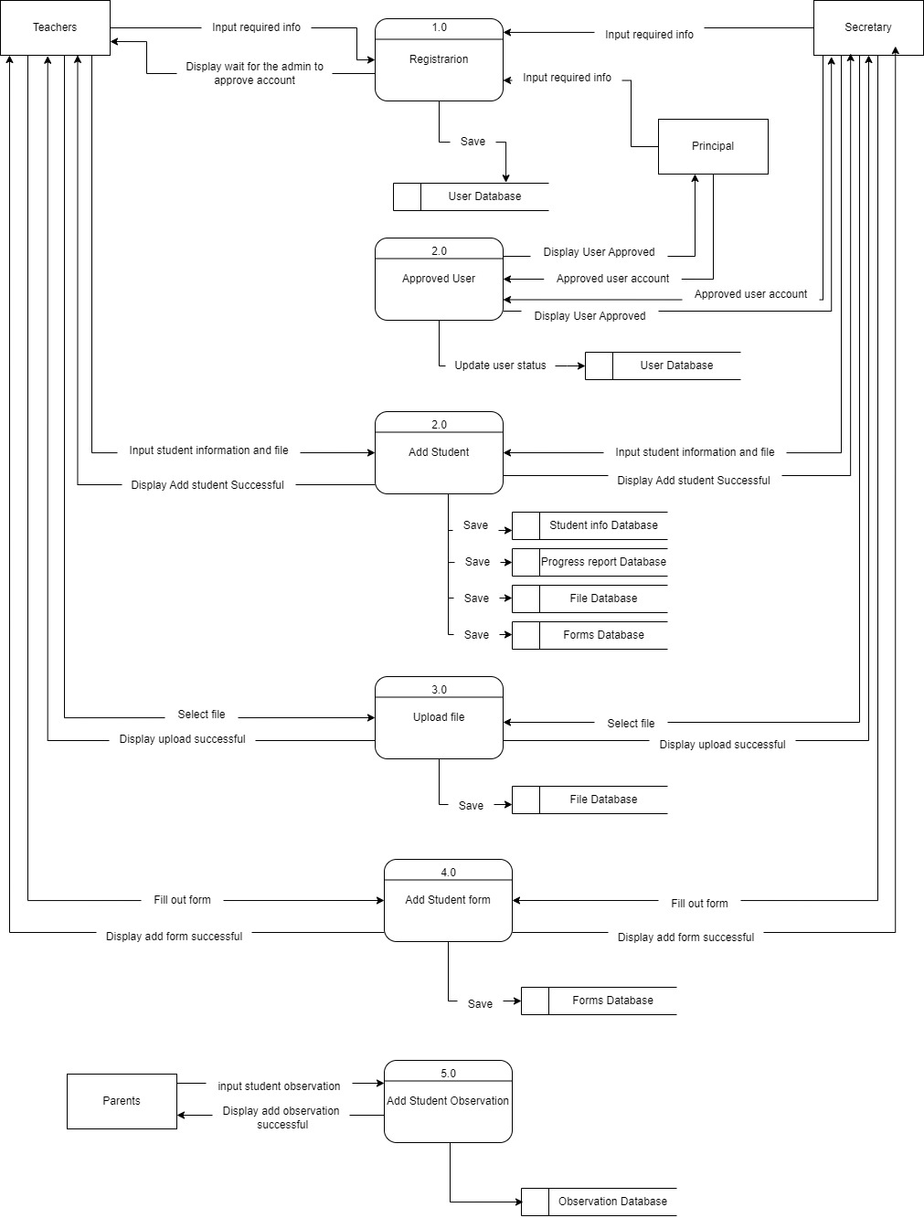

**Data Dictionary**

**Table 29:** Data dictionary for Users

|  |  |  |  |  |
| --- | --- | --- | --- | --- |
| **Field Name** | **Key** | **Description** | **Length** | **Field type** |
| user_id | PK | ID of users | 11 | INT |
| teacher_id | FK | Teachers Employee number | 7 | INT |
| fname |  | First name of user | 50 | VARCHAR |
| mname |  | Middle name of user | 50 | VARCHAR |
| lname |  | Last name of user | 50 | VARCHAR |
| contact_no |  | Contact number of user | 15 | VARCHAR |
| gender |  | Gender of the user | 6 | VARCHAR |
| address |  | Address of user | 255 | VARCHAR |
| birth_date |  | Birth date of the user | 255 | DATE |
| image |  | photo of user | 255 | VARCHAR |
| category |  | Category of user | 1 | INT |
| status |  | Status of user registration | 20 | VARCHAR |
| email |  | Password of user | 100 | VARCHAR |
| password |  | Signature of the user | 150 | VARCHAR |

**Table 30.** Data dictionary for User Types

|  |  |  |  |  |
| --- | --- | --- | --- | --- |
| **Field Name** | **Key** | **Description** | **Length** | **Field type** |
| ut_id | PK | User type ID | 11 | INT |
| user_type | FK | User type name | 50 | VARCHAR |

The table above shows the table for user type, this is to identify what kind of user is a user based on its ID.

**Table 31.** Data dictionary for Students

|  |  |  |  |  |
| --- | --- | --- | --- | --- |
| **Field Name** | **Key** | **Description** | **Length** | **Field type** |
| student_id | PK | ID of student | 11 | INT |
| lrn | FK | lrn of student | 7 | INT |
| fname |  | First name of student | 50 | VARCHAR |
| mname |  | Middle name of user | 50 | VARCHAR |
| lname |  | Last name of student | 50 | VARCHAR |
| contact_no |  | Guardian contact number of student | 15 | VARCHAR |
| gender |  | Gender of the student | 6 | VARCHAR |
| address |  | Address of student | 255 | VARCHAR |
| birth_date |  | Birth date of the student | 255 | DATE |
| birth_place |  | Birth place of student | 100 | VARCHAR |
| m_tongue |  | Mother tongue of the student | 100 | VARCHAR |
| guardian |  | Guardian of the student | 100 | VARCHAR |
| work |  | Work of the guardian | 100 | VARCHAR |
| email |  | Email address of the guardian | 100 | VARCHAR |
| enroll_status |  | Enrollment status of student | 100 | VARCHAR |
| image |  | photo of student | 255 | VARCHAR |

**Table 30.** Data dictionary for student category

|  |  |  |  |  |
| --- | --- | --- | --- | --- |
| **Field Name** | **Key** | **Description** | **Length** | **Field type** |
| category_id | PK | User type ID | 11 | INT |
| category | FK | User type name | 50 | VARCHAR |

The table above shows the table for student category, this is to identify what category student belongs based on its category.

**Table 32.** Data dictionary for folder

|  |  |  |  |  |
| --- | --- | --- | --- | --- |
| **Field Name** | **Key** | **Description** | **Length** | **Field type** |
| folder_id | PK | ID of the folder | 11 | INT |
| lrn | FK | lrn of student | 7 | INT |
| folder_year |  | School year of the folder | 4 | int |
| teacher | FK | Teacher ID of the folder | 11 | int |
| date_added |  | Date when the folder is created |  | Date |

**Table 33.** Data dictionary for IEP difficulty

|  |  |  |  |  |
| --- | --- | --- | --- | --- |
| **Field Name** | **Key** | **Description** | **Length** | **Field type** |
| iep_id | PK | IEP id where difficul belongs | 11 | INT |
| lrn | FK | Student LRN | 7 | INT |
| teacher_id | FK | Teacher ID | 11 |  |
| folder_id | FK | Folder ID | 2 | INT |
| d_seeing |  | What type of difficulty student has | 2 | VARCHAR |
| d_seeing |  | What type of difficulty student has | 2 | VARCHAR |
| barrier_3 |  | What type of difficulty student has | 2 | VARCHAR |
| barrier_4 |  | What type of difficulty student has | 2 | VARCHAR |

**Table 33.** Data dictionary for IEP barriers

|  |  |  |  |  |
| --- | --- | --- | --- | --- |
| **Field Name** | **Key** | **Description** | **Length** | **Field type** |
| barrier_id | PK | ID of users | 11 | INT |
| iep_id | FK | IEP id where barrier belongs | 11 | INT |
| lrn | FK | Student LRN | 7 | INT |
| folder_id | FK | Folder ID | 11 | INT |
| barrier_1 |  | What type of teaching barrier student has | 255 | VARCHAR |
| barrier_2 |  | What type of teaching barrier student has | 255 | VARCHAR |
| barrier_3 |  | What type of teaching barrier student has | 255 | VARCHAR |
| barrier_4 |  | What type of teaching barrier student has | 255 | VARCHAR |

**Table 33.** Data dictionary for IEP Functional

|  |  |  |  |  |
| --- | --- | --- | --- | --- |
| **Field Name** | **Key** | **Description** | **Length** | **Field type** |
| functional_id | PK | ID of users | 11 | INT |
| iep_id | FK | IEP id where functional belongs | 11 | INT |
| lrn | FK | Student LRN | 7 | INT |
| folder_id | FK | Folder ID | 11 | INT |
| functional_1 |  | Functional performance evaluation | 255 | VARCHAR |
| functional_2 |  | Functional performance academic, developmental and/or functional strengths | 255 | VARCHAR |
| functional_3 |  | What type of Functional performance academic, developmental and/or functional needs | 255 | VARCHAR |
| functional_4 |  | What type of teaching barrier student has | 255 | VARCHAR |
| functional_5 |  | Functional performance parental concern | 255 | VARCHAR |
| functional_1_2 |  | Functional performance evaluation | 255 | VARCHAR |
| functional_2_2 |  | Functional performance academic, developmental and/or functional strengths | 255 | VARCHAR |
| functional_3_2 |  | What type of teaching barrier student has | 255 | VARCHAR |
| functional_4_2 |  | Functional performance academic, developmental and/or functional strengths | 255 | VARCHAR |
| functional_5_2 |  | Functional performance parental concern | 255 | VARCHAR |
| functional_1_3 |  | Functional performance evaluation | 255 | VARCHAR |
| functional_2_3 |  | Functional performance academic, developmental and/or functional strengths | 255 | VARCHAR |
| functional_3_3 |  | What type of teaching barrier student has | 255 | VARCHAR |
| functional_4_3 |  | Functional performance academic, developmental and/or functional strengths | 255 | VARCHAR |
| functional_5_3 |  | Functional performance parental concern | 255 | VARCHAR |

**Table 35.** Data dictionary for IEP Goals

|  |  |  |  |  |
| --- | --- | --- | --- | --- |
| **Field Name** | **Key** | **Description** | **Length** | **Field type** |
| goal_id | PK | ID of student | 11 | INT |
| iep_id | FK | IEP id where goals belongs | 11 | INT |
| lrn | FK | Student LRN | 2 | INT |
| folder_id | FK | Folder ID | 2 | INT |
| interest |  | Students interest | 255 | VARCHAR |
| goal |  | Teachers goal | 255 | VARCHAR |
| Intervention |  | Teacher intervention | 255 | VARCHAR |
| timeline |  | Students timeline | 255 | VARCHAR |
| Individual_responsible |  | Students individual responsiveness | 255 | VARCHAR |
| remarks |  | Teachers remark | 255 | VARCHAR |
| progress |  | Teachers next step and student progress | 255 | VARCHAR |
|  |  |  |  |  |

**Table 33.** Data dictionary for IEP Functional

|  |  |  |  |  |
| --- | --- | --- | --- | --- |
| **Field Name** | **Key** | **Description** | **Length** | **Field type** |
| special_factor_id | PK | ID of users | 11 | INT |
| iep_id | FK | IEP id where team belongs | 11 | INT |
| lrn | FK | Student LRN | 7 | INT |
| folder_id | FK | Folder ID | 2 | INT |
| factor_1 |  | If the student having difficulty relating with people | 3 | CHAR |
| factor_2 |  | appropriateness of developing | 3 | CHAR |
| factor_3 |  | If the student having difficulty in moving or walking | 3 | CHAR |
| factor_4 |  | If the student having difficulty in seeing | 3 | CHAR |
| factor_5 |  | If the student having difficulty in communicating | 3 | CHAR |
| factor_6 |  | If the student having difficulty in concentrating | 3 | CHAR |
| factor_7 |  | If the student having difficulty in hearing | 3 | CHAR |
| factor_8_type |  | Type of special factor | 3 | CHAR |
| factor_9 |  | Functional performance academic, developmental and/or functional strengths | 3 | CHAR |
| comment_3 |  | Comment If the student having difficulty in moving or walking | 255 | VARCHAR |
| comment_4 |  | Comment If the student having difficulty in moving or walking | 255 | VARCHAR |
| comment_5 |  | Comment If the student having difficulty in communicating | 255 | VARCHAR |
| comment_6 |  | Comment If the student having difficulty in communicating | 255 | VARCHAR |
| comment_7 |  | Comment If the student having difficulty in Hearing | 255 | VARCHAR |
| comment_8 |  | Comment if the student need assistive tool | 255 | VARCHAR |

**Table 33.** Data dictionary for IEP Team

|  |  |  |  |  |
| --- | --- | --- | --- | --- |
| **Field Name** | **Key** | **Description** | **Length** | **Field type** |
| Iep_team_id | PK | IEP team ID | 11 | INT |
| iep_id | FK | IEP id where team belongs | 11 | INT |
| lrn | FK | Student LRN | 7 | INT |
| folder_id | FK | Folder ID | 11 | INT |
| psych |  | Psychologist who assesst the student | 50 | VARCHAR |
| nurse |  | Nurse present in the assessment | 50 | VARCHAR |
| therapist |  | Therapist present in the assessment | 50 | VARCHAR |
| language |  | Language use during the assessment | 100 | CHAR |
| If_18 |  | If student will not be 18 in one year | 3 | CHAR |
| distribution |  | Distribution it either folder or receiving teacher | 50 | VARCHAR |
| date |  | Date of the assessment |  | DATE |
| guidance |  | Guidance councilor present in the assessment | 50 | VARCHAR |
| principal |  | Current principal during the assessment | 50 | VARCHAR |
| sp_teacher |  | Special education teacher | 50 | VARCHAR |

**Table 35.** Data dictionary for IEP Transition

|  |  |  |  |  |
| --- | --- | --- | --- | --- |
| **Field Name** | **Key** | **Description** | **Length** | **Field type** |
| transition_id | PK | ID of student | 11 | INT |
| iep_id | FK | IEP id where transition belongs | 11 | INT |
| lrn | FK | Student LRN | 7 | INT |
| folder_id | FK | Folder ID | 11 | INT |
| interest |  | Students interest | 255 | VARCHAR |
| work |  | Work oppurtunities | 255 | VARCHAR |
| skills |  | Transition or intervention skills | 255 | VARCHAR |
| Individual_responsible |  | Students individual responsiveness | 255 | VARCHAR |
| remarks |  | Teachers remark | 255 | VARCHAR |

**Table 35.** Data dictionary for ILMP

|  |  |  |  |  |
| --- | --- | --- | --- | --- |
| **Field Name** | **Key** | **Description** | **Length** | **Field type** |
| ilmpID | PK | ID of student | 11 | INT |
| ilmp_id | FK | IEP id where transition belongs | 11 | INT |
| lrn | FK | Student LRN | 7 | INT |
| folder_id | FK | Folder ID | 11 | INT |
| learning_area |  | Learning area | 255 | VARCHAR |
| learner_need |  | Learners need | 255 | VARCHAR |
| intervention |  | Student intervention | 255 | VARCHAR |
| monitoring_date |  | Monitoring date of ILMP |  | DATE |
| insignificant |  | Insignificant progress | 255 | VARCHAR |
| significant |  | Significant progress | 255 | VARCHAR |
| mastery |  | Mastery of the student | 255 | VARCHAR |

**Table 35.** Data dictionary for ILMP group

|  |  |  |  |  |
| --- | --- | --- | --- | --- |
| **Field Name** | **Key** | **Description** | **Length** | **Field type** |
| Ilmp_group_id | FK | IEP id where transition belongs | 11 | INT |
| lrn | FK | Student LRN | 7 | INT |
| folder_id | FK | Folder ID | 11 | INT |
| c_1 |  | Intervention status choice one | 3 | CHAR |
| c_2 |  | Intervention status choice two | 3 | CHAR |
| c_3 |  | Intervention status choice three | 3 | CHAR |

**Table 33.** Data dictionary for ILP

|  |  |  |  |  |
| --- | --- | --- | --- | --- |
| **Field Name** | **Key** | **Description** | **Length** | **Field type** |
| ilp_id | PK | ID of users | 11 | INT |
| lrn | FK | Student LRN | 7 | INT |
| folder_id | FK | Folder ID | 11 | INT |
| school_year |  | School year of ILP | 11 | INT |
| principal |  | Current principal of the school year ILP | 50 | VARCHAR |
| educ_history |  | Educational history of student | 255 | VARCHAR |
| interview_learner |  | Interview with learner | 255 | VARCHAR |
| strength_1 |  | Strength of the student in daily living skill | 255 | VARCHAR |
| strength_2 |  | Strength of the student in developmental | 255 | VARCHAR |
| strength_3 |  | Strength of the student in psychomotor | 255 | VARCHAR |
| strength_4 |  | Strength of the student in cognitive | 255 | VARCHAR |
| strength_5 |  | Strength of the student in creativity | 255 | VARCHAR |
| strength_6 |  | Strength of the student in behavioral | 255 | VARCHAR |
| strength_7 |  | Strength of the student in orientation and mobility | 255 | VARCHAR |
| need_1 |  | Need of the student in daily living skill | 255 | VARCHAR |
| need_2 |  | Strength of the student in developmental | 255 | VARCHAR |
| need_3 |  | Need of the student in psychomotor | 255 | VARCHAR |
| need_4 |  | Need of the student in cognitive | 255 | VARCHAR |
| need_5 |  | Need of the student in creativity | 255 | VARCHAR |
| need_6 |  | Need of the student in behavioral | 255 | VARCHAR |
| need_7 |  | Need of the student in orientation and mobility | 255 | VARCHAR |

**Table 35.** Data dictionary for ILP assessment

|  |  |  |  |  |
| --- | --- | --- | --- | --- |
| **Field Name** | **Key** | **Description** | **Length** | **Field type** |
| assessment_id | PK | Assessment ID | 7 | INT |
| ilp_id | FK | Where ILP the assessment belongs | 11 | INT |
| lrn | FK | Student LRN | 7 | INT |
| folder_id | FK | Folder ID | 11 | INT |
| type_assessment |  | Intervention status choice one | 50 | VARCHAR |
| date |  | Intervention status choice two |  | DATE |
| chronological_age |  | Intervention status choice three | 3 | INT |
| administrator |  | Who administer the assessment | 50 | VARCHAR |
| result |  | Result of the assessment | 255 | VARCHAR |
| date_interview |  | Date of the interview |  | DATE |
| date_interview_student |  | Date of the interview to student |  | DATE |
| adviser |  | Adviser of the student | 100 | VARCHAR |

**Table 33.** Data dictionary for ILP priority

|  |  |  |  |  |
| --- | --- | --- | --- | --- |
| **Field Name** | **Key** | **Description** | **Length** | **Field type** |
| priority_id | PK | ID of users | 11 | INT |
| lrn | FK | Student LRN | 7 | INT |
| Ilp_id | FK | ILP ID where priority belongs | 11 | INT |
| folder_id | FK | Folder ID | 11 | INT |
| priority_1 |  | Priority in daily living skill | 255 | VARCHAR |
| priority _2 |  | Priority in developmental | 255 | VARCHAR |
| priority _3 |  | Priority in psychomotor | 255 | VARCHAR |
| priority_4 |  | Priority in cognitive | 255 | VARCHAR |
| priority_5 |  | Priority in creativity | 255 | VARCHAR |
| priority _6 |  | Priority in behavioral | 255 | VARCHAR |
| priority _7 |  | Priority in orientation and mobility | 255 | VARCHAR |

**Table 33.** Data dictionary for ILP transition

|  |  |  |  |  |
| --- | --- | --- | --- | --- |
| **Field Name** | **Key** | **Description** | **Length** | **Field type** |
| transition_id | PK | ID of users | 11 | INT |
| lrn | FK | Student LRN | 7 | INT |
| Ilp_id | FK | ILP ID where transition belongs | 11 | INT |
| folder_id | FK | Folder ID | 11 | INT |
| transition_1 |  | Transition of student one | 255 | VARCHAR |
| transition_2 |  | Transition of student two | 255 | VARCHAR |
| transition_3 |  | Transition of student three | 255 | VARCHAR |
| transition_4 |  | Transition of student four | 255 | VARCHAR |
| transition_5 |  | Transition of student five | 255 | VARCHAR |

**Table 33.** Data dictionary for log history

|  |  |  |  |  |
| --- | --- | --- | --- | --- |
| **Field Name** | **Key** | **Description** | **Length** | **Field type** |
| log_id | PK | Log history ID | 11 | INT |
| lrn | FK | Student LRN | 7 | INT |
| teacher_id | FK | Teacher ID | 11 | INT |
| action_type |  | What type of action teacher done | 100 | VARCHAR |
| previous |  | Previous file or detail of action | 11 | INT |
| updated |  | Updated file or details of action | 255 | VARCHAR |
| details |  | Details of log history | 255 | VARCHAR |
| school |  | School where the teacher belong | 100 | VARCHAR |

**Table 33.** Data dictionary for Parent Observation

|  |  |  |  |  |
| --- | --- | --- | --- | --- |
| **Field Name** | **Key** | **Description** | **Length** | **Field type** |
| observation_id | PK | Log history ID | 11 | INT |
| lrn | FK | Student LRN | 7 | INT |
| teacher_id | FK | Teacher ID | 11 | INT |
| action_type |  | What type of action teacher done | 100 | VARCHAR |
| previous |  | Previous file or detail of action | 11 | INT |
| updated |  | Updated file or details of action | 255 | VARCHAR |
| details |  | Details of log history | 255 | VARCHAR |
| school |  | School where the teacher belong | 100 | VARCHAR |

**Table 33.** Data dictionary for Progress report

|  |  |  |  |  |
| --- | --- | --- | --- | --- |
| **Field Name** | **Key** | **Description** | **Length** | **Field type** |
| progress_id | PK | Progress ID | 11 | INT |
| lrn | FK | Student LRN | 7 | INT |
| folder_id | FK | Folder ID | 11 | INT |
| type |  | Index of the progress report | 255 | VARCHAR |
| q1 |  | Grade of the student in quarter one | 2 | CHAR |
| q2 |  | Grade of the student in quarter two | 2 | CHAR |
| q3 |  | Grade of the student in quarter three | 2 | CHAR |
| q4 |  | Grade of the student in quarter four | 2 | CHAR |

**Table 33.** Data dictionary for Student File

|  |  |  |  |  |
| --- | --- | --- | --- | --- |
| **Field Name** | **Key** | **Description** | **Length** | **Field type** |
| student_file_id | PK | Progress ID | 11 | INT |
| lrn | FK | Student LRN | 7 | INT |
| folder_id | FK | Folder ID | 11 | INT |
| Teacher_id | FK | Teacher ID | 11 | INT |
| year |  | Year of the file | 2 | CHAR |
| file_type |  | Grade of the file type of the student file | 100 | VARCHAR |
| file_name |  | File name of the student file | 255 | VARCHAR |
| descrpition |  | Description of the file | 100 | VARCHAR |
| date |  | Date the file uploaded |  | DATE |
| status |  | Status of the file | 100 | VARCHAR |
| school |  | School wher the file uploaded | 6 | CHAR |

**Table 33.** Data dictionary for Teacher remark

|  |  |  |  |  |
| --- | --- | --- | --- | --- |
| **Field Name** | **Key** | **Description** | **Length** | **Field type** |
| remark_id | PK | Remark ID | 11 | INT |
| lrn | FK | Student LRN | 7 | INT |
| folder_id | FK | Folder ID | 11 | INT |
| teacher_id |  | Teacher ID | 11 | INT |
| remark_q1 |  | Remark of the student in quarter one | 255 | VARCHAR |
| remark_q2 |  | Remark of the student in quarter two | 255 | VARCHAR |
| remark_q3 |  | Remark of the student in quarter three | 255 | VARCHAR |
| remark_q4 |  | Remark of the student in quarter four | 255 | VARCHAR |
| ramark_date |  | Remark date |  | DATE |

1. **Project Schedule**

**Project Schedule**

**Table 39.** Project Schedule

|  |
| --- |
| Title:  **SPLWD: Student Profiling for Learners with Disabilities in Sta. Cruz District of Laguna** |
| Project Team:   1. Joshua B. Pascual 2. Irish Cathlyn E. Nual 3. Dan Henry T. Bonozo   ADVISER:  Mrs. Mia Villarica |

|  |  |  |  |  |
| --- | --- | --- | --- | --- |
| **Tasks Description** | **Predecessor** | **People Involved** | **Target Date** | **Milestones** |
| **Phase 1: Conception and Project Initiation** | | | | |
| a. Preliminary interview with Mr. Armin Cabrales, Principal IV of Sta. Cruz Elementary School | Signed communication letter | Project Team,  Mr. Armin Cabrales | June 2, 2022 | Gathered information about the assessment of LWD students |
| b. Title presentation and approval |  | Project Team,  Mrs. Mia Villarica  Mr. Gerald Villaran  Mr. Mark Bernardino  Mr. Gener Mosico | June 15, 2022 | Title approved |
| c. In this Phase, MOA will be the output | SCES has agreed to participate in the study | Pascual, Project Team,  Mr. Armin Cabrales  Mr. Luis M. Germina | June 17, 2022 |  |
| d. SCES is interviewed in order to gather information and features that will be added to the system to meet their needs. |  | Project Team,  Ms.Mariel Ansay  Ms. Mary Joice Nhel Ella  Ms. Gina Salcedo | June 22, 2022 |  |
| e. Storyboard illustration and conceptualization of program flow. |  | Project Team, | June, 28, 2022 | Storyboard has been created |
| **Phase 2: Project Planning** | | | | |
| a. Coordination and consultative meetings with the school administrators | Approval of the school administrators | Project Team,  Ms.Mariel Ansay  Ms. Mary Joice Nhel Ella  Ms. Gina Salcedo | June 30, 2022 |  |
| b. Devise Training plan for a specific user of the system |  | Project Team,  Ms.Mariel Ansay  Ms. Mary Joice Nhel Ella  Ms. Gina Salcedo | July 4, 2022 |  |
| c. Schedule of project testing for users | Coordinate with the user for scheduling the project testing with them in person | Project Team,  Ms.Mariel Ansay  Ms. Mary Joice Nhel Ella  Ms. Gina Salcedo | July 20, 2022 |  |
| d. Project orientation and launching | Evaluation of user readiness and approval by the school administrator | Project Team,  Ms.Mariel Ansay  Ms. Mary Joice Nhel Ella  Ms. Gina Salcedo | July 22, 2022 |  |
| **Phase 3: Project Execution** | | | | |
| a. Perform pretest examination for the users | Meeting with the school administrators | Project Team,  Ms.Mariel Ansay  Ms. Mary Joice Nhel Ella  Ms. Gina Salcedo | July 27, 2022 |  |
| b. Conduct a suggestions after the pretest |  | Project Team, | July 29, 2022 |  |
| c. Consolidate the user suggestions |  | Project Team, | August 1, 2022 |  |
| **Phase 4: Project Monitoring and Control** | | | | |
| a. Plan a consultation program |  | Project Team, | August 4, 2022 |  |
| b. Test and implement the consultation program |  | Project Team, | August 8, 2022 |  |
| c. Conduct an interview to the participants to assess the skills and knowledge transfer |  | Project Team, | August 10, 2022 |  |
| d. Develop a strategy for collecting information regarding the system usage. |  | Project Team, | August 12, 2022 |  |
| e. Create the terminal report for the project |  | Project Team, | August 14, 2022 |  |
| **Project 2: SYSTEM DEVELOPMENT** | | | | |
| **Phase 1: Conception and Project Initiation** | | | | |
| a. Creation of use case diagram. |  | Project Team, | June 20, 2022 |  |
| b. Creation of  Sequence Diagram |  | Project Team, | June 21, 2022 |  |
| c. Creation of Data flow diagram |  | Project Team, | June 23, 2022 |  |
| d. d. Creation of Data Model |  | Project Team, | June 24, 2022 |  |
| **Phase 2: UI/UX Planning** | | | | |
| a. Creation of wireframes |  | Project Team, | Jun2 25, 2022 |  |
| b. Selection of color palette, font-face, and UI design implementation. |  | Project Team, | June 26, 2022 |  |
| **Phase 3: Rapid Application Development** | | | | |
| a. Requirements planning |  | Project Team, | June 27, 2022 |  |
| b. User design  b1. Prototype  b2. Test  b3. Refine |  | Project Team, | June 29, 2022 |  |
| c. Construction |  | Project Team, | July 1, 2022 |  |
| **Phase 4: Project Monitoring and Control** | | | | |
| a. Plan a consultation for user concerns or inquiries. |  | Project Team, | July 3, 2022 |  |
| b. Implement the planned consultation. |  | Project Team, | July 4, 2022 |  |
| c. Set up a weekly consultation with the user to discuss their concerns and suggestions. |  | Project Team, | July 5, 2022 |  |
| d. Create the terminal report for the project. |  | Project Team, | July 8, 2022 |  |
| **Phase 5: Project Completion** | | | | |
| a. Continuously monitor and support the system for maintenance to formulate a 2nd revision of the system and possible project expansion. |  | Project Team,  Ms.Mariel Ansay  Ms. Mary Joice Nhel Ella  Ms. Gina Salcedo | December 2022 |  |

|  |
| --- |
| People Involved and their responsibilities   1. ***Project Heads***   Joshua B. Pascual - Back-Ender/Document Editor  Irish Cathlyn E. Nual - Document Editor  Dan Henry T. Bonozo - Document Editor   1. ***Members and their functions***   *SPLWD Designs and Build Team*  Head: Joshua B. Pascual  Members: Irish Cathlyn E. Nual  Dan Henry T. Bonozo   1. ***Consultants***   Mia V. Villarica - Adviser  Gerald Villaran            - Subject Matter Expert  Alliana Miranda - Technical editor  Cherobie Aranas               - Statistician  Cezanne Dimaculangan - Language Critic |

The table above shows the researchers' project schedule. The preliminary phase, system development testing, and user evaluation phase are all included. The researchers used these stages as a guide or a starting point to decide what they would do next.

**Hierarchical Input Process Output Model**

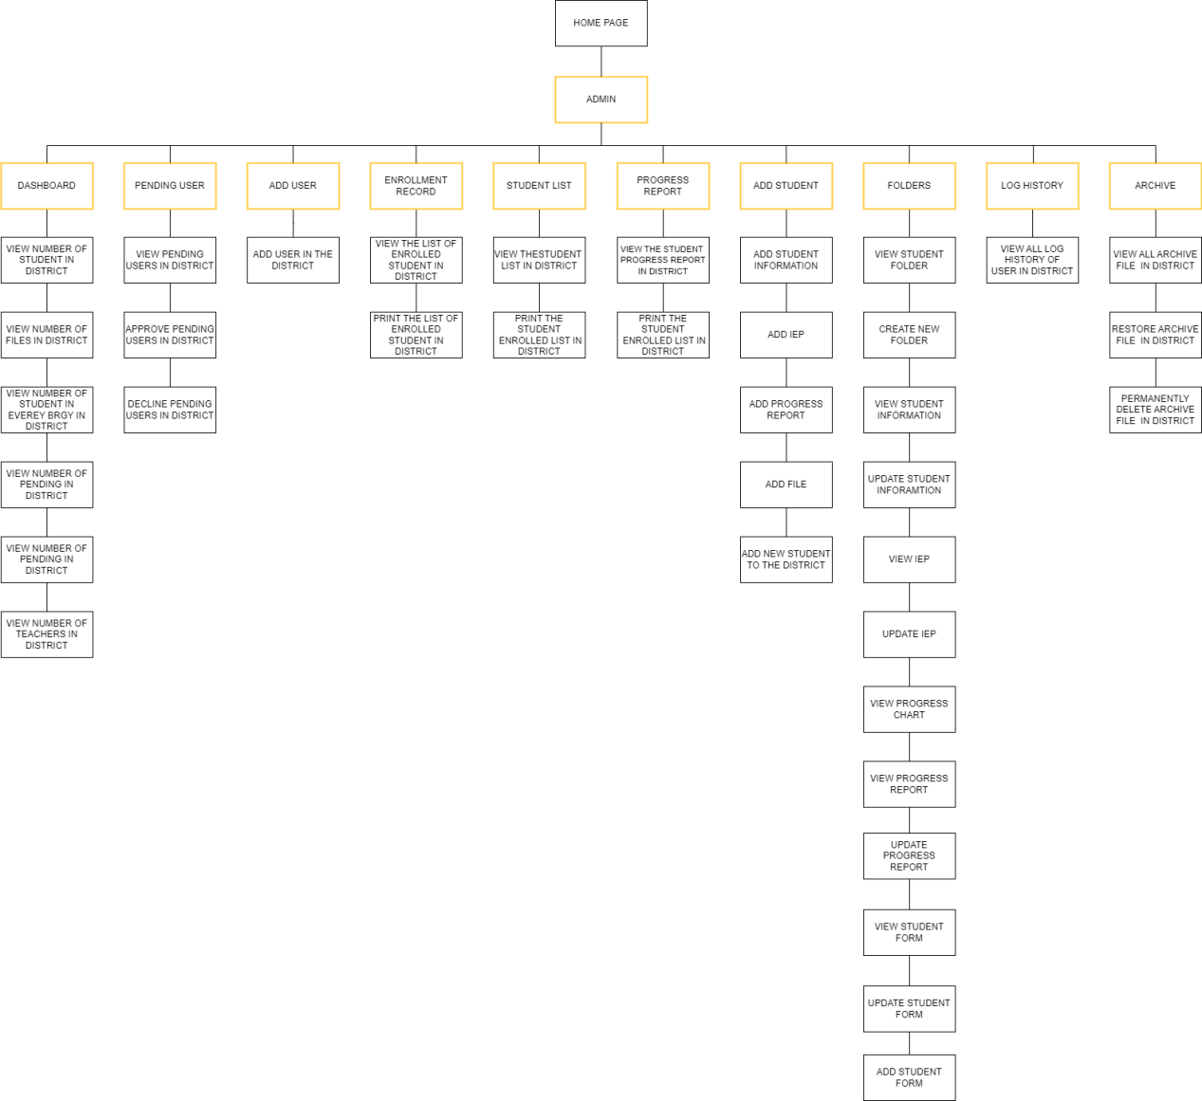

**Figure 60.** Admin HIPO. The figure above illustrates the module of the system hierarchy to show the system design in the Admin account.

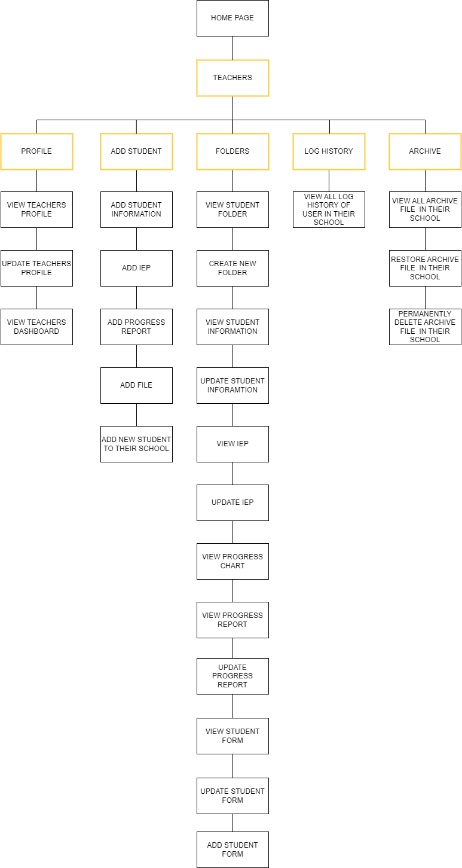

**Figure 60.** Teachers HIPO. The figure above illustrates the module of the system hierarchy to show the system design in the teachers account.

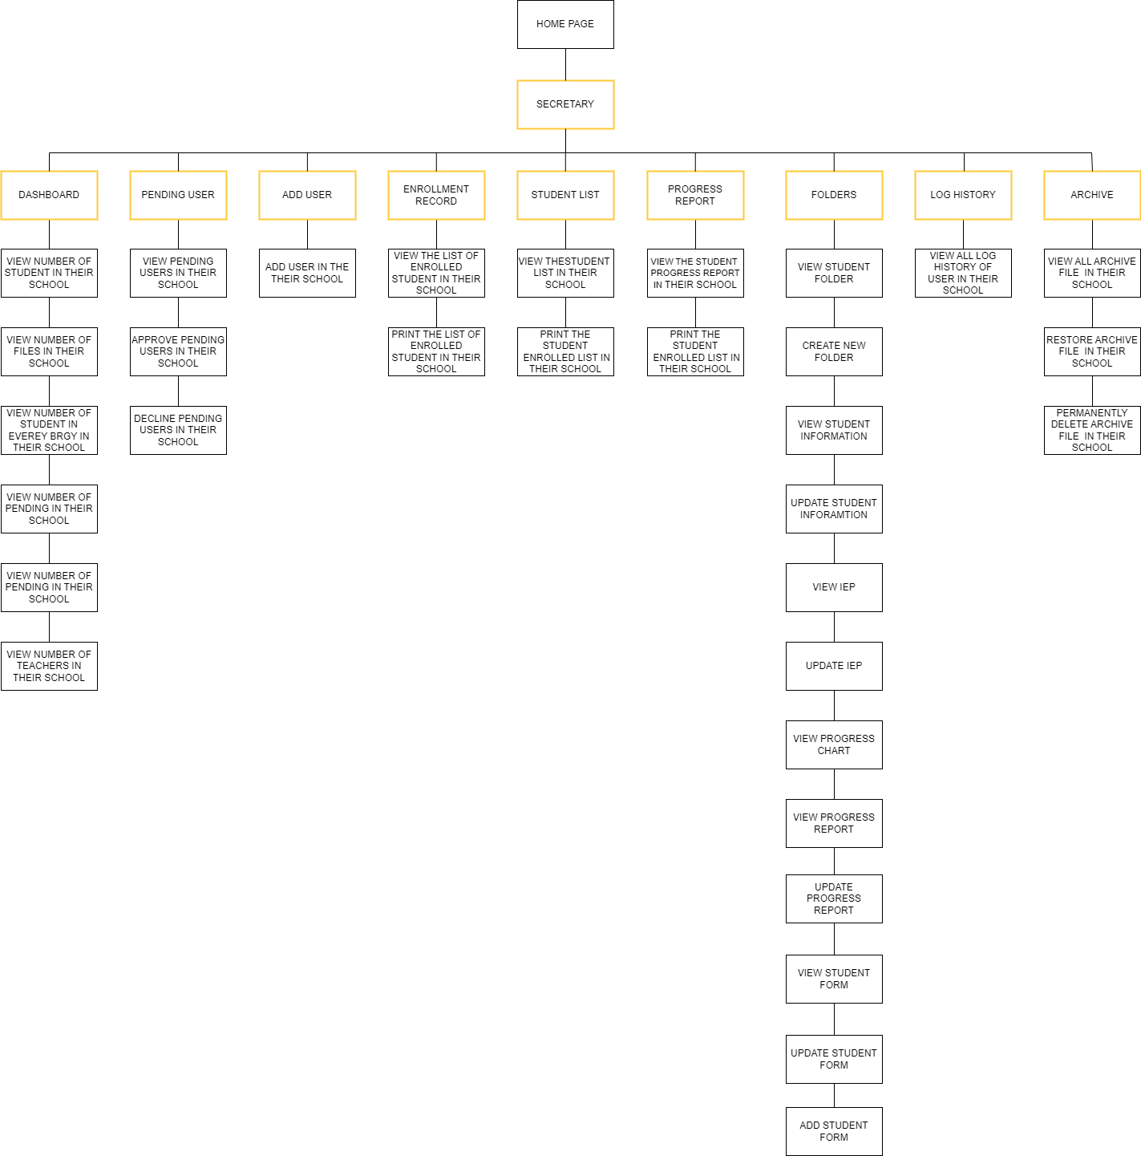

**Figure 60.** Secretary HIPO. The figure above illustrates the module of the system hierarchy to show the system design in the Secretary account.

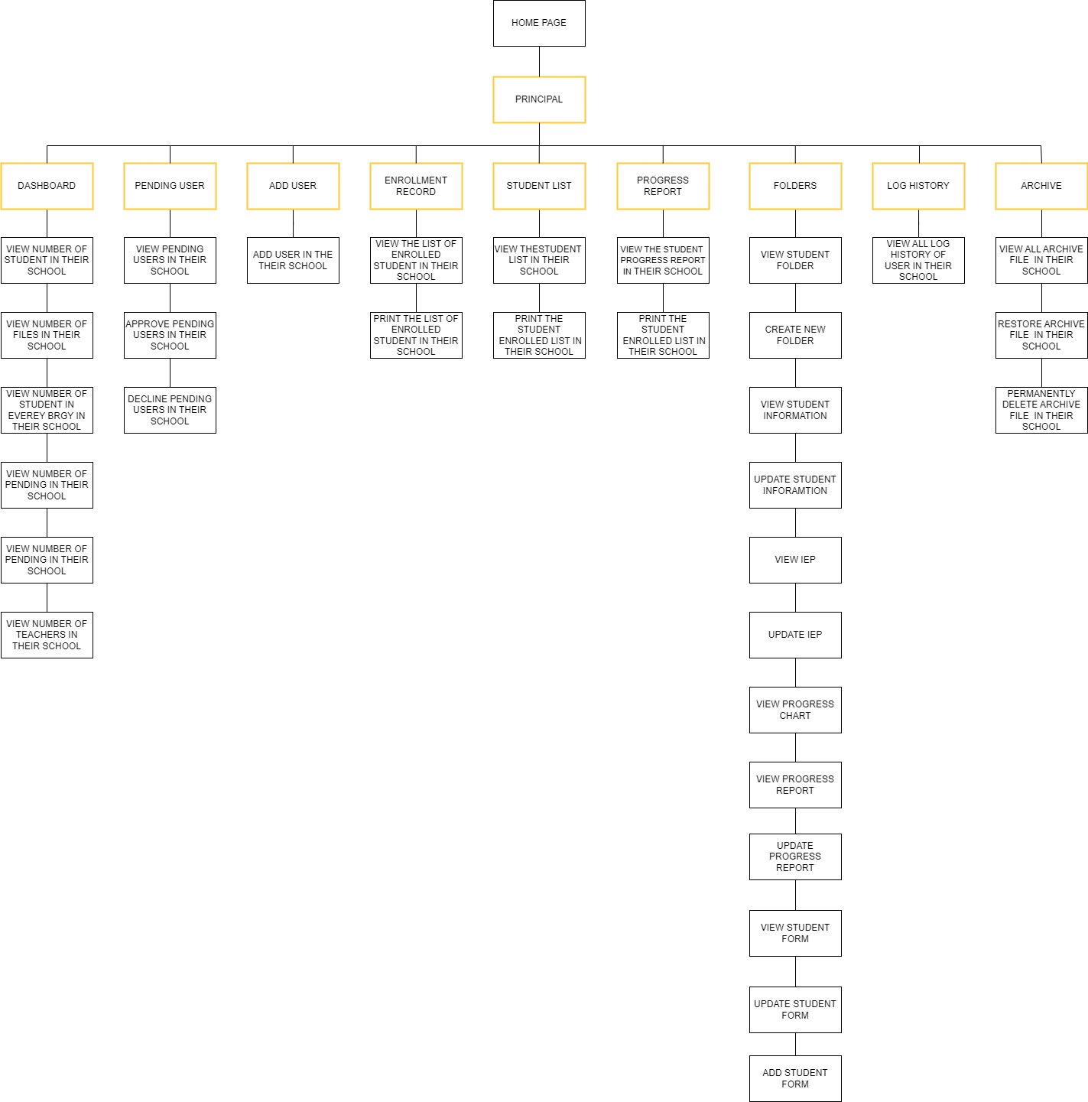

**Figure 60.** Principal HIPO. The figure above illustrates the module of the system hierarchy to show the system design in the Principal account.

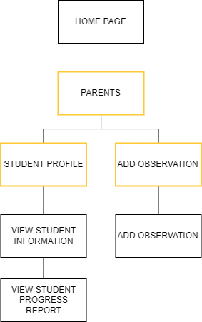

**Figure 60.** Parents HIPO. The figure above illustrates the module of the system hierarchy to show the system design in the Parents account.

**Hardware and Software Resources**

### Table 40. Hardware Requirements

|  |  |
| --- | --- |
| **HARDWARE REQUIREMENTS** | **Existing** |
| Laptop or Desktop Computer | Yes |
| RAM 4GB or Higher | Yes |
| Processor Intel Celeron or higher or any equivalent. | Yes |
| CPU (Intel/AMD Architecture) (64/86 bit) | Yes |
| Mobile Phone at least 2G ready | Yes |

The table above shows the hardware requirements needed to run TxTTOMS. The “Existing” column shall be filled with “Yes” if the needed hardware is existing in the client's store and “No” if not. Based on the interviews the clients stated that they have these required hardware.

### Table 41. Software Requirements

|  |  |
| --- | --- |
| **SOFTWARE REQUIREMENTS** | **Existing** |
| Windows OS 7 or 10(32/64-bit) | Yes |
| Web Browser | Yes |
| Wi-Fi or Data Internet connection | Yes |
| Strong Cell Phone Signal | Yes |

The table above illustrates the software requirements needed to run TxTTOMS. The “Existing” column shall be filled with “Yes” if the needed software is existing in the client's device and “No” if not. Based on the interviews the clients stated that they have these required software.

**Input, Output, Reports Screenshots**

**Input Screenshot**

Teacher’s Login

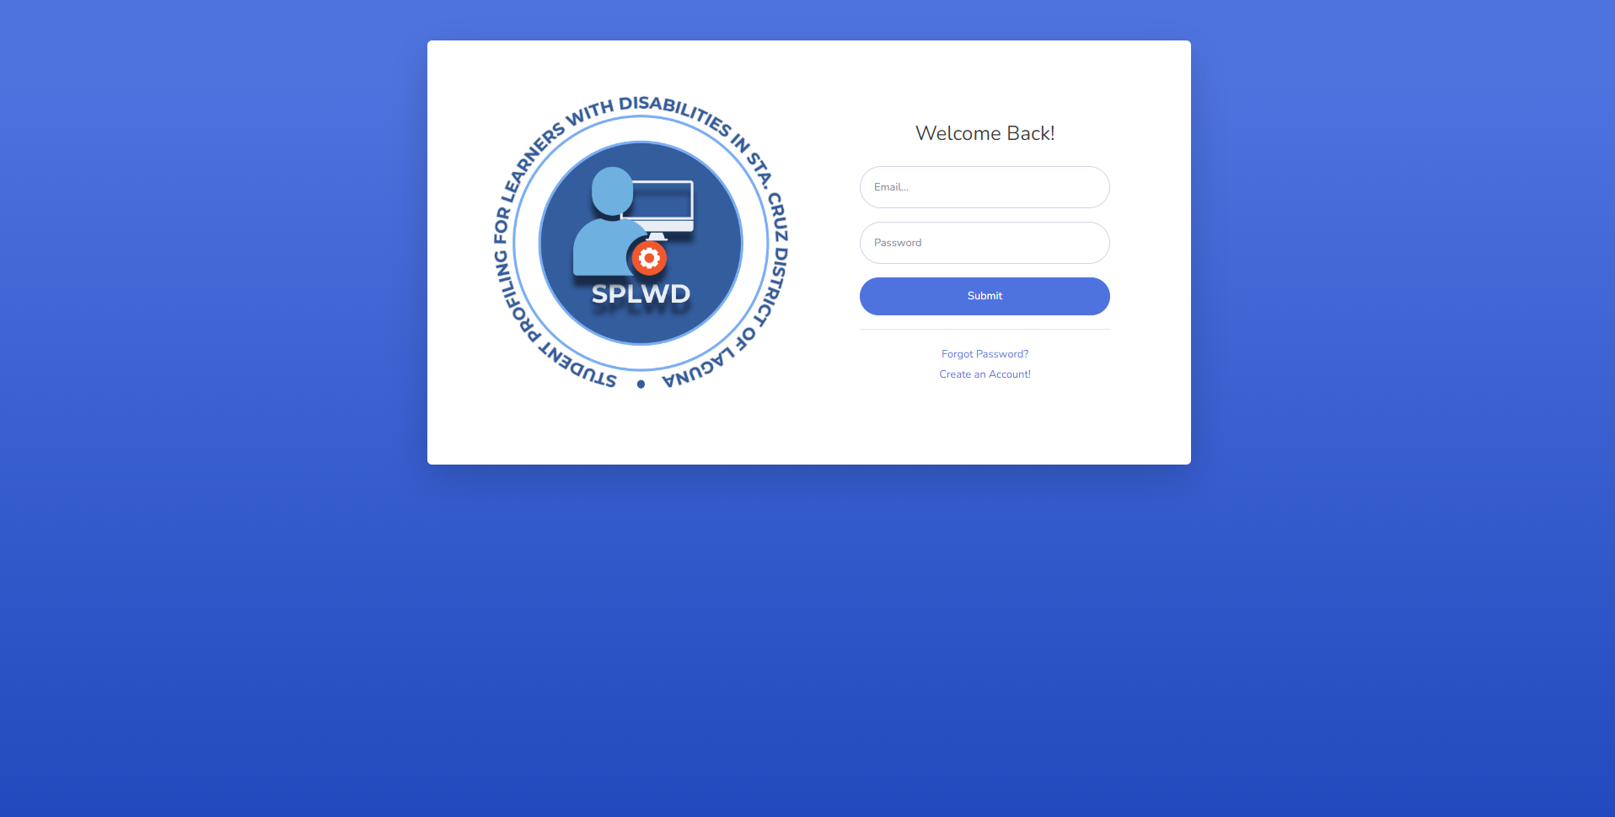

Teacher’s Update Information

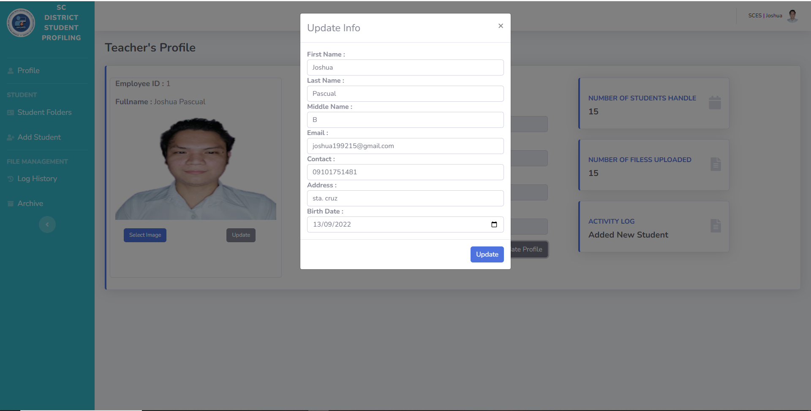

Update Enrollment Status

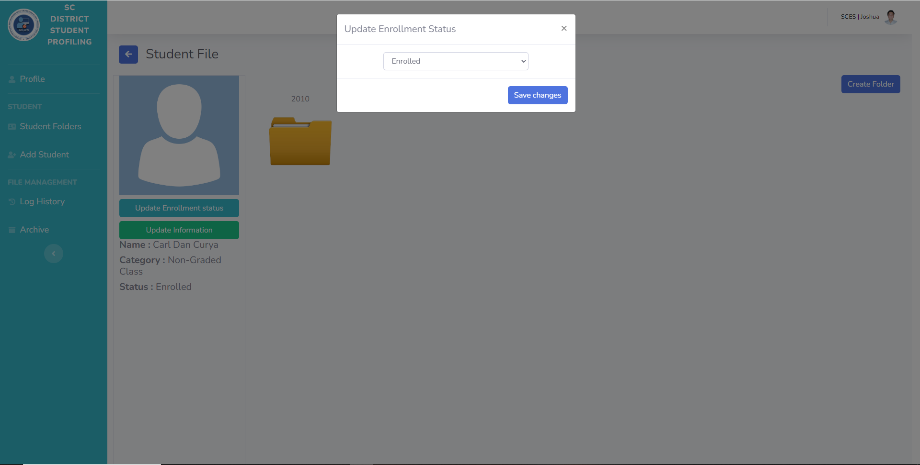

Update Student Information

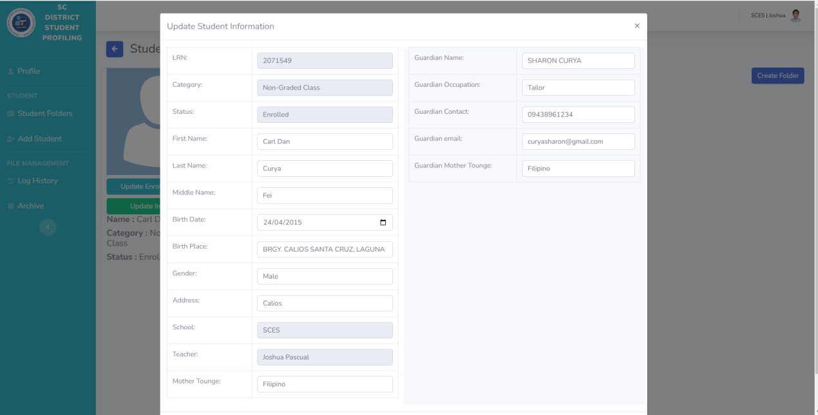

Update Student IEP

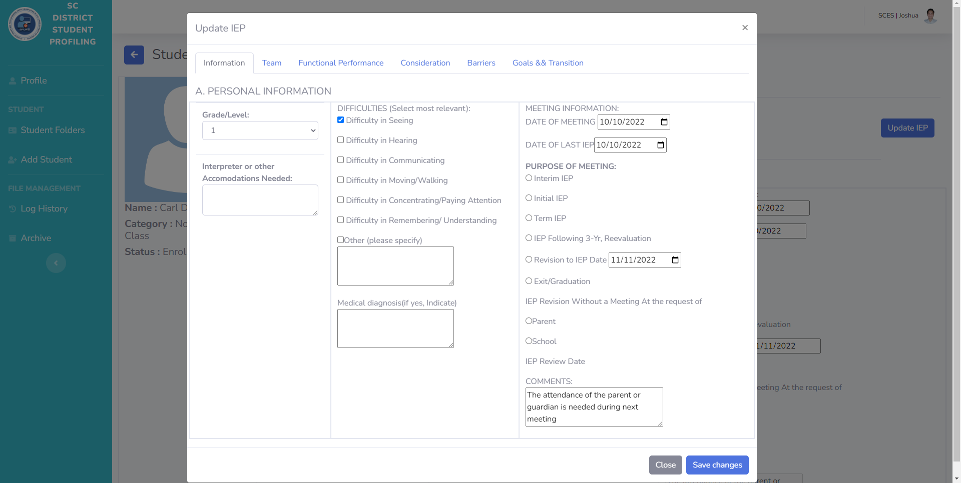

Update Student Progress Report

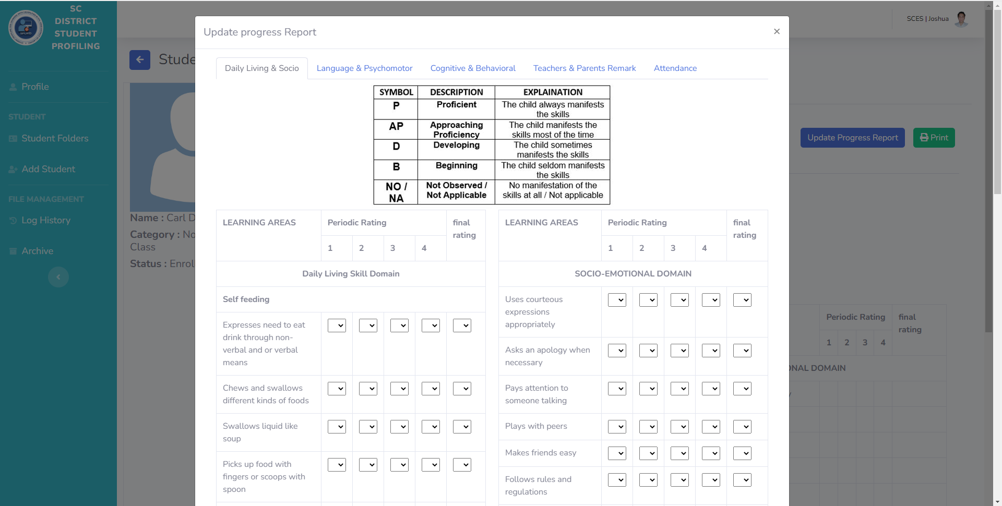

Upload Student File

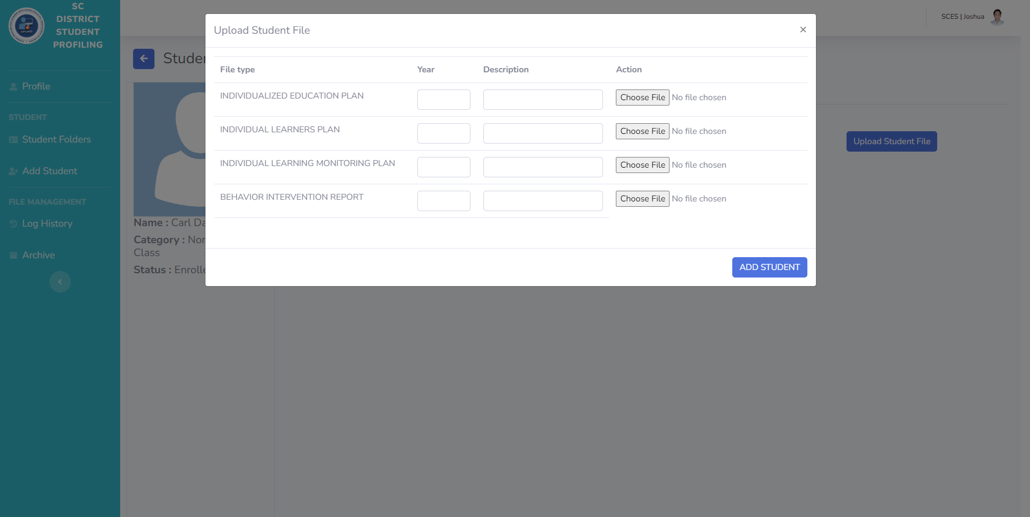

Add Student IEP

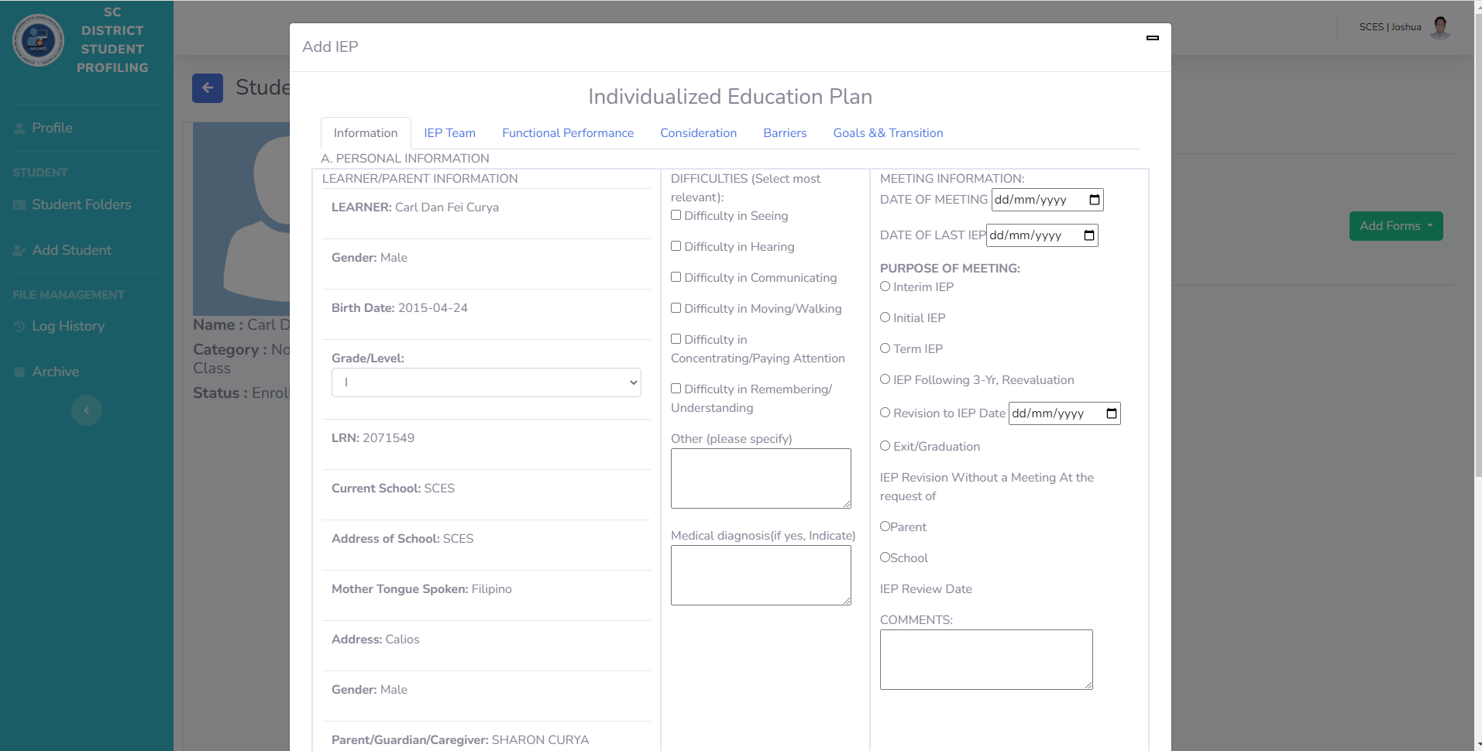

Add Student ILP

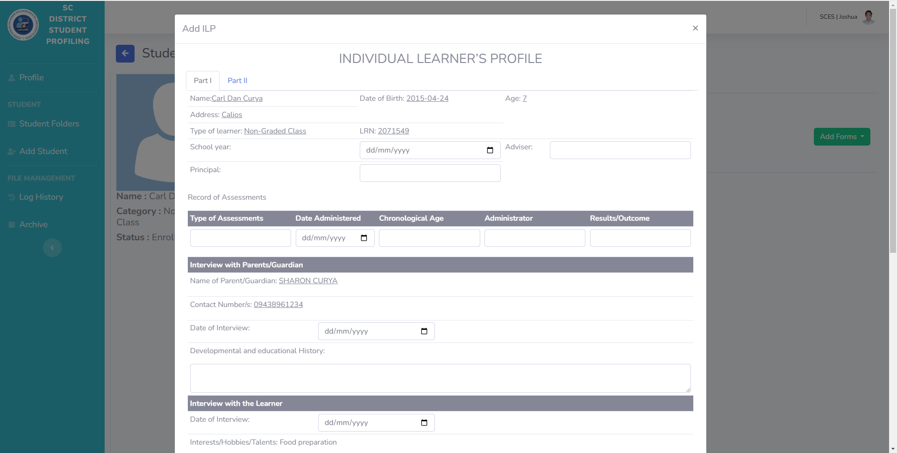

Add Student ILMP

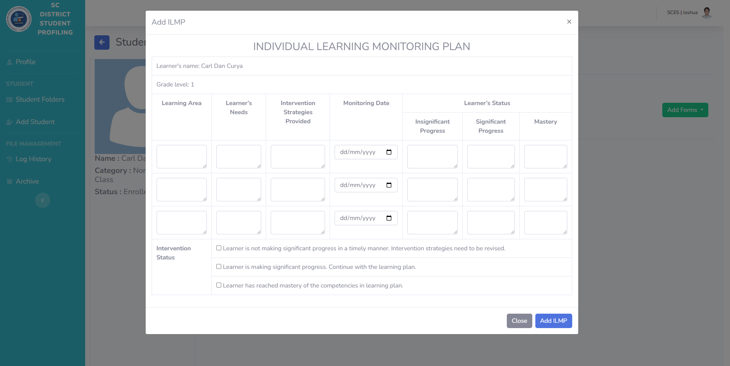

**Add Student BIR**

Add New Student

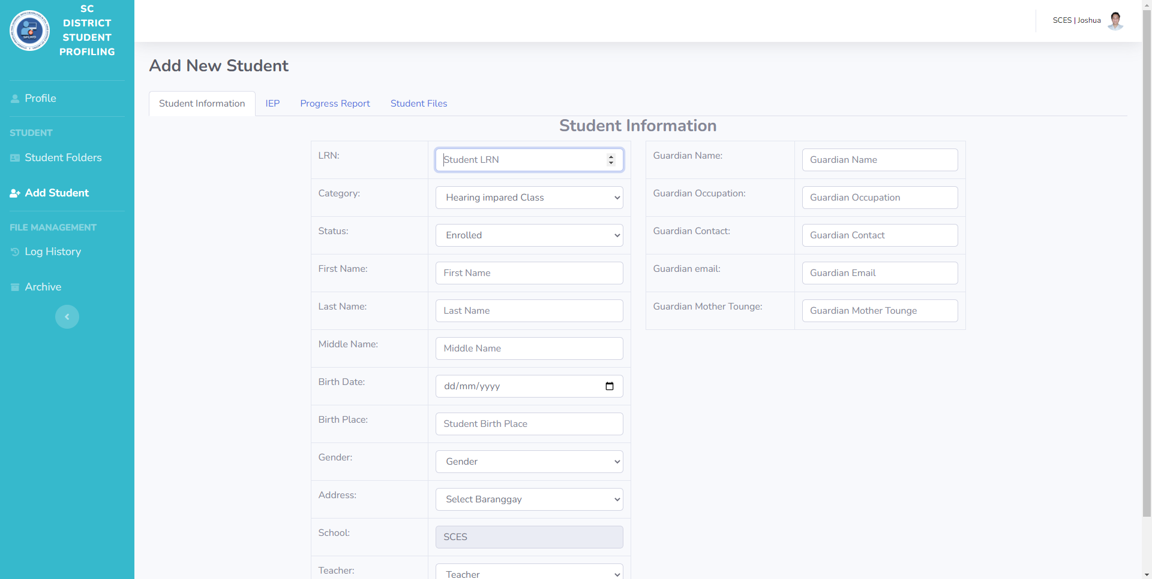

**Principal’s Add Users Account**

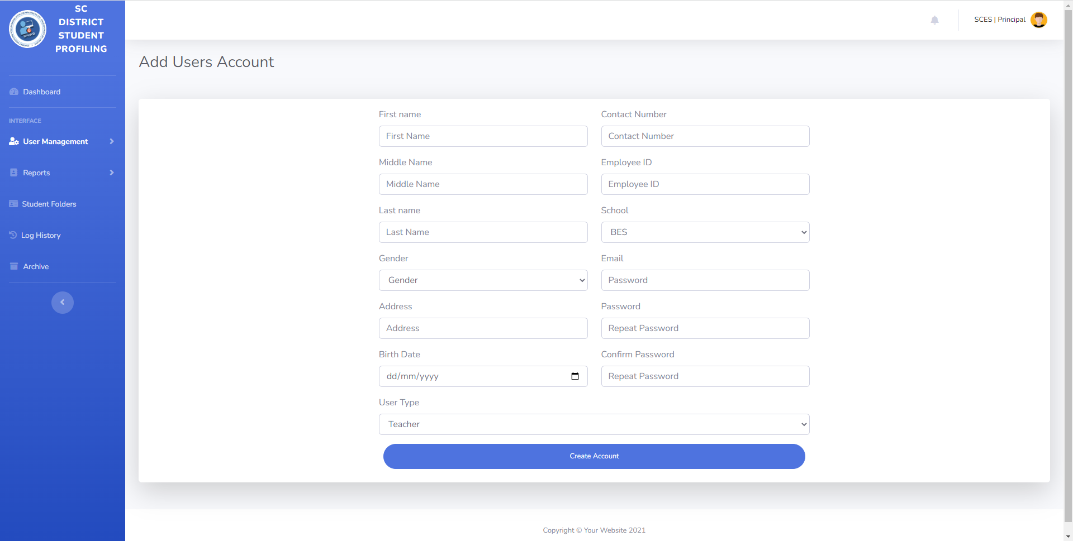

**Secretary’s Add Users Account**

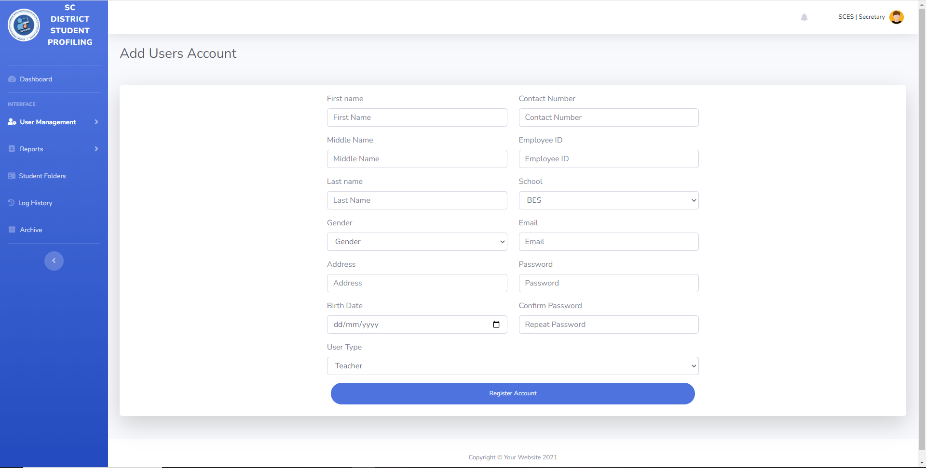

**Transfer Student**

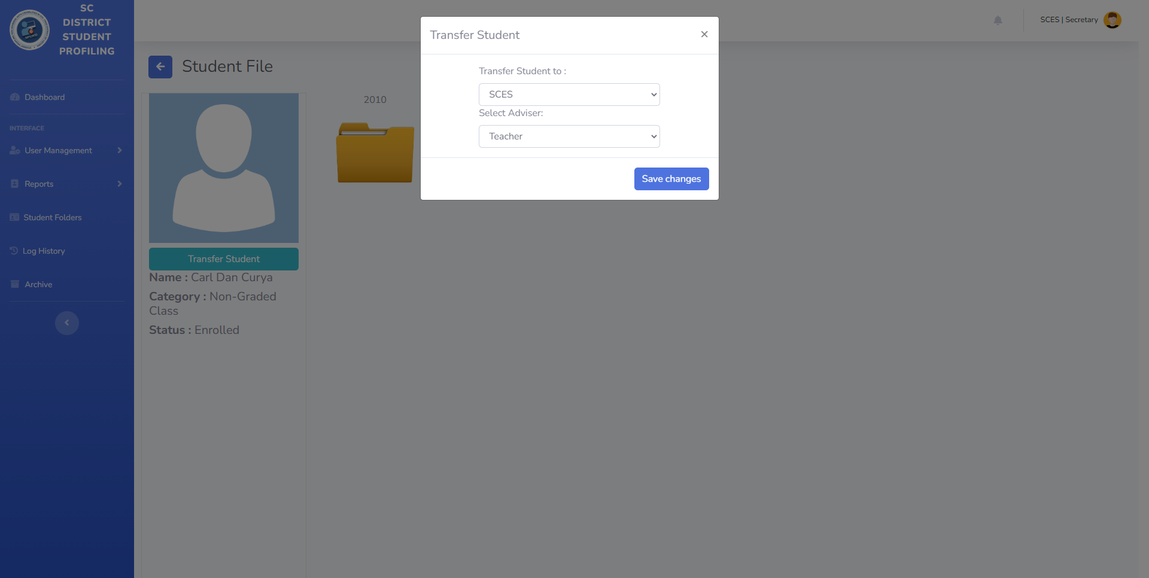

**Parent’s Add Student Observation**

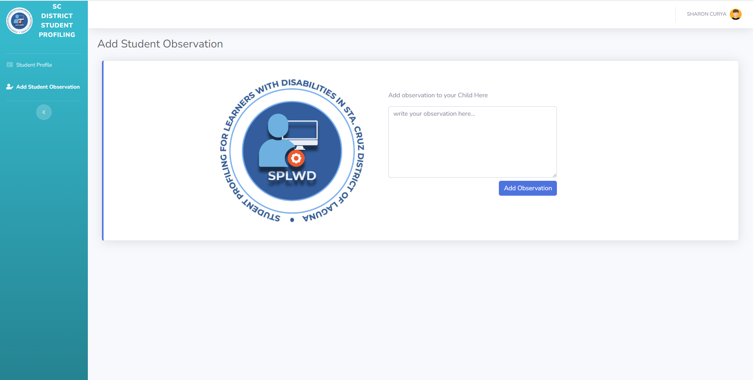

**Output Screenshot**

Teacher’s Profile

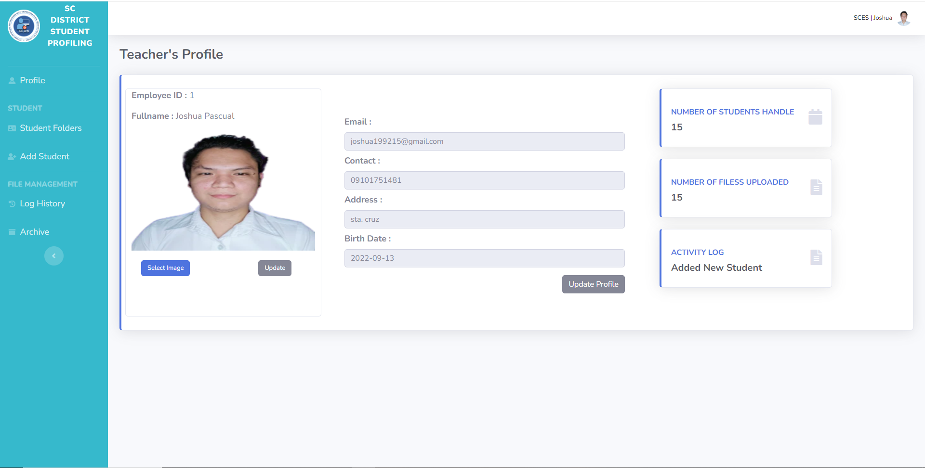

Student Folders

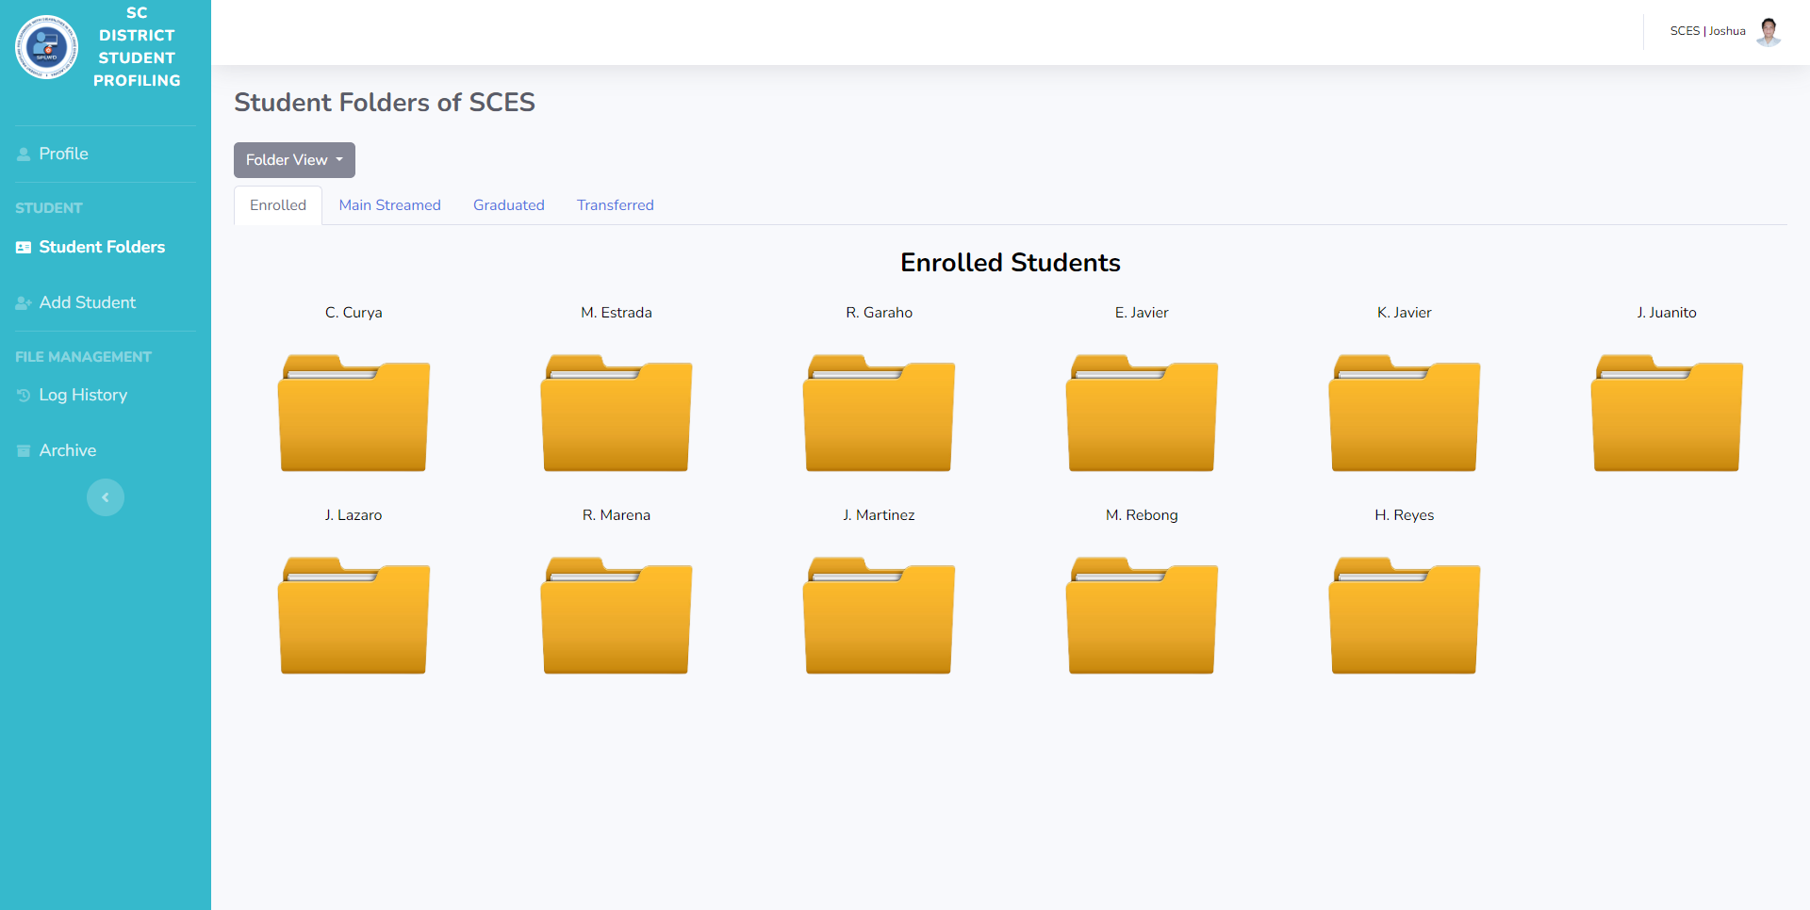

Table View of Student Folders

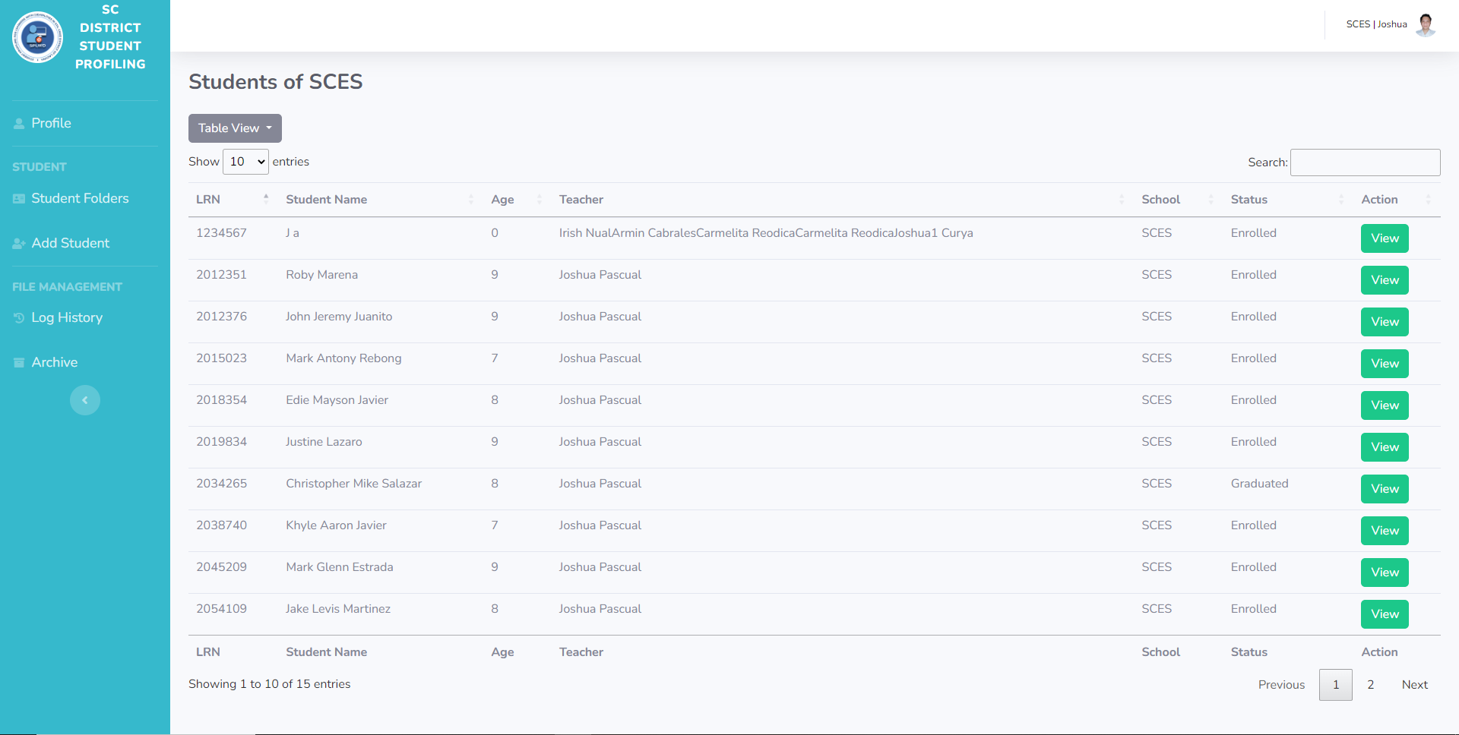

Teacher’s Log History

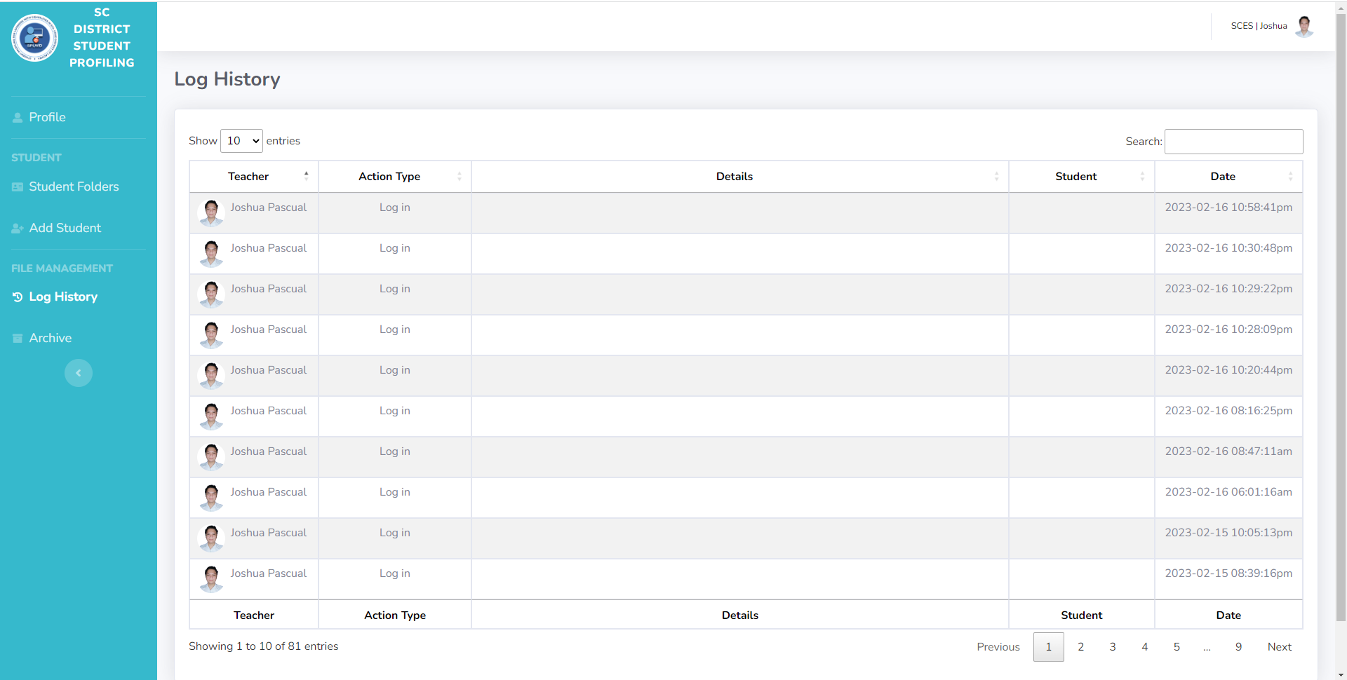

**Teacher’s Archive Files**

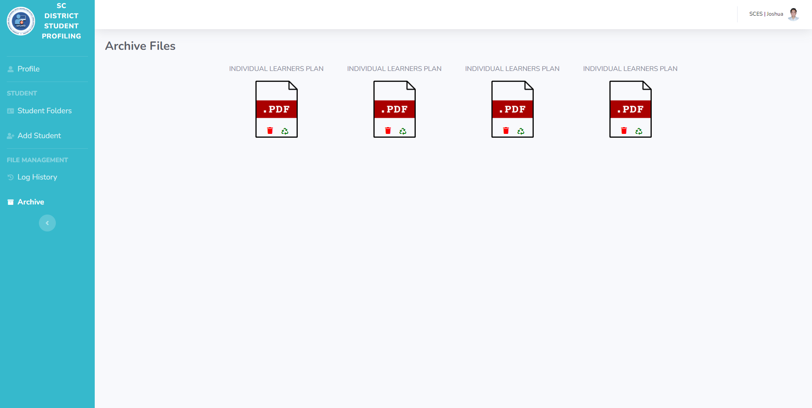

Secretary’s Dashboard

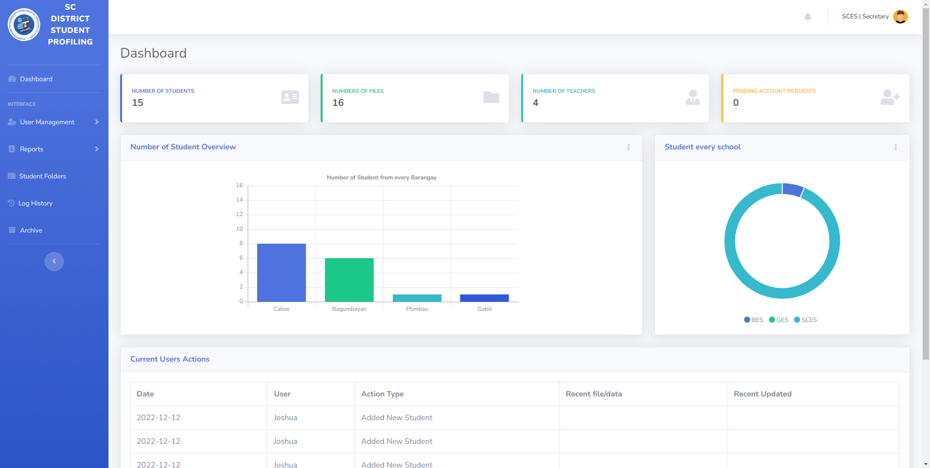

**Secretary’s Pending Users**

**Student’s Enrollment List**

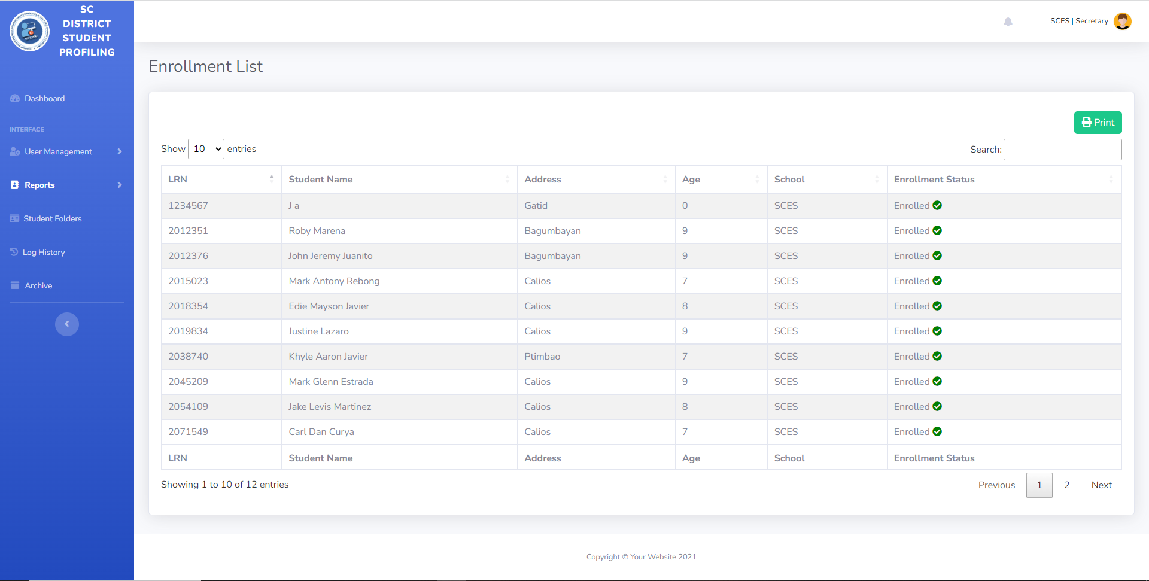

View Progress Report

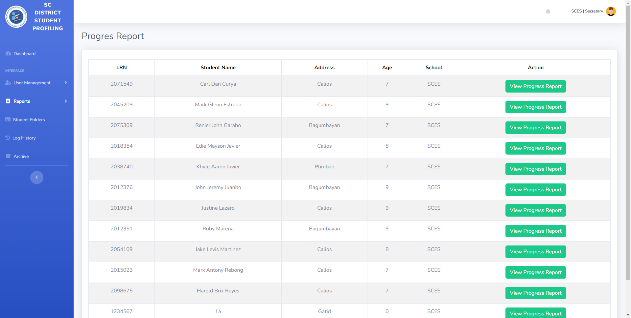

Secretary’s Student List

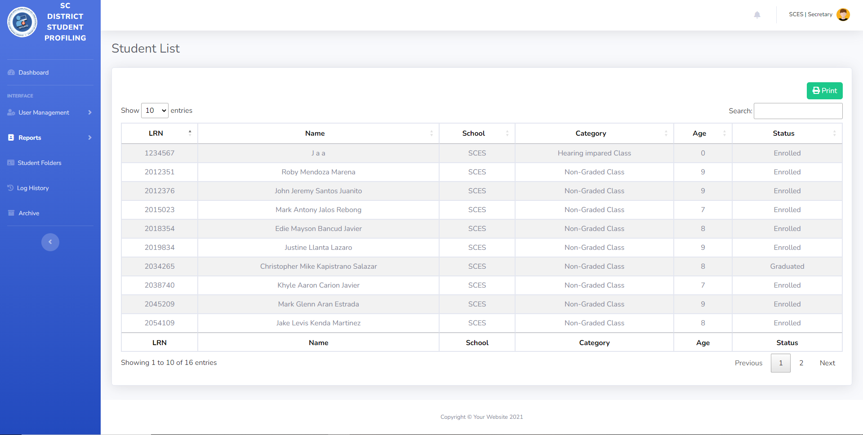

**Secretary’s Student Folders**

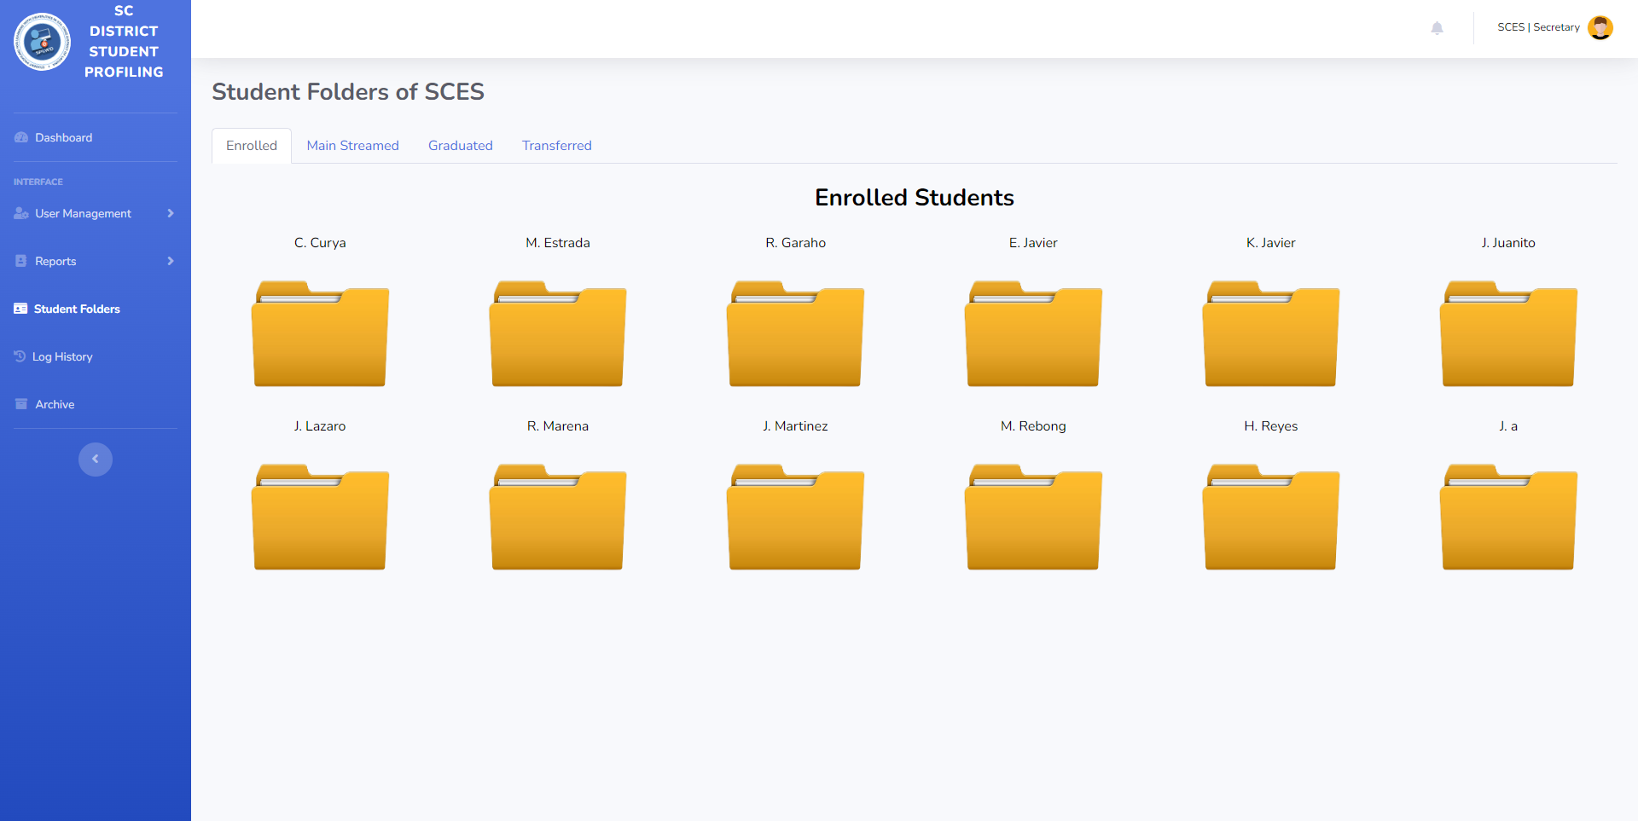

**Secretary’s Student File**

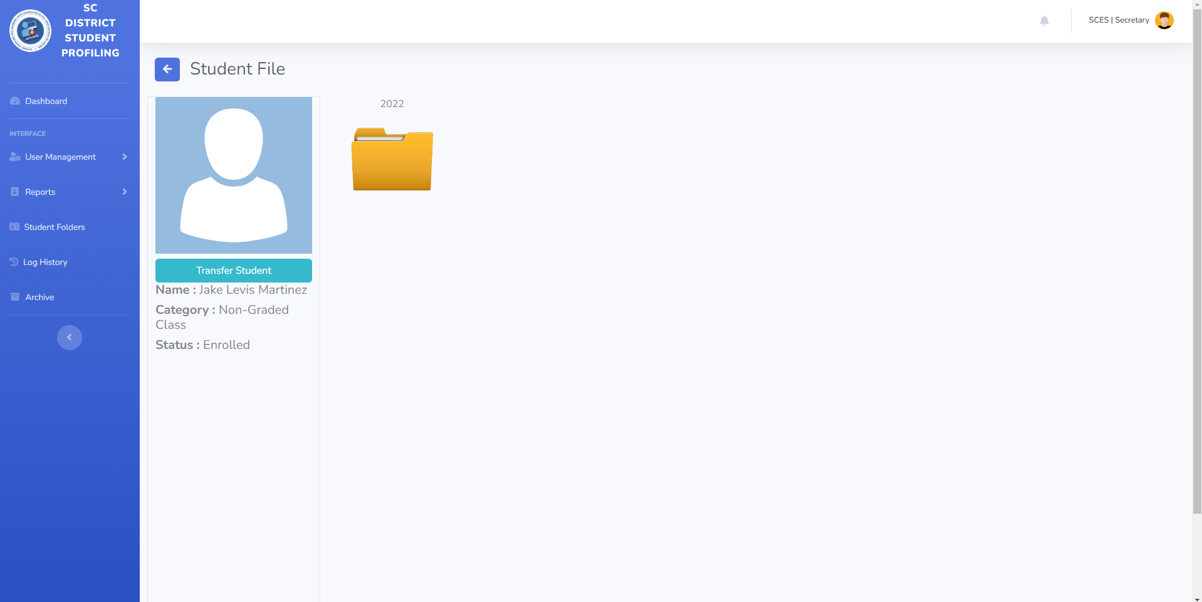

**Secretary’s Student IEP**

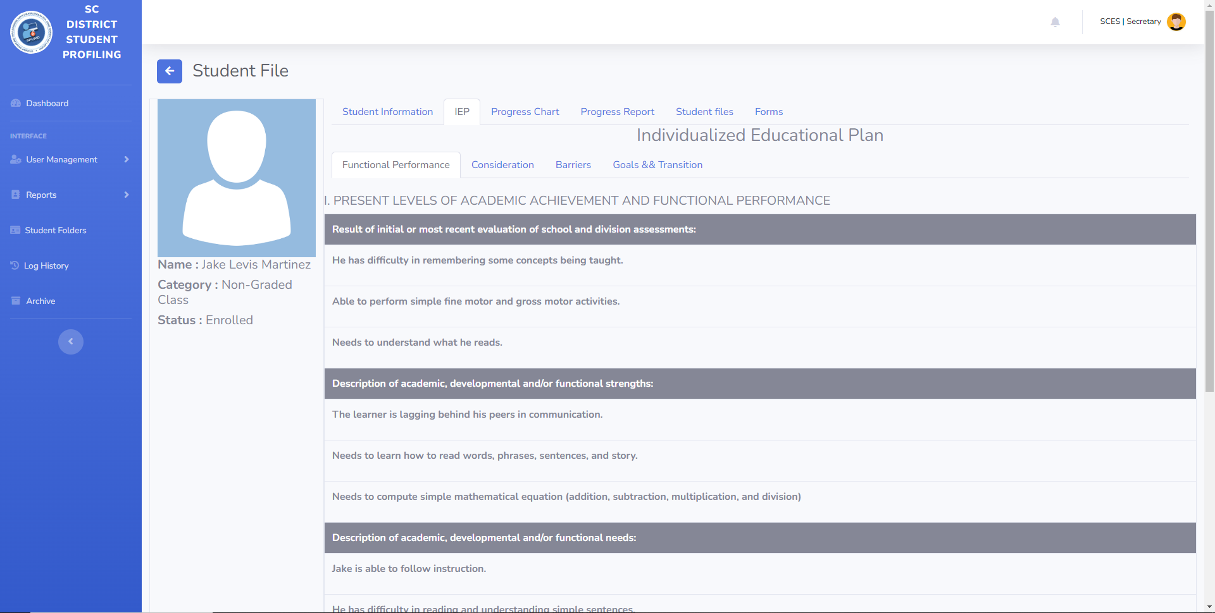

**Secretary’s Progress Chart**

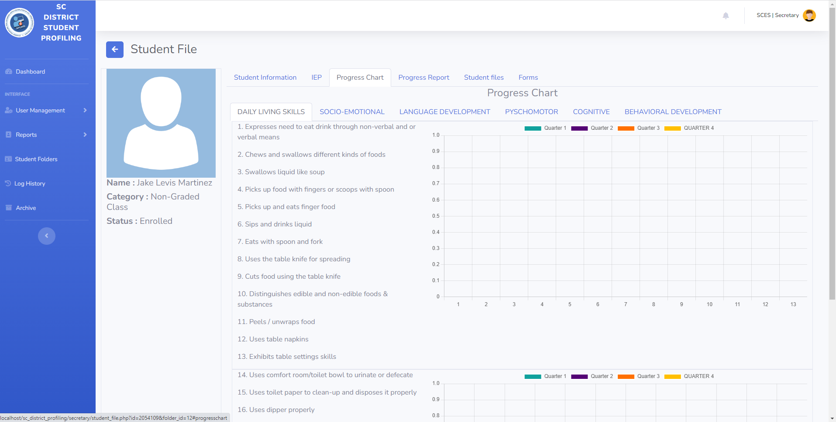

**Secretary’s Progress Report**

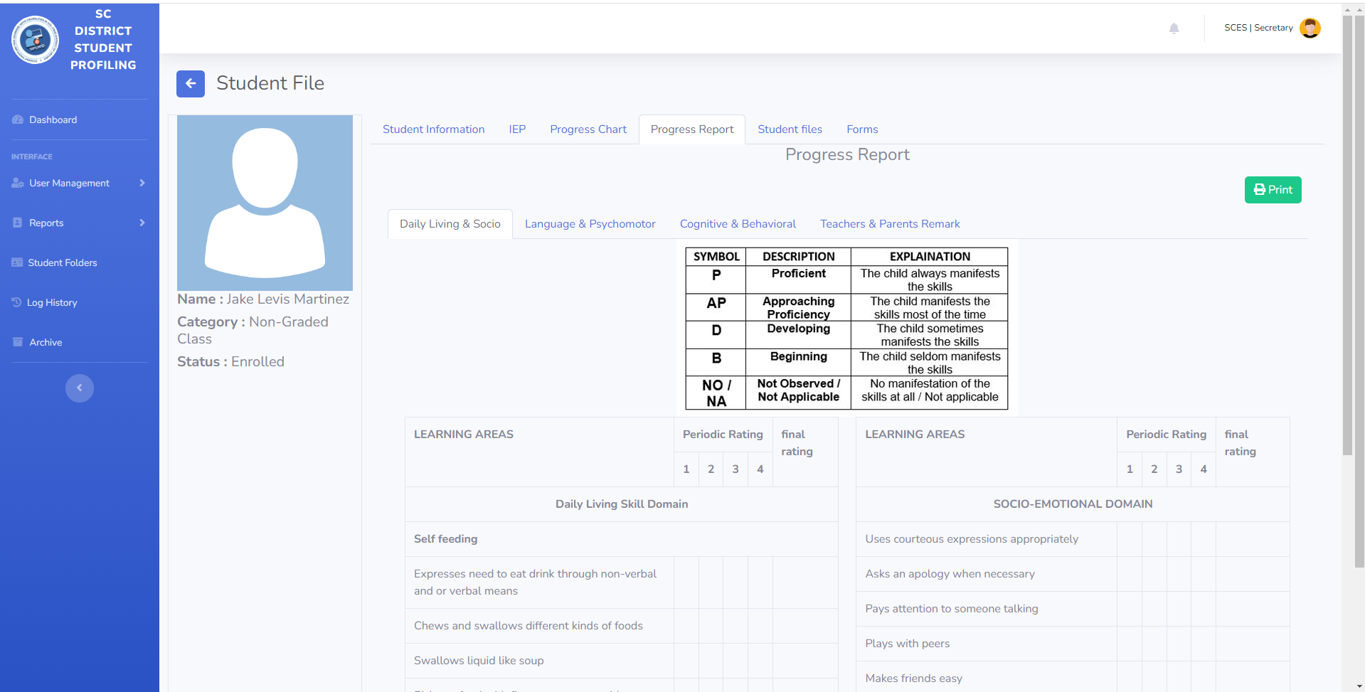

**Secretary’s Student File**

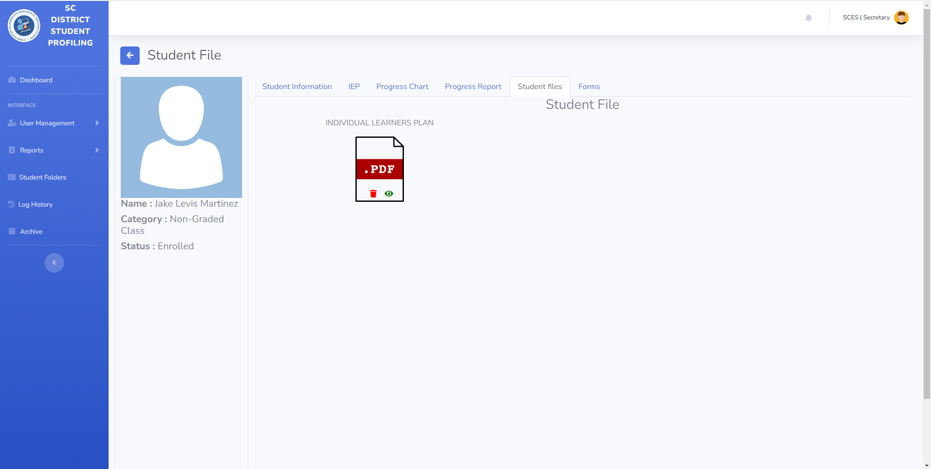

**Secretary’s Student Forms**

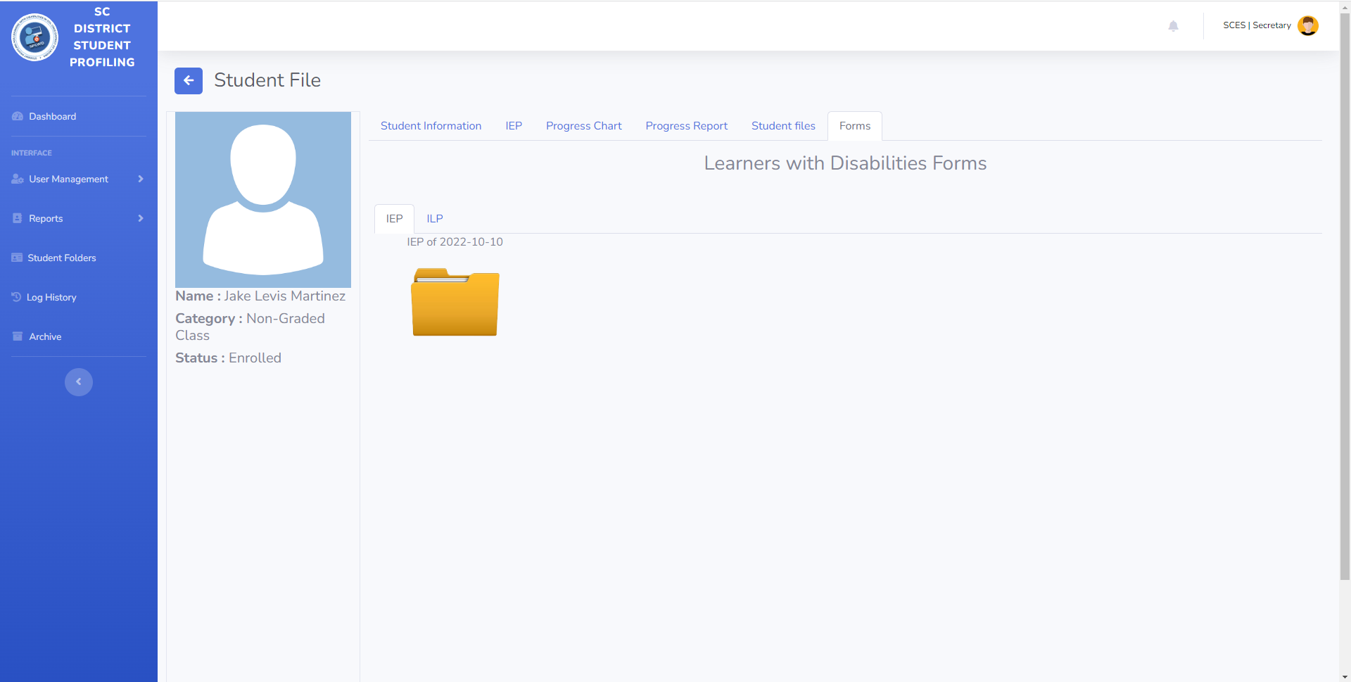

**Secretary’s Student Information**

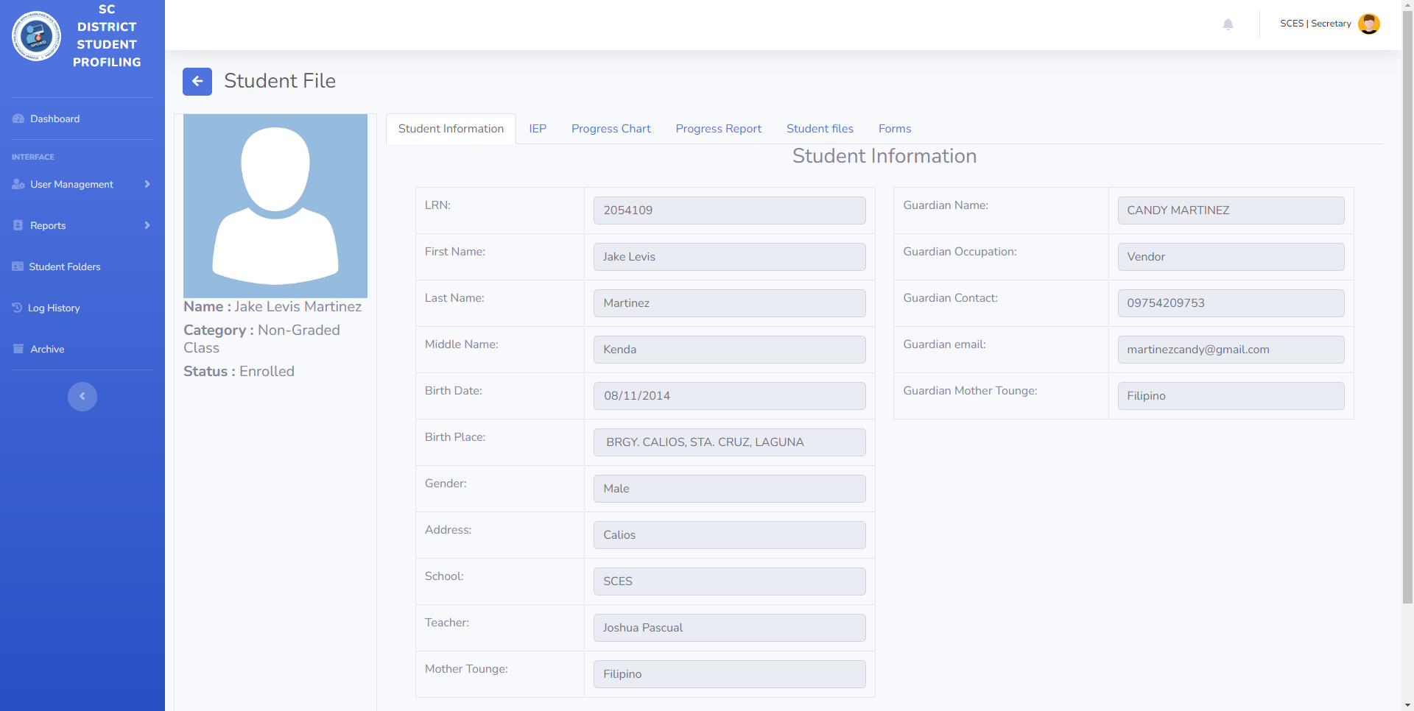

**Secretary’s Log History**

**Secretary’s Archive Files**

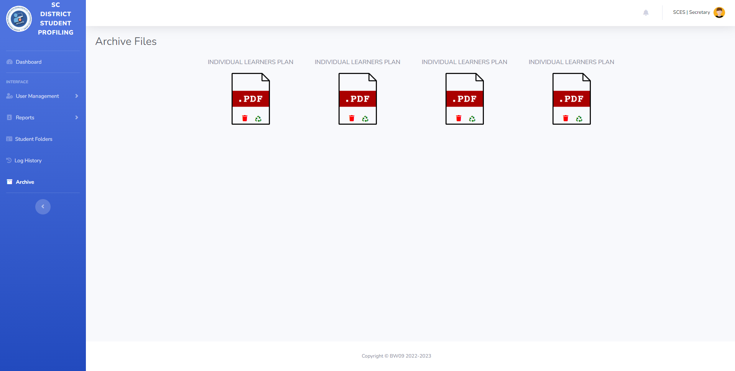

Principal’s Dashboard

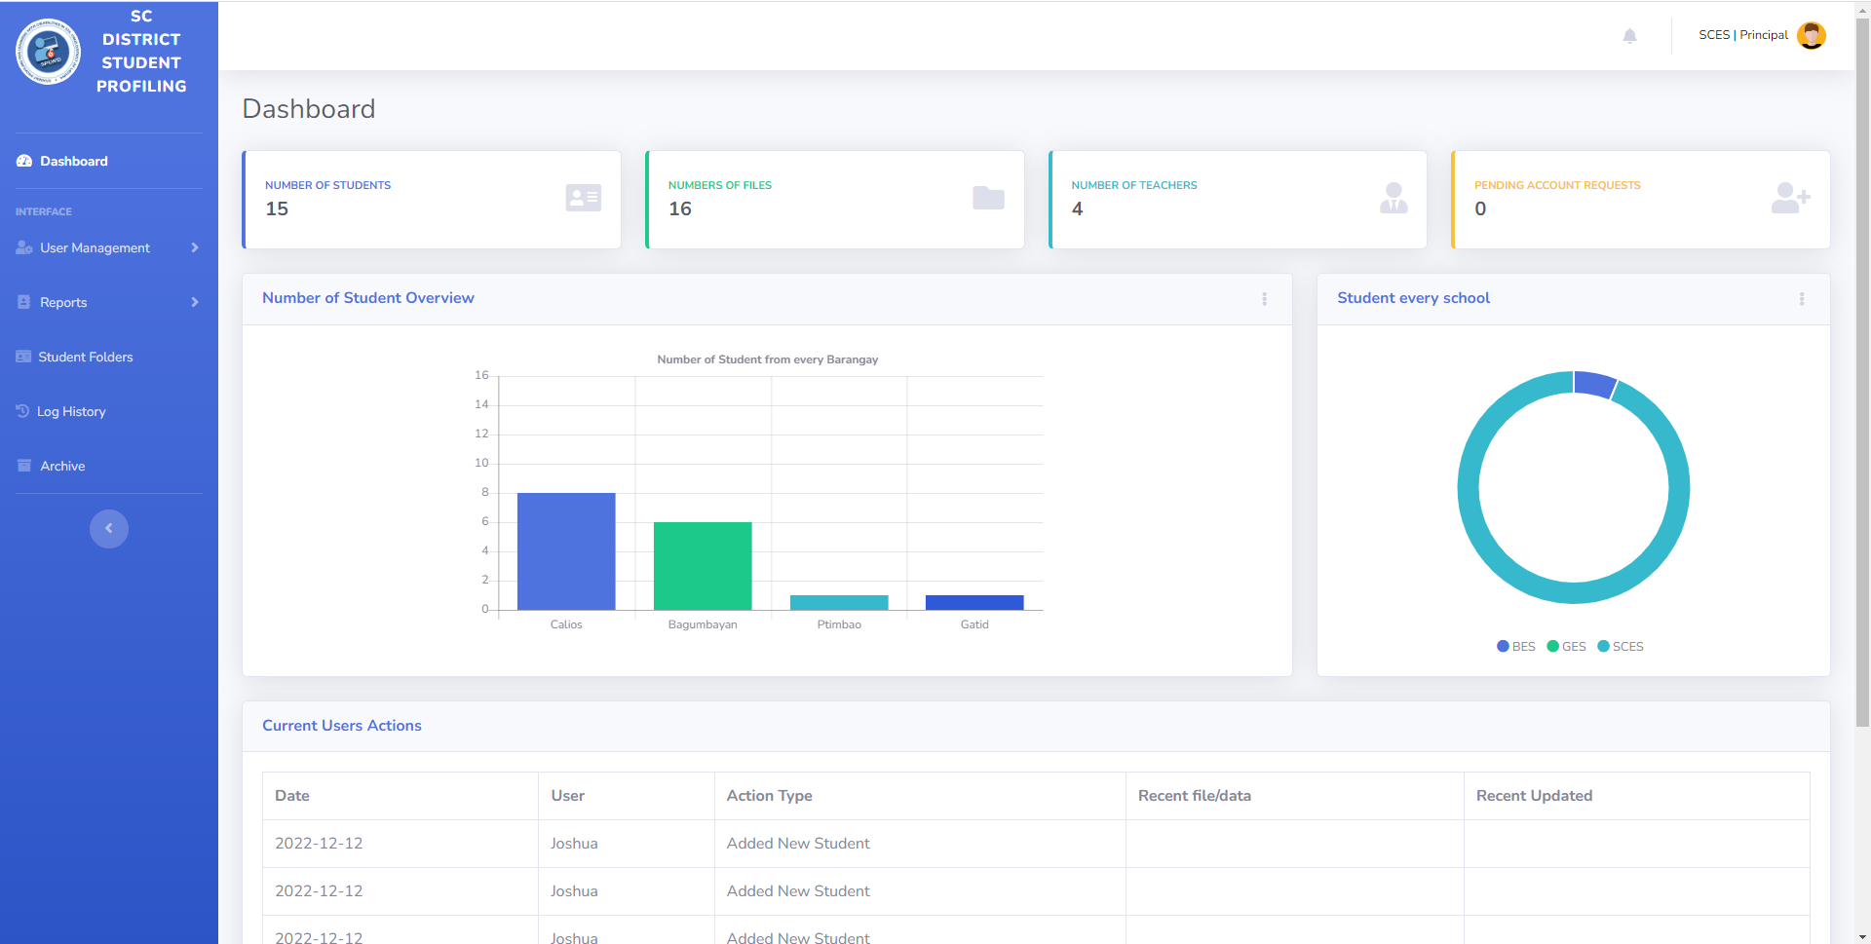

Principal’s Enrollment List

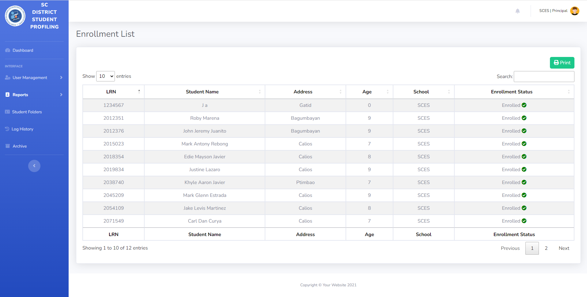

Principal’s Progress Report

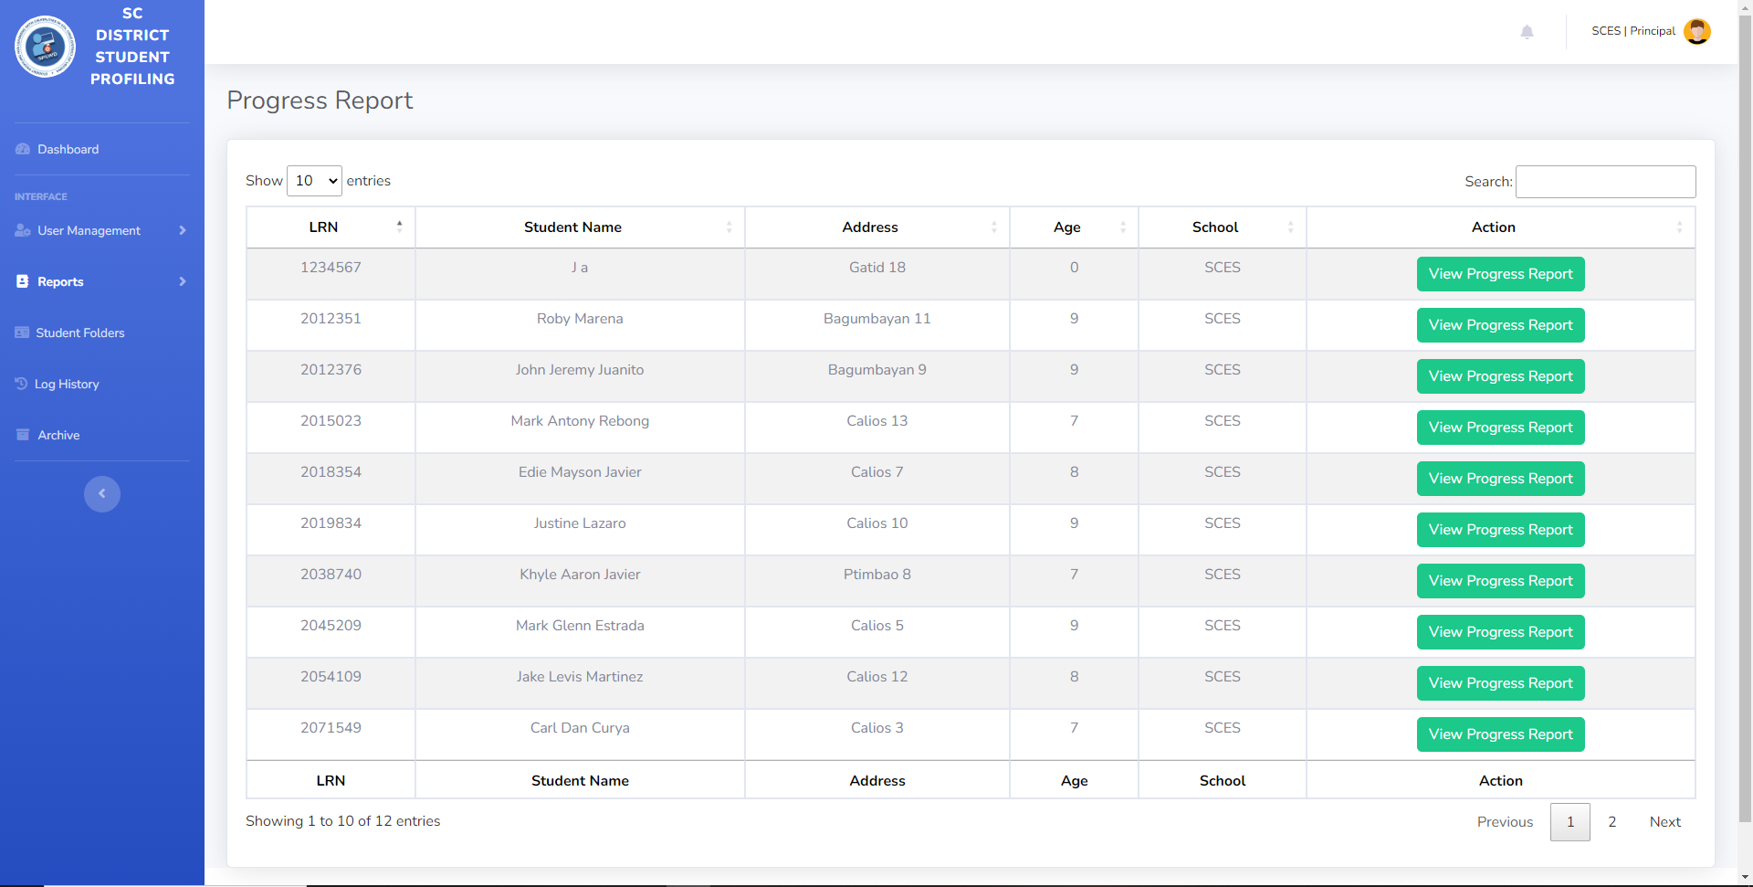

Principal’s Student List

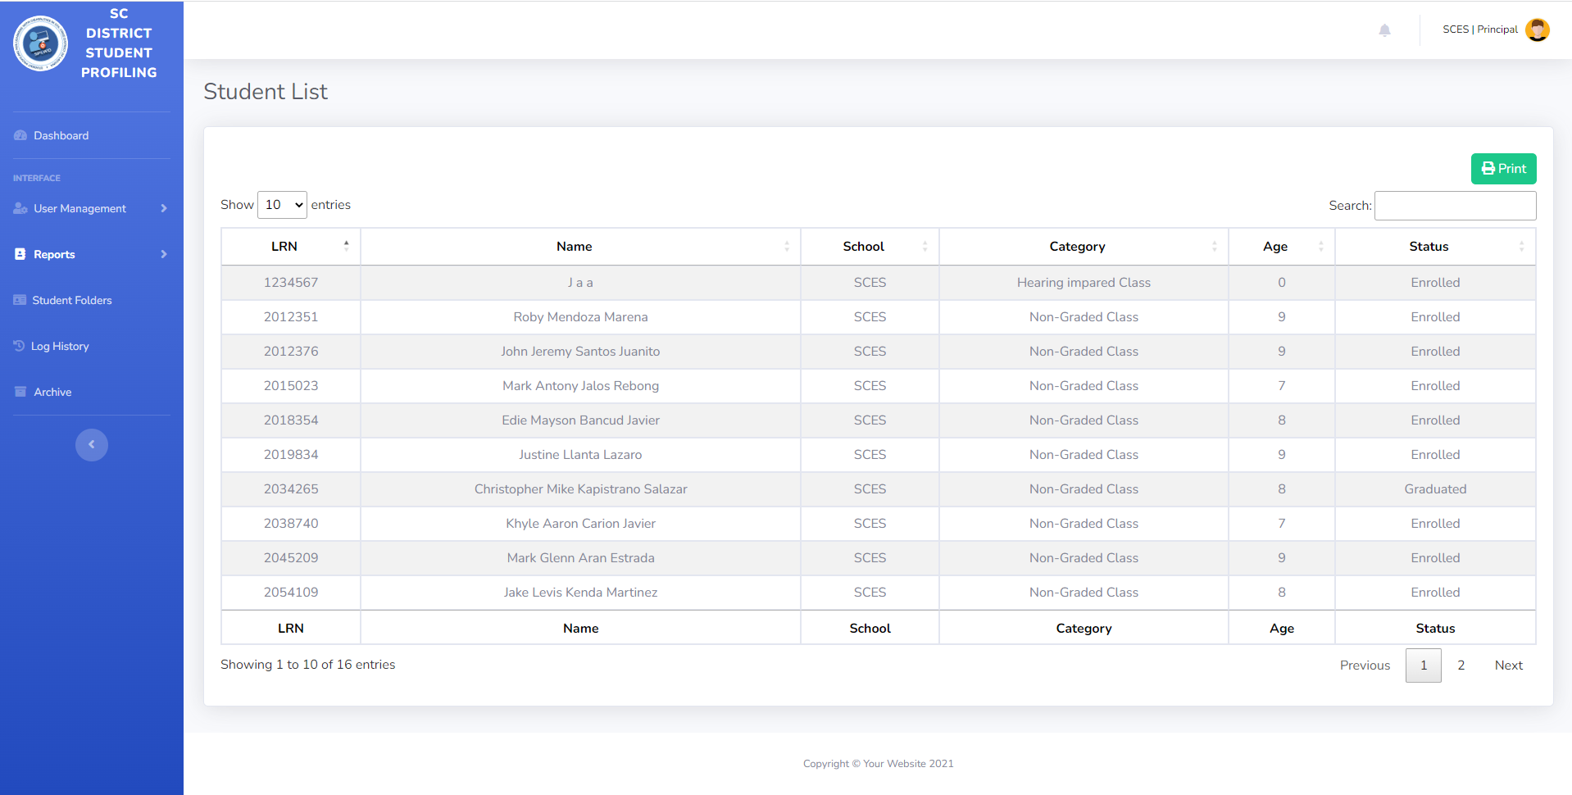

**Principal’s Pending Users**

**Principal’s Student Folders**

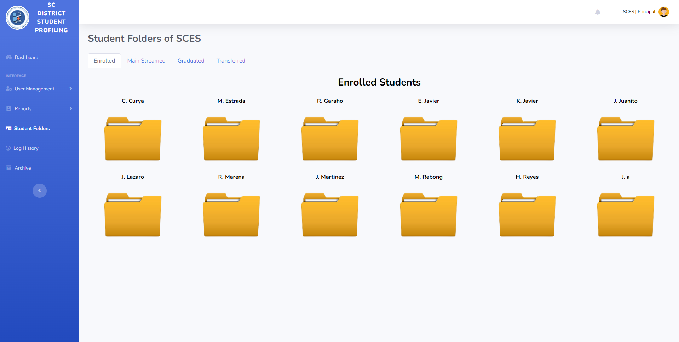

**Principal’s Student File**

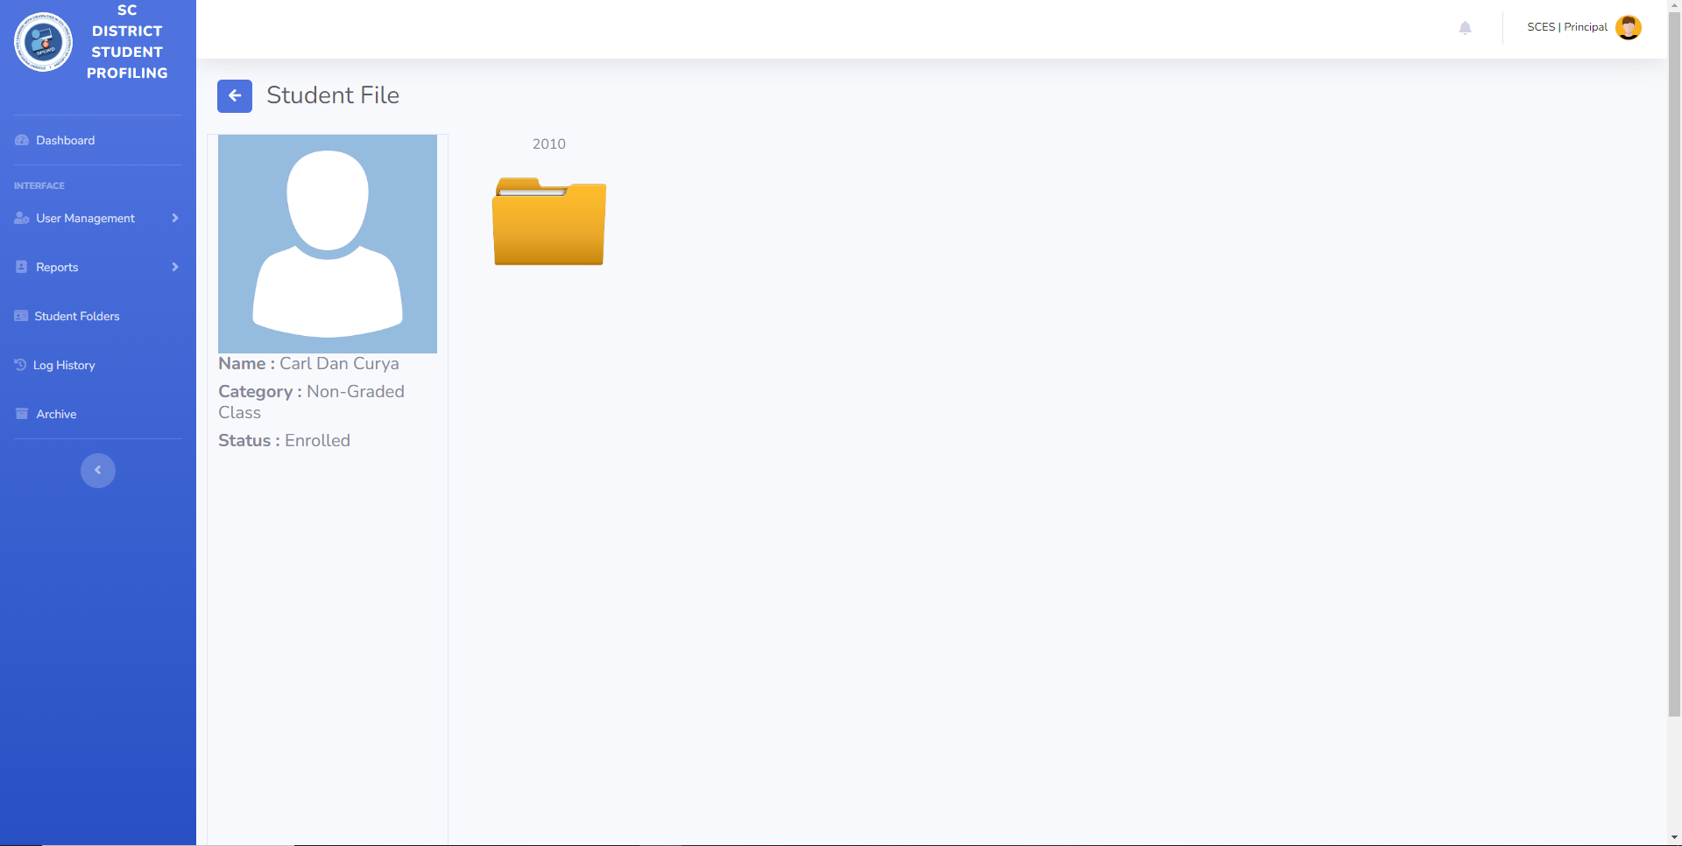

**Principal’s Student Information**

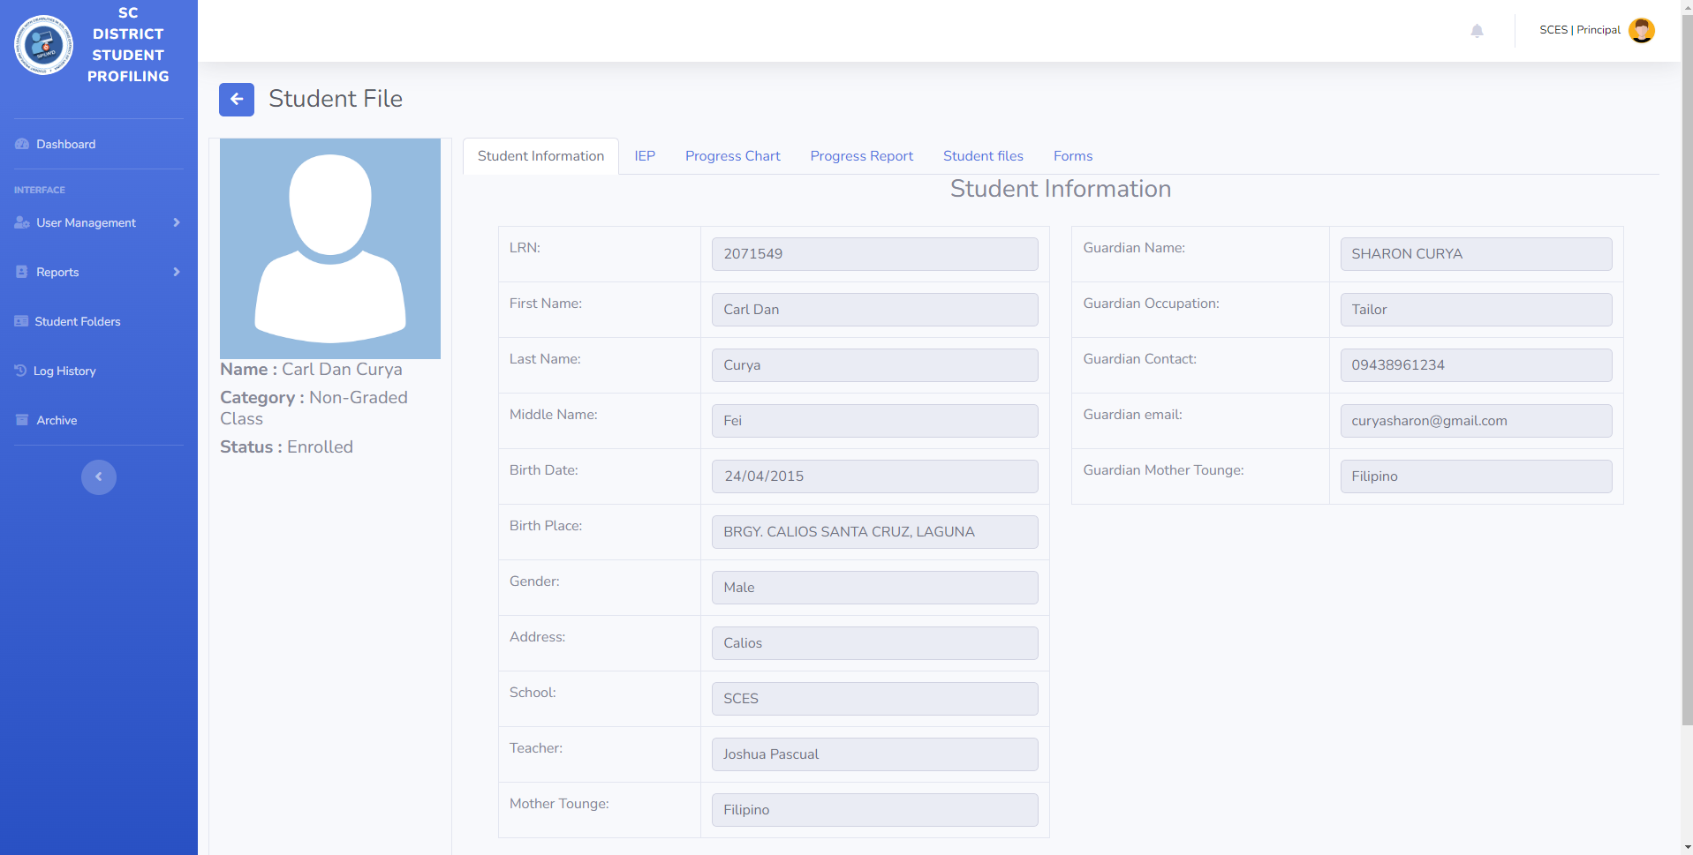

**Principla’s Student IEP**

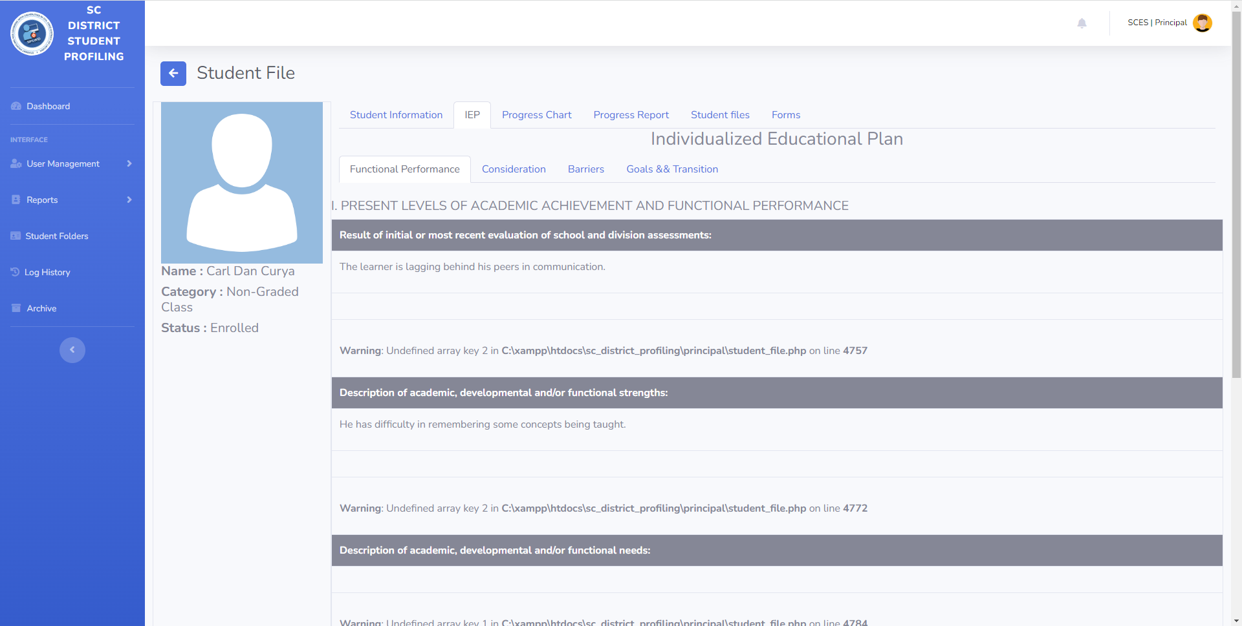

**Principal’s Student Progress Chart**

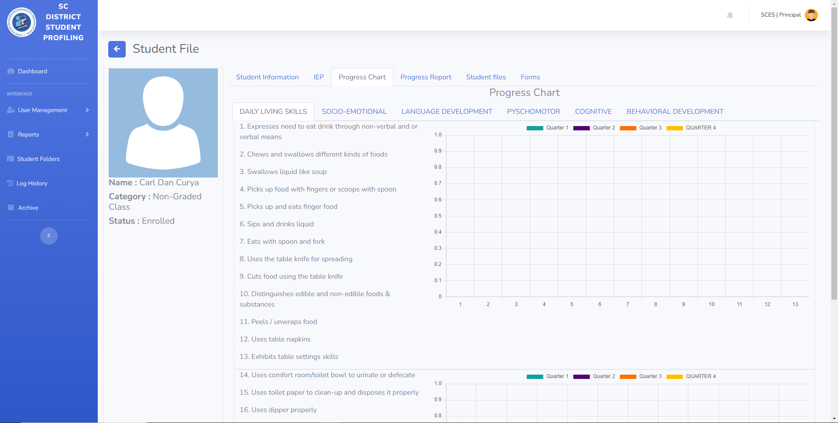

**Principal’s Student Progress Report**

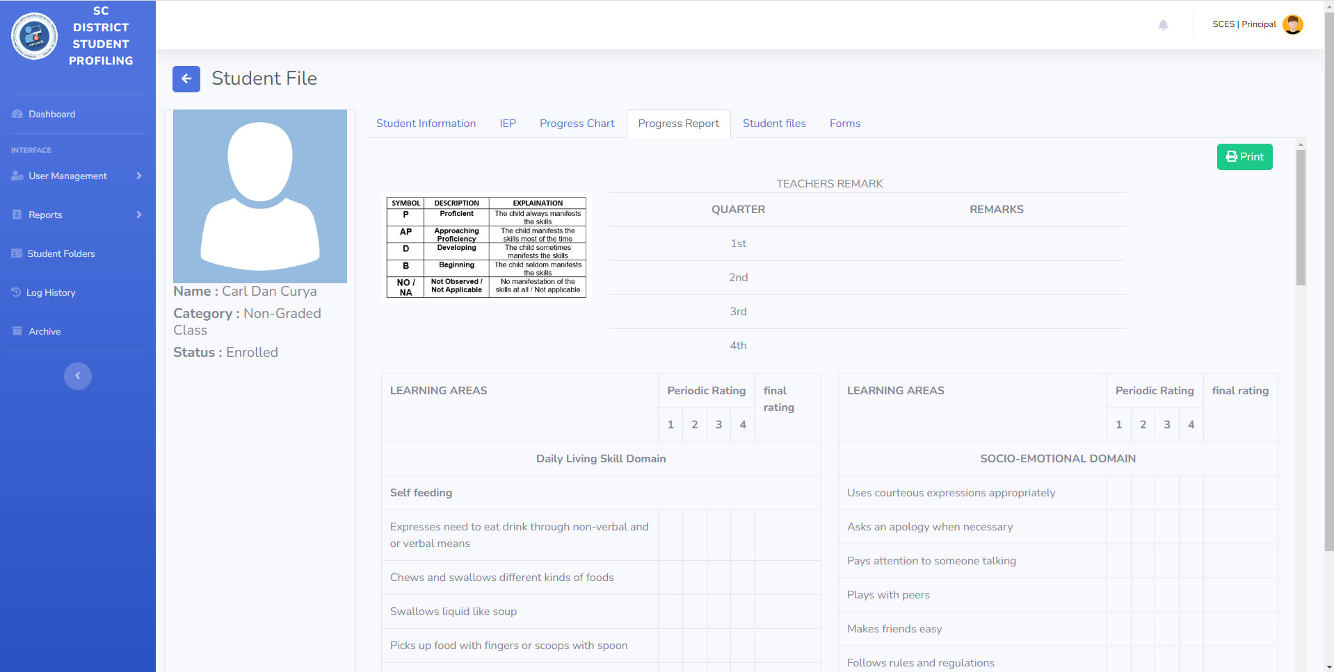

**Principal’s Student Files**

**Principal’s LWD Forms**

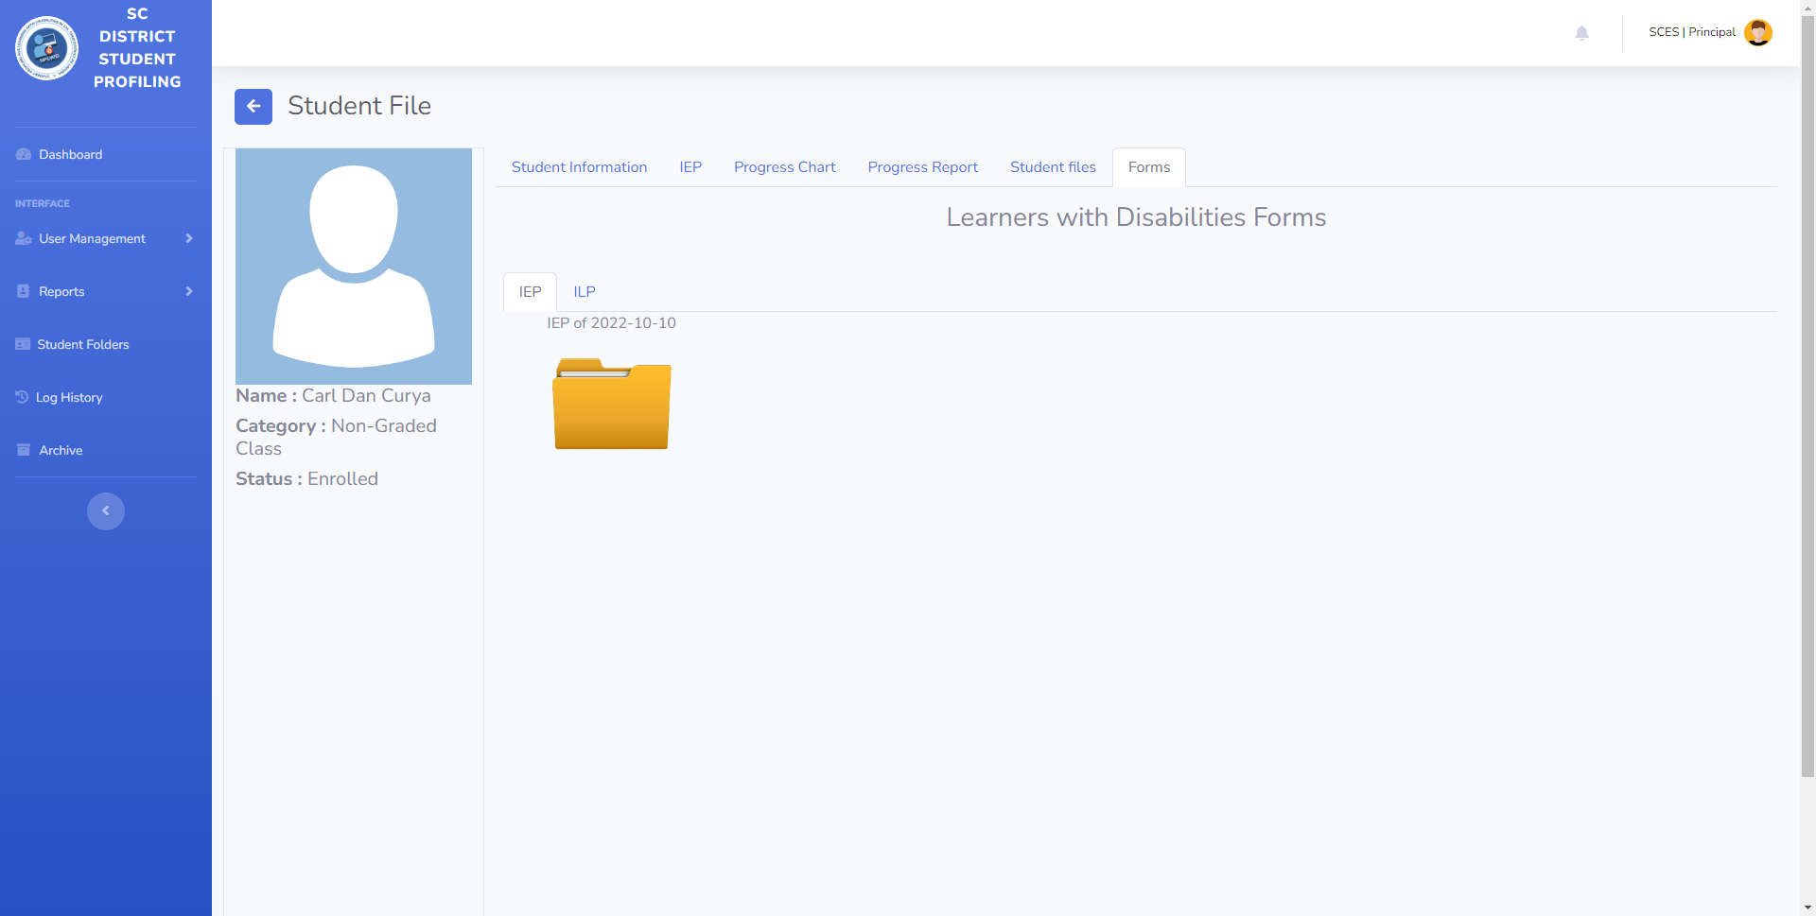

**Principal’s Log History**

**Principal’s Archive Files**

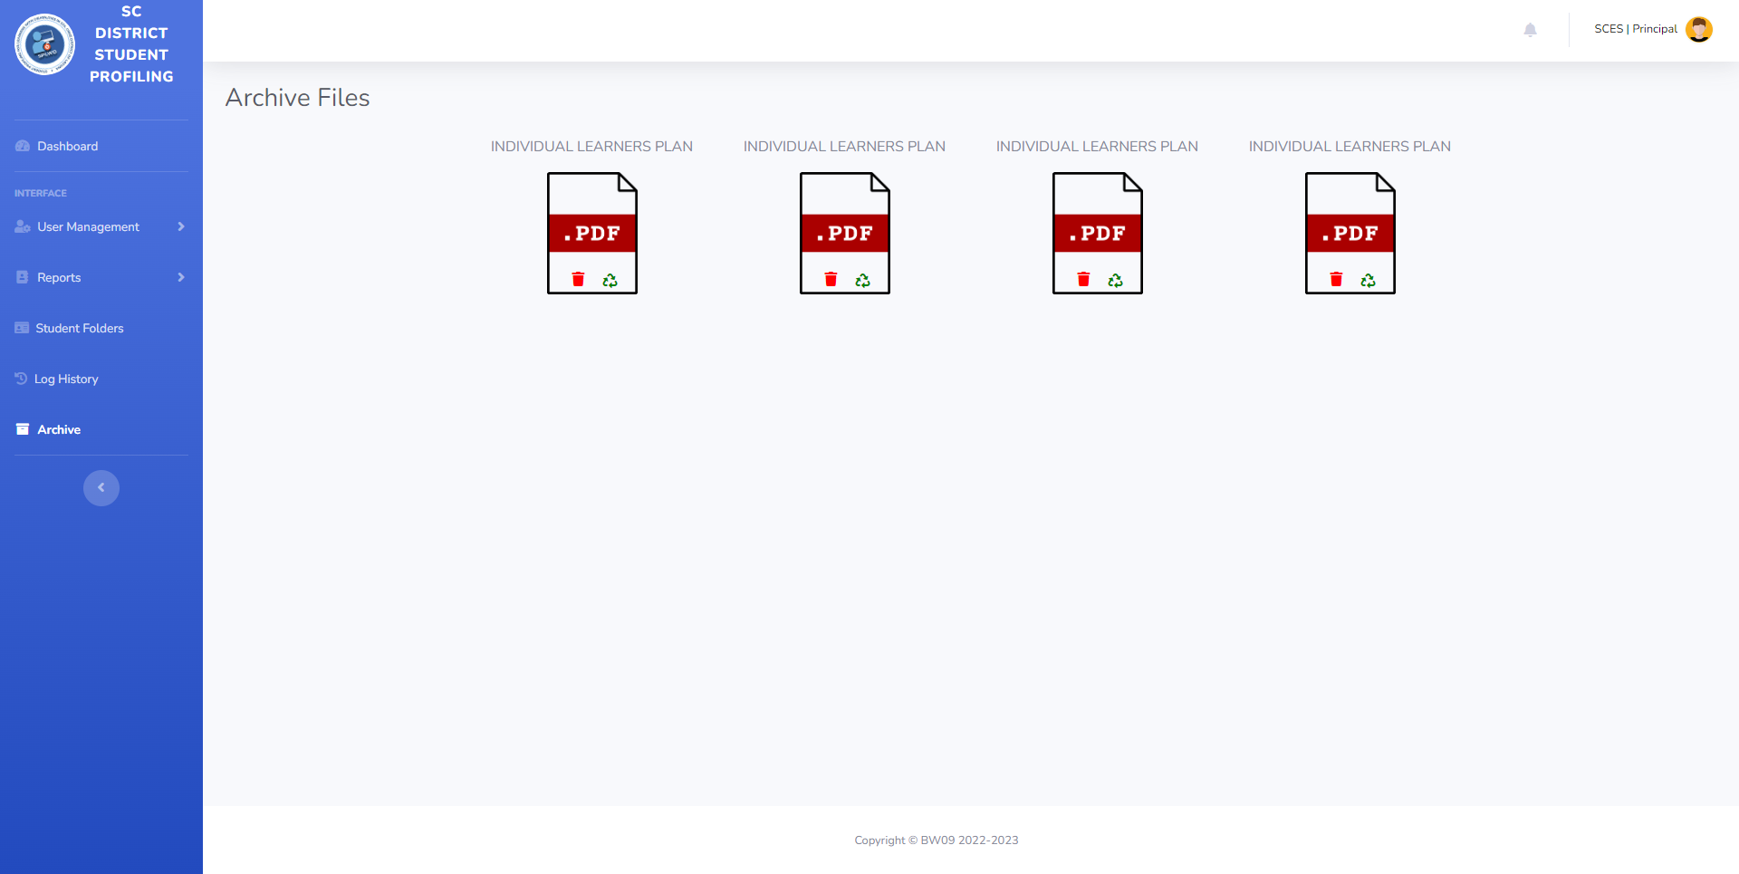

**Parent’s Student Profile**

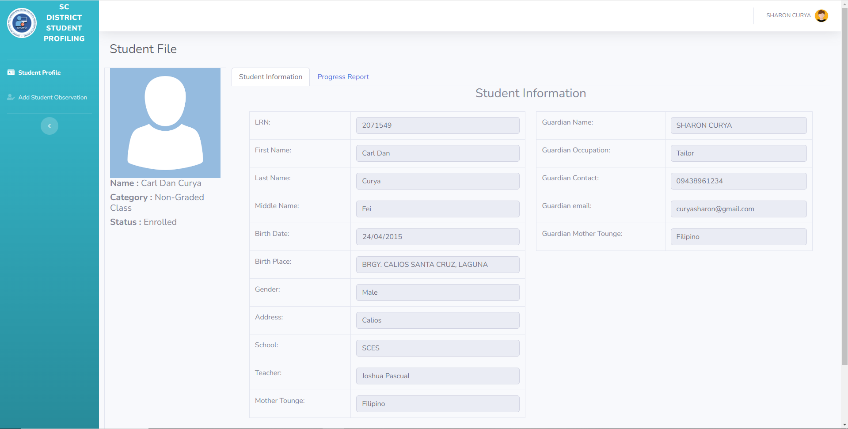

**Parent’s Student Progress Report**

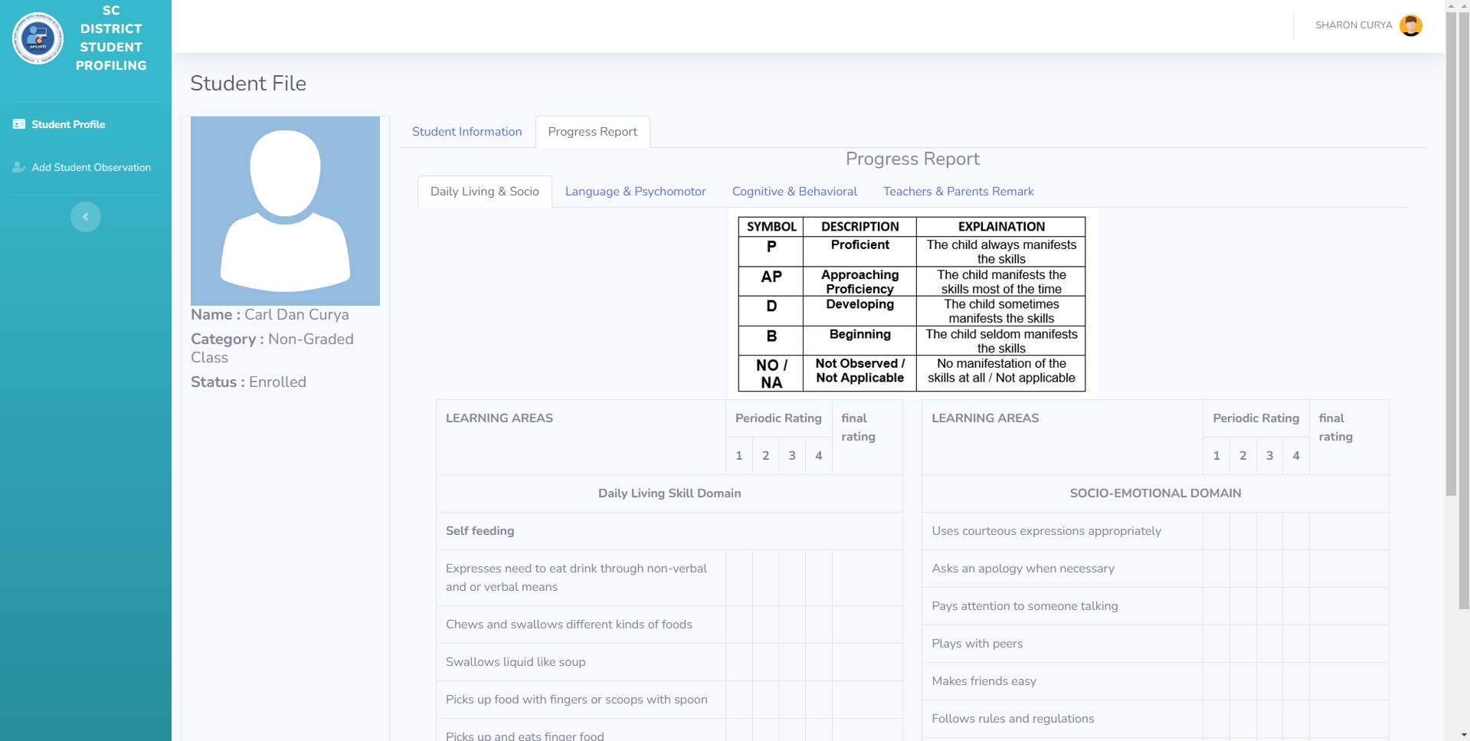

**Testing and Evaluation Instruments**

This section displays the testing and evaluation tools that were used by the researchers during the user evaluation and testing phase of the study.

**Technology Acceptance Model (TAM) Questionnaire – for Parents**

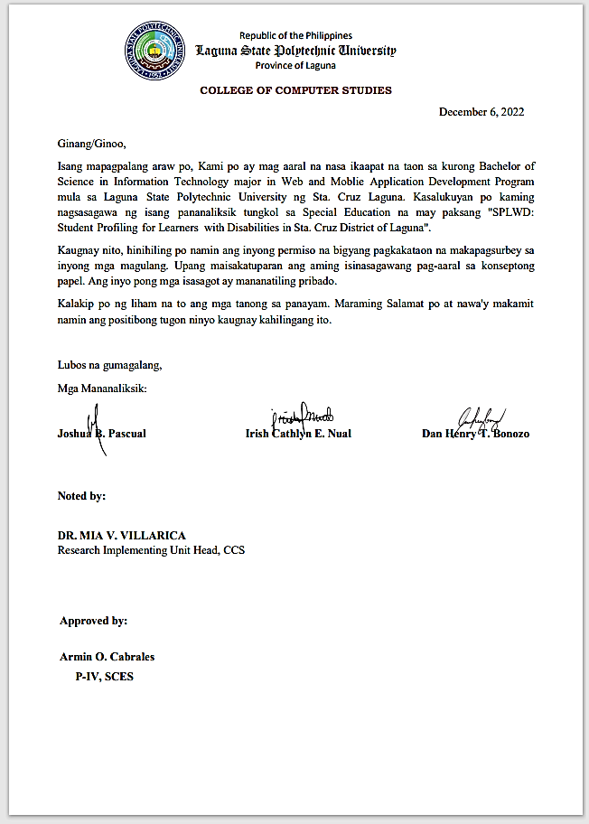

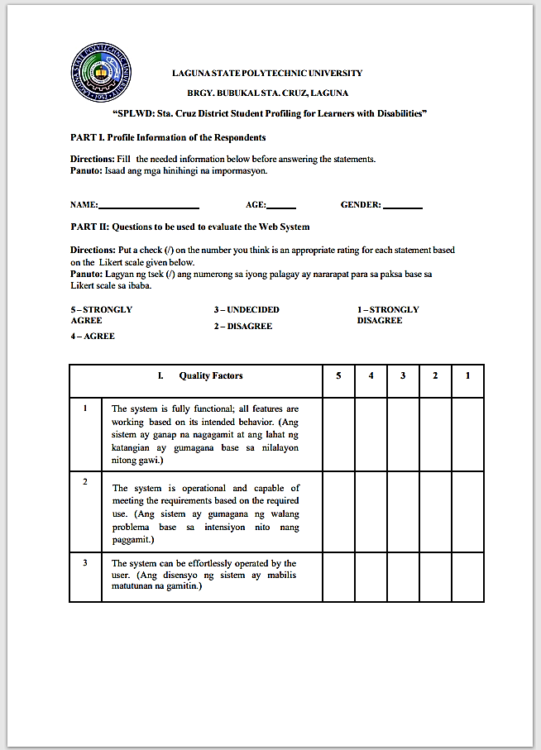

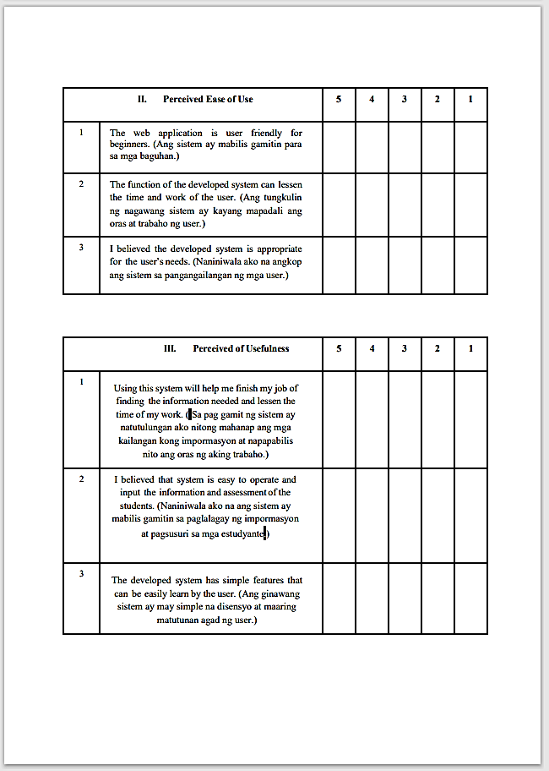

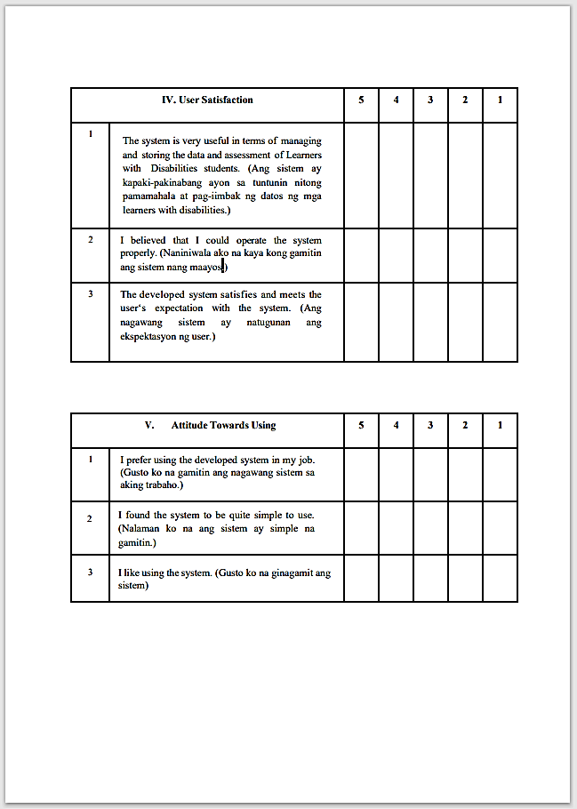

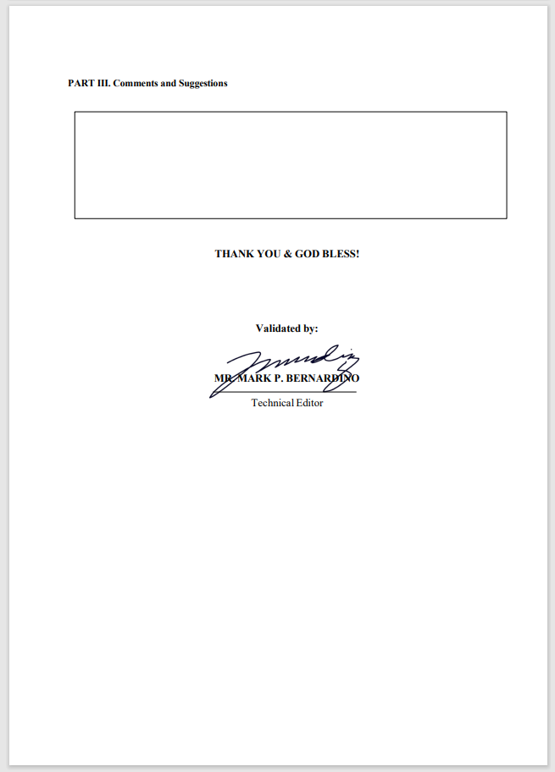

**Blackbox Testing Questionnaire**

**User’s Manual**

**Relevant Source Code**

**APPENDIX B**

**Communication Letters and Forms**

**Communication Letters**

**ISO Forms**

**Final Oral Defense Rating Sheet**

**Summary of Recommendations for Final Oral Defense**

**APPENDIX C**

**Curriculum Vitae**

**Tester’s Curriculum Vitae**

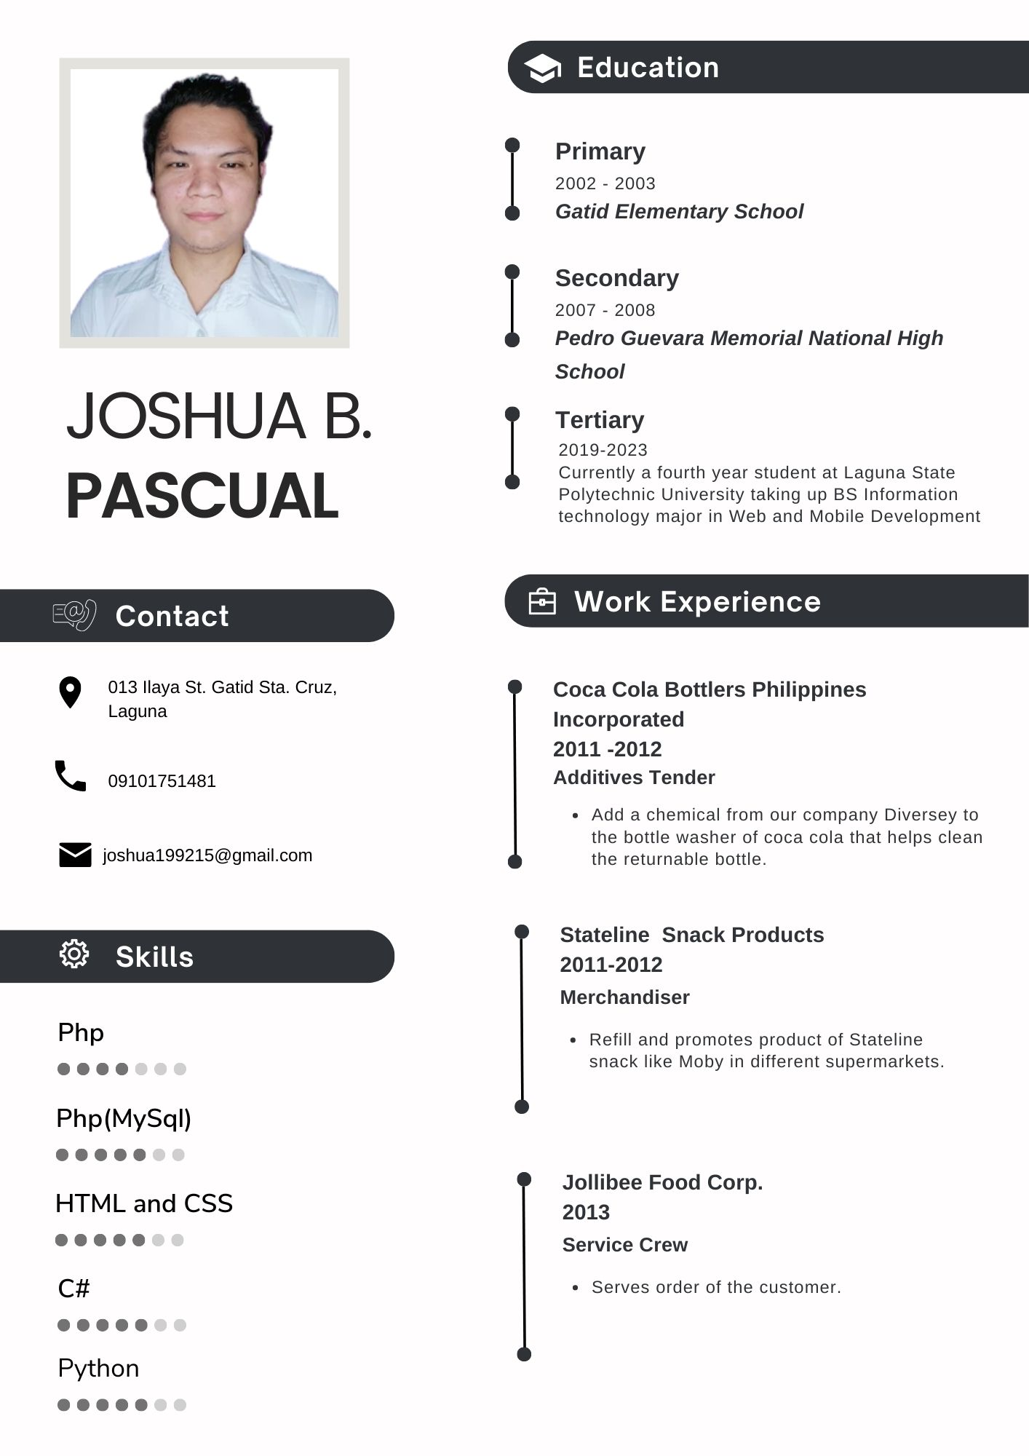**Researcher’s Curriculum Vitae**

